UNIT 1
CONCEPT
1.1 STUDY OF FASHION (FAD, CLASSIC) –
Fashion may be defined as the mass behaviour followed over a period of time and it keeps on changing. The behaviour may include clothing, life style, etc.
Or
The prevailing style of clothing, life style, etc in a time is called as fashion.
Or
Fashion may be defined as the style that acquires popular position in mass due to which its designs remain in more demand than other style over a period of time.
e.g. Presently casual style in clothing is in fashion like T-shirts, sportswear, etc.
To study fashion following parameters are important –
- Types of Fashion
- Need or Evolution of Fashion
- Fashion Theories
- Fashion Principles
- Fashion Cycle

Types of Fashion – To study fashion types following basis of classification are used:
- On the basis of life of fashion – FAD and CLASSIC
- On the basis of acceptance of fashion – HI FASHION and MASS FASHION
- On the basis of time period of fashion – 60s FASHION, 70S FASHION, VICTORIAN, BYZANTINE, EGYPTIAN, etc
- On the basis of nature of fashion – TRADITITONAL, ABSTRACT, MODERN, CONTEMPARORY, etc
- On the basis of category of fashion – FORMAL/INFORMAL, SPORTS/CASUAL, SUMMER/WINTER, MENS/WOMENS, TEENS/KIDS, OFFICIAL/PARTY, etc
FAD - The fashion which introduces and become popular very fast and also declines soon is called as FAD fashion. It is also called as short lived fashion. E.g. Baggy pants, bell bottoms, hippie look, etc.
CLASSIC – The fashion which keeps on moving with little fall or rise in demand over a long period of time is called as classic fashion. It is also called long lived or evergreen fashion. E.g. Men’s shirt, Blazer, Coat, etc.
HI-FASHION – The fashion at its initial stage is accepted by elite people when it is new and fresh and also very expensive. This type of fashion is called as hi-fashion or high fashion. E.g. Designer Wear from a renowned designer.
MASS FASHION – It is a fashion that is accepted by mass or public when it becomes popular and at normal cost. That is why it is called as mass fashion. E.g. Readymade garments.
NEED OF FAHSION – To understand the need of fashion it is important to known how fashion evolved as following:
- At start humans started clothing to cover their body to protect from heat or cold – protective need
- Then with the rise of knowledge and society the humans developed feeling of shame and they developed clothing to hide body parts as a part of social shame – psychological need
- Finally they developed clothing as a mean for personal adornment and here comes the need of fashion – Aesthetic need

FASHION THEORIES – The theories that helps designers and scholars to understand the movement of fashion from one person to other are called as fashion theories. These theories guides designers to understand how a style becomes popular and what are its various courses that make it prevailing among others.
These fashion movement or the basis of fashion theories are due to following two reasons –
a. To match the social status of others (economical concept)
b. To exist in public (feeling of insecurity concept)
On the basis of studies done by various scholars following fashion theories have been developed –
1. TRICKLE DOWN THEORY
2. TRICKLE ACROSS THEORY
3. BOTTOM UP THEORY
TRICKLE DOWN THEORY – This theory suggests that fashion moves from elite class of people to lower economic class. This theory gave the concept of fashion leader which consists of celebrities, sportspersons, actors etc. They generally purchase hi-fashion and their fan follows their fashion resulting in movement of fashion economically downwards direction. This theory was an outcome of studies by John Row and others.
TRICKLE ACROSS THEORY – This theory suggests that fashion can also move at same economic level i.e. within a workgroup like office, college, school, etc. It suggested the concept of role model. In this theory, person working together may choose any one colleague as their role model and then they follow its style/ fashion. In this way economically horizontal movement of fashion occurs. This theory was an outcome of studies by Charles W King.
BOTTOM UP THEORY – This theory suggested that fashion can also move from low economic group to high elite class. They suggested the concept of youth power. According to this theory the youth have tendency to start any new fashion and it can be later on become popular among high economic class people also. That is why it results in a fashion movement of economically upwards. This theory was an outcome of studies by Glynn and Green.

FASHION PRINCIPLES – The principles that guides fashion buyer or designer to understand the world of fashion and its basic rules. These basic rules are applied on fashion world wide and that is why they are known and fashion principles.
There are basically following principles of fashion –
- Fashion is a mass acceptance.
- Fashion is follow the leader process.
- The constant in fashion is change.
- The change in a fashion is a gradual process.
- Every fashion reflects its era.
- All fashion ends in excess.
- Some exceptions can be there.
Fashion is a mass acceptance – According to this principle, fashion is that style which is accepted by group of people or mass. The style may initiate through an individual but it will become fashion only when it becomes popular in public.
Fashion is follow the leader process – Fashion scholar E Rogers did research on various fashion changes and he concluded that every fashion has a life which is known as life cycle. It can be studied in three stages i.e. rise or beginning, , popularity or establishment and fall or decline as mentioned below -
Rise – A= Initial Acceptors as high fashion
B= Followers to popularise the style
Popularity – C= Mass followers at popular stage
D= Mass followers at later stage
Decline – E= Laggards or followers at decline (Stage with discounts or benefits)
Hence, it is concluded that fashion initiates as high fashion and thereafter it is followed over by people through different stages that is why it is called as follow the leader process.
The constant in fashion is change – The only thing constant in fashion is change. Fashion has life in which it starts, become popular and then ends. Thus, no fashion remains stable with time and keeps on changing. There are following factors that are responsible for this change –
SNO | FACTORS | EXAMPLES
1 | Social | Culture, Sub-Culture
2 | Rational | Burqa, Veil now discontinued with time
3 | Industrial | Ready Made Garments
4 | Technological | New Fibres- Lycra
5 | Economical | Power of Purchasing
6 | Political | Freedom for Fashion
7 | Creativity | Urge of Creativity
8 | Psychological | Boredom

The change in fashion is a gradual process – The change in fashion occurs with time gradually and not revolutionary. The change takes place step by step over time but when changes become extremely different then it appears to be a sudden change. But actually it is not an immediate change as change in fashion is a gradual process.
Every fashion reflects its era – Every fashion was outcome of creativity, social and economic activities, cultural state of its time and hence the designs show the effect of its time. No design or fashion can be stated as right or wrong as the fashion identifies its era in which it was popular.
All fashion ends in excess – Generally all fashion that become extremely popular and has reached through all people in excess will start to decline and finally ends The excess of fashion occurs when all the scope of minute changes in it becomes less or when trends get shift very far over the time.
Some exceptions can be there – Generally these principles are true and followed throughout the world. But in certain critical situations, some of them fail. There can be some cases in which exceptions can occur in these principles. E.g. world war, civil war, economic crisis, flood, famine, etc.

Fashion Cycle – Every fashion has life. Fashion is not stable. Fashion keeps on changing with time. Every fashion starts, becomes popular over a time and then ends. This behaviour of fashion over a period of time is known as fashion cycle.
As fashion is follow the leader process where fashion starts as high fashion and then followed by others at different stages. The combination of these stages draws the fashion cycle. Research on fashion cycle was done by E Rogers who studied behaviour of different fashions over time and suggested that a fashion cycle generally has following stages –
- Introduction
- Rise or Popularity
- Fall or Decline
He surveyed that fashion behaviour and found following graphs –
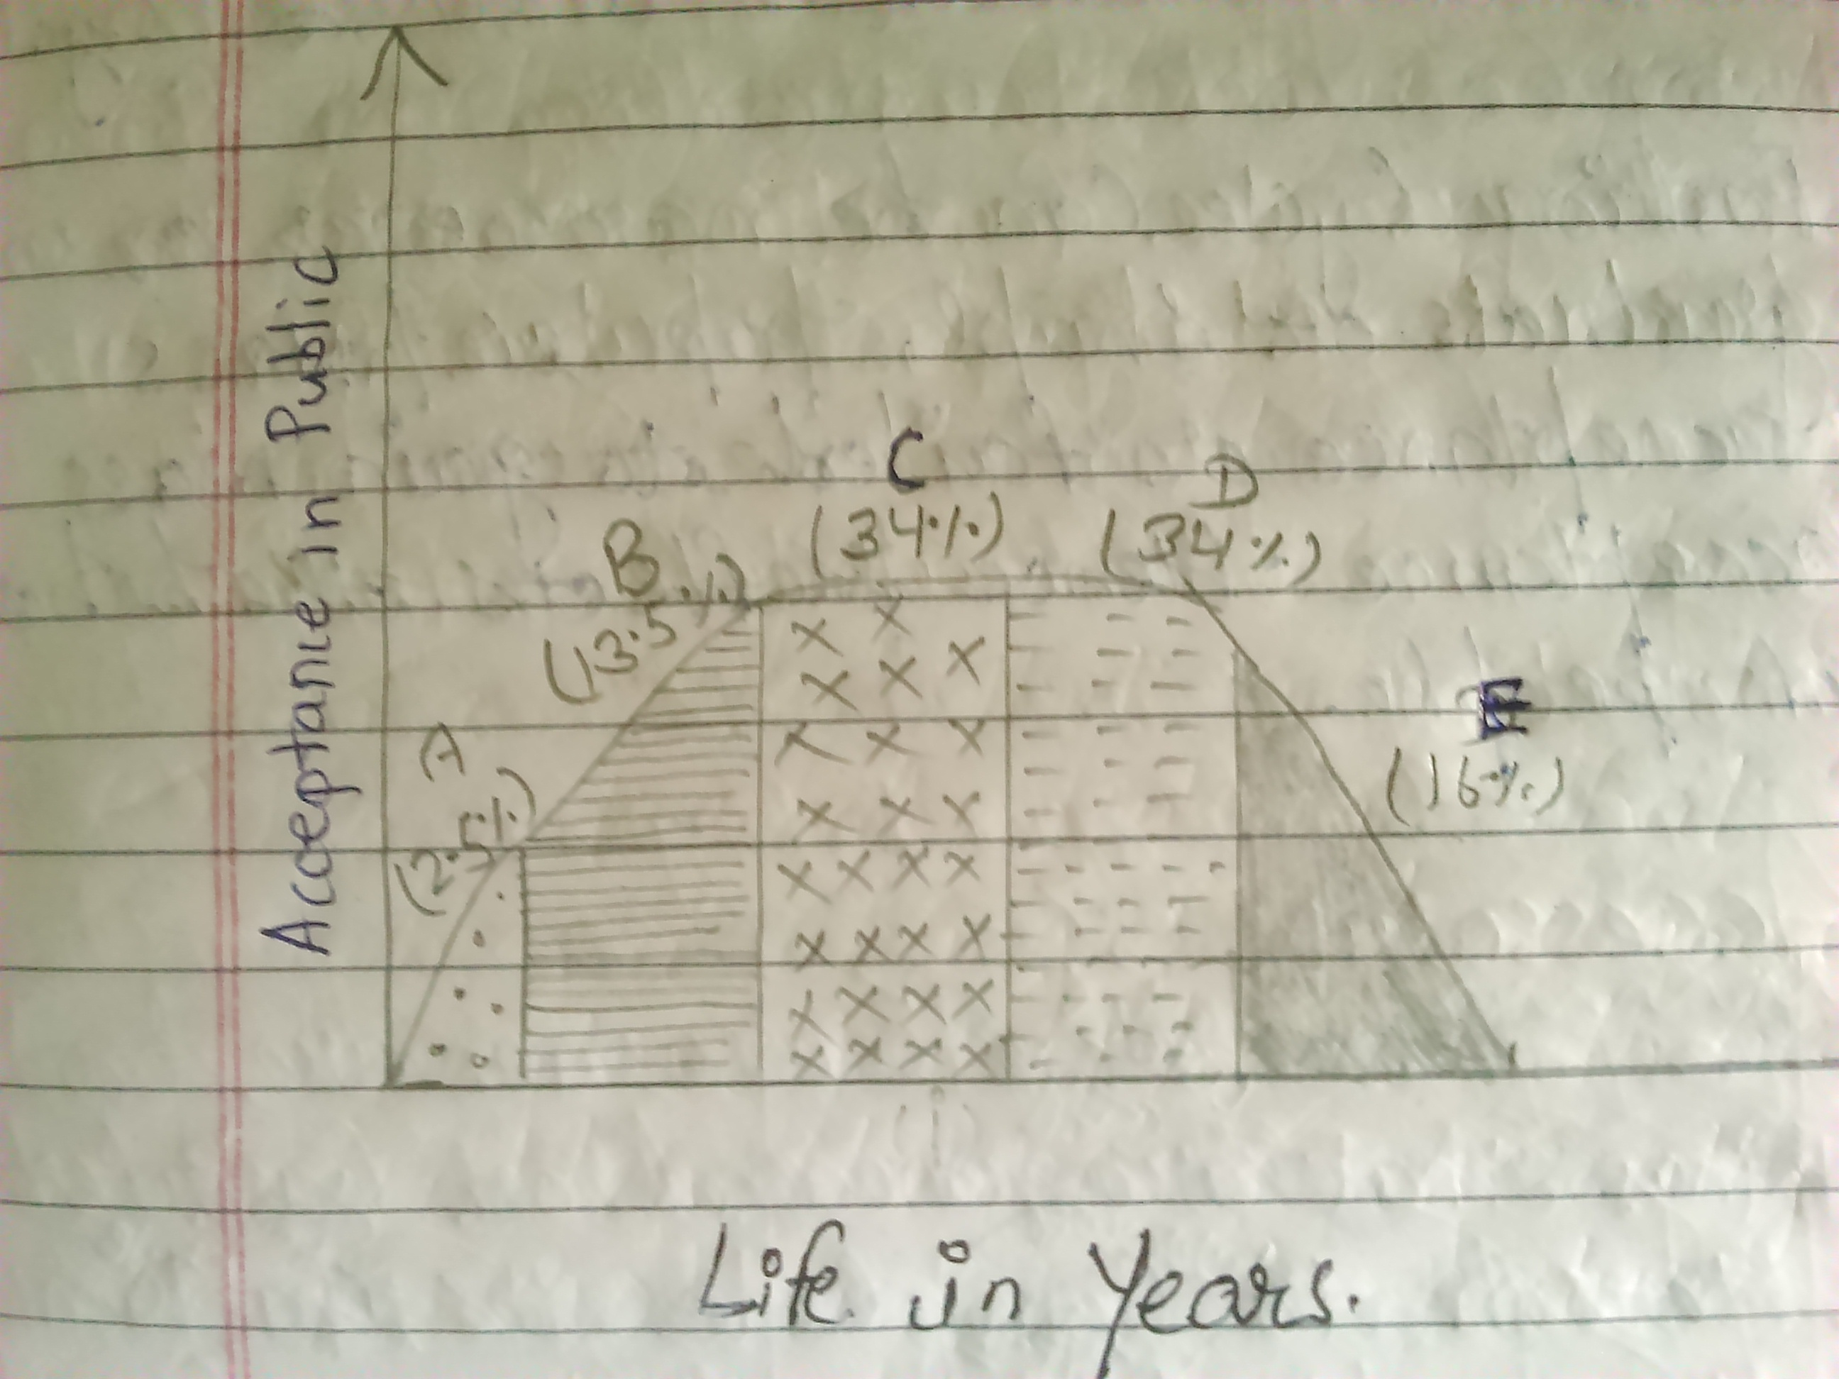
Rise – A= Initial Acceptors as high fashion
B= Followers to popularise the style
Popularity – C= Mass followers at popular stage
D= Mass followers at later stage
Decline – E= Laggards or followers at decline (Stage with discounts or benefits)

SNO | FASHION | FASHION CYCLE | BASIS
1 | Fad and Classic |  | On the life of fashion
2 | Hi-Fashion and Mass Fashion |  | On the acceptance of fashion
3 | Gradual or Sharp |  | On the popularity of fashion

USES OF FASHION CYCLE –
- It guides fashion designer to take decision for new designs by understanding previous trends or cycle.
- It helps fashion buyer or traders to take investments decision and planning for that fashion by studying these cycles.
- It guides students of fashion to understand fashion behaviour overtime.

1.2 FASHION TERMS –
Boutique – A boutique is a French word given to a place where dress making is carried out at a smaller scale but in unusual or local design demand environment. A boutique acts as a self employment mean to various dress makers. A boutique may have its own dress collection or may stitch to customer choice or even both. A boutique has very good flexibility for local adaptation of designs. A boutique may have in house or external dress making workshop.
Couture – The fine art of dress making is termed as couture in French. The thing that makes it special is its French origin. In couture the dress making is treated to its finest details or class to give customer full satisfaction with design and fit both.
Haute-Couture – The dressmaking of garment houses in France especially in Paris that belongs to Chamber Syndicate Criteria to be on its Couture creation list is termed as Haute-couture. Thus this is couture which falls under high class of recognition for its dress making that focuses dress making as an art rather than business and works to provide customer complete satisfaction in dressmaking. It includes assistance in fabric selection, design selection, measurement trials, cutting-stitching, etc to customers need and satisfaction. It is a long but quality process of dressmaking. It is very expensive.
Pret-a-porter – The term Pret-a-porter is used for the new trend in garment making which is also called as ready to wear or ready to carry designs. It’s a French word that refers to a dressmaking by using a standard fit pattern to produce dresses in bulk for people, which they can try and carry immediately with them. It is much faster way to supply dresses to customers than in couture. Moreover mass production of dresses results in price fall and hence dresses become cheaper than in couture. But its quality in terms of material and fit cannot be compared with couture.
Avant Garde – The fashion style that is not linked with a current trend but a designer has designed for experimentation to show its creativity to check its acceptability, is known as avant garde. It can become a huge success or a huge failure. Still the concept is used by designers to experiment their creativity in designing and to understand customer’s for possible future trends.
Hi- Fashion – The fashion which is accepted by a few at its very initial stage when it is fresh and expensive is called as hi-fashion or high fashion. The upper economic class elite persons follow high fashions. It may later on becomes popular or may not but initially it is adopted by these persons. These persons acts as fashion leaders for such fashion.
Fashion Trend – The direction in which a fashion style is moving is known as fashion trend. A fashion trend is very important to be understand by a designer to meet customer’s acceptance to its new design. A fashion trend keeps on changing and it can repeat also.
Designer – The person or artist who uses its creativity and skills to deliver new designs of dresses or costumes by carefully observing latest or future trends is known as designer. They may follow current trend or may initiate some new trend. The success of their designs depend on mass acceptance.
Accessories – Accessories are an input or raw material for a costume or dress. Accessories supports costumes by adding look or function to them. E.g. belts, bows, jewelleries, hats, caps, handbags, shoes, etc.
Apparel – Apparel is a name given to clothing that is not necessary to be fashionable.
Atelier – It is a French word for designer’s workshop. It is classified as flou (for soft dressmaking) or tailleur (for pre tailoring suits and coats).
Bespoke – It is an English term used for made to measure men’s suits.
Collection – A collection may be defined as the group of dresses or costumes designed for a specific season or occasion.
Fashion Forecast – Fashion forecast may be defined as a prediction of forthcoming fashion or trend in costumes, trims, accessories, colour, etc.
Style – Style is a unique characteristic of a costume that distinguishes it from other costumes. It is a sub-division within a fashion.
Stylist – Stylist is a fashion expert, generally selects colours, prints or styles for presentation or prepares fashion merchandise for photographic presentation in an advertisement or catalogue or event.
Vendor – A vendor is a seller, resource, manufacturer or supplier of fashion trims and accessories.

1.3 Economic, social, environmental and political factors influencing fashion
These are some important factors as we studied in the principle that fashion keeps on changing. The details are as following –
Economic Factors – Economical factors has a deep impact on fashion which can be understand through following examples –
- Recession and Feel Good Factor – Recession weakens economy and thus reduce fashion business on the other side growing stable economy give feel good factor and thus increase fashion business.
- Unemployment – An increase in unemployment will have negative influence while employment favours fashion growth positively.
- Home ownership – Home owner can spend more for fashion while one who does not own a house will look for savings and other requirements than fashion.
- Credit facilities – Credit facilities like credit cards, trade cards, etc empower people to spend on fashion on the other side lack of credit facilities does not motivate people for fashion. Growing economies provide more credit facilities to its natives.
Social Factors – Social factors may comprise of following –
- Leisure – A more time of leisure will enhance casual fashion, daily wear, routine wear, street fashion etc. Busy routine will deprive people away from such fashion and they will prefer more formal fashion.
- Work – More work culture will enhance office fashion and will reduce scope of creative and sporty fashion.
- Fair Trade – A well developed society will enhance fair trade and avoid child labour. This will cause reduction in profits and competition in fashion.
- Culture – The culture and social build of a race will guide its people to fashion. A reserved culture has low scope for fashion while an open culture has more scope for fashion.
Environment Factors – It can be studied through following points –
- Seasons – Change in weather or climate will affect certain type of fashion product e.g. thermal wear, sweaters, rain coats and hence fashion trade in these products get affected.
- Green House – Since people are becoming more and more aware with environmental problems issue they are shifting towards green fashion. E.g. no to leather, no to fur, increase in second hand clothing, no to chemical finishes, yes to natural finishes, etc. More popularity of organic products and such other factors influence fashion.
Political Factors – It may be understand through following –
- GATT, MFA – GATT stands for General Agreement on Trade and Tariffs while MFA stands for Multi Fibre Agreement. These agreements restricts or control flow of products from developing countries to developed countries. Such political control restricts fashion trade.
- Minimum wages – The ceiling of wages also affects flow of fashion industry. A rise in minimum wages affects profits of manufacturers and hence influence fashion trade.
- BS 5722 – It is a test no. Which is compulsory to perform before exporting children wear to London. Such tests increase costs of manufacturing and hence influence fashion.
- Copyright – Copyrights avoid stealing of design and hence affects fashion to move distant places.

UNIT 2
FASHION INDUSTRY PROFILE
2.1 Current Indian export and India’s position in the world apparel/textile market –
The Indian export and India’s Position in the world apparel or textile market can be studied as following –
(The data is based from Asian Textile Journal 2011 )
- Apparel or Textile industry contributes about 14% to Industrial Production of India.
- It contributes about 12% to export earnings.
- It is the 2nd largest job provider after agriculture in India.
- It provides direct employment to over 35 million people.
- The fibre wise production of India is shown in following table:
SNO | ITEM | PRODUCTION | SHARE IN WORLD | POSITION IN WORLD
1 | Cotton | 05.00 billion kg | 22% | 2nd (China-1st)
2 | Silk | 17.00 million kg | 13% | 2nd (China-1st)
3 | Jute | 01.70 billion kg | 56% | 1st
4 | Cellulosic | 00.33 billion kg | 12% | 2nd (China-1st)
5 | Synthetic | 02.40 billion kg | 06% | 4th (China-1st)

- India has the 3rd largest sheep population which is 6.15 Cr producing 45 million kg of raw wool. It is 3.1% of world production.
- India is the 2nd largest exporter of jute products.
- As on Oct 31, 2009, there were 1,834 cotton/ synthetic fibre textile mills in India having 37.07 million spindles.
- There are 13 readymade garment clusters in India e.g. NCR, Ludhiana, Mumbai, Bengaluru, Chennai, etc.
- As on Dec, 31, 2009, there were 5.03 lakh unit of fabric with 22.38 lakh power looms.
- The following table shows state wise industrial activities for important fibres:
SNO | INDUSTRY BASED ON | STATES
1 | Jute | West Bengal
2 | Silk | Andhra Pradesh, Karnataka, Tamil Nadu
3 | Cotton | All Over India
4 | Synthetic and Woollen | Maharashtra, Gujarat, Punjab, Haryana, Madhya Pradesh, Uttar Pradesh

- The total production of cloth by all sectors:
SNO | SECTOR | PRODUCTION SHARE
1 | Knitting/ Hosiery | 19%
2 | Mill | 5%
3 | Handloom | 11%
4 | Power loom | 65%
- Broad sub grouping of the product is as following:
SNO | PRODUCT GROUP | SHARE
1 | Ready Made Garments (Gents) | 60%
2 | Ready Made Garments (Ladies) | 30%
3 | Ready Made Garments (Kids) | 10%
- Major Companies in Indian Textile Industry:
Welspun India Ltd, Vardhman Group, Alok Industries Ltd, Raymonds Ltd, Arvind Mills Ltd, Bombay Dyeing and Manufacturing Company Ltd, Garden Silk Mills, ITC, Orient Craft Ltd, Madura Garments, etc.
- Value Chain analysis:
SNO | PROCESS | VALUE SHARE (of Sales Price)
1 | Basic Raw Material | 50-60%
2 | Processing Charges (Dyeing/ Printing/ Bleaching) | 10-15%
3 | Cutting and Fabrication | 10-15%
4 | Fitting and Accessories | 10%
5 | Finishing and Packing | 5-6%
6 | Embroidery and Other Handworks | 25%

2.2 Organisation structure of export house and buying house –
2.2.1 Export House – An export house is an apparel manufacturing unit that source raw materials from suppliers and manufactures garments on large scale with required quality for exports to buyers. The definition can be understand through following diagram – 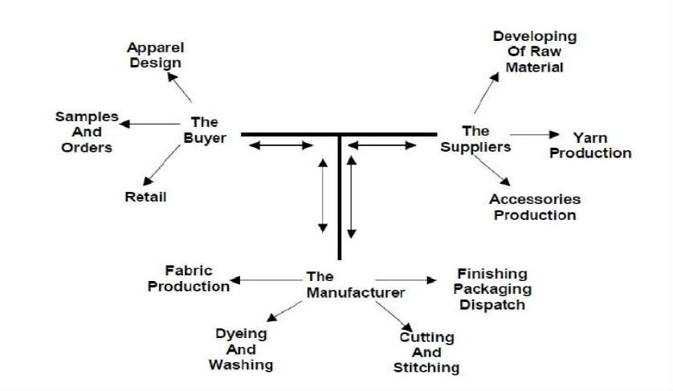
The export house consists of various departments that coordinates with each other to achieve its organisation goal i.e. to produce garments as per buyers need. The completer organisation structure is as following –
1. Marketing Department – It is responsible for bringing new orders and buyers to export house and selling merchandise to the markets.
a. Sampling Department – It develops samples with merchandising department as per spec sheets received through buyers.
b. Merchandising Department – It communicates with buyers for sample approvals, production orders, comments etc until final shipment is delivered to them. It closely coordinates between buyer and other departments.
c. Designing Department – It develops new designs for marketing department to present them to new buyers for convincing them to do business with their export house.
d. Retailing Department – It retails merchandise (garments) into the market if the export house also produces garments to sell them into market with their own brands.
2. Production Department – It is responsible to manufacture the orders of marketing department as required by the buyer in desired quality and time.
a. Cutting Department – CAD- It creates pattern markers and cut fabric into patterns as per plan received from PPC department.
b. Stitching Department – It stitches patterns into garments as per cutting received from cutting department and instructions received from PPC department.
c. Processing Department – Dry Processing and Wet Processing (Washing)- It processes garments as per buyer’s instructions e.g. whiskering, resin finishing, stone wash, enzyme wash, etc.
d. Finishing and Packing Department – It adds required trims to garments like buttons, labels, etc and finishes garment to make them ready to pack e.g. trimming extra threads, ironing, measuring, etc. It also packs the finished garments into packages as per buyer’s requirements.
e. Production Planning and Control Department (PPC) – It prepares a plan for each garment order for every department. So that the shipment can be delivered in time.
3. Supporting Department – These departments directly or indirectly supports both marketing and production department to achieve their goals successfully.
a. Industrial Engineering Department – It helps production department in achieving desired productivity by conducting time and motion studies. It also helps merchandising department in calculations required for costing of a garment.
b. Quality Department – It monitors production department in each and every process so that desired quality can be achieved without defects.
c. Human Resource Department – It arranges skill labour and staff for different departments and also manage their needs.
d. Engineering Department – It helps in providing and maintaining different facilities like electricity supply, steam supply, air pressure supply, maintenance of machinery, etc.
e. Finance Department – Accounts – It deals with all monetary and financial matters.
f. Sourcing Department – Purchasing Department and Store or Warehouse – It finds, purchase and procure different raw materials in time so that production department can get regular supply without any delays.
4. Administrative Department – It is overall responsible for the functioning and performance of an export house and manages all the departments and looks after their coordination. The organisation structure of an export house can be understand through following diagram:
ADMINISTRATIVE DEPARTMENT
MARKETING DEPARTMENT
SAMPLING
DESIGNING
MERCHANDISING
RETAILING
PRODUCTION DEPARTMENT
STITCHING
CUTTING - CAD
PROCESSING – DRY & WET
FINSHING & PACKING
PPC
INDUSTRIAL ENGINEERING
QUALITY
HUMARN RESOURCE
ENGINEERING
FINANCE-ACCOUNTS
SOURCING-PURCHASE & STORE/WAREHOUSE

The working of an export house in a simple way can be understand through following flowchart –

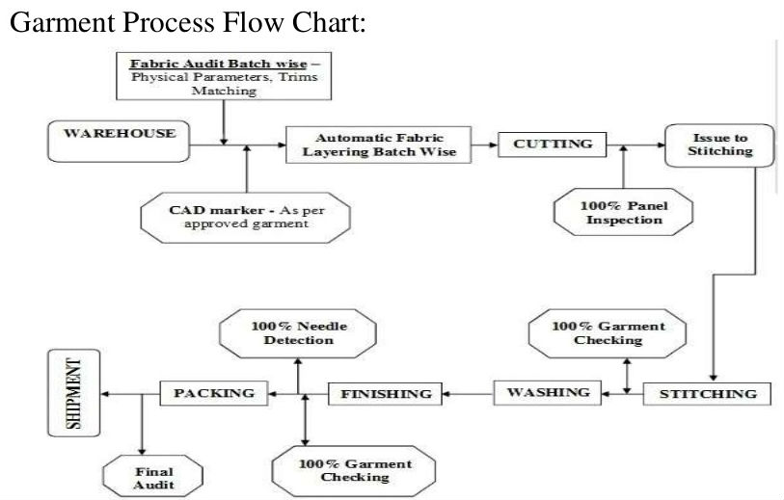

2.2.2 Buying House –
The office that procures garments from the manufacturers and exports to other countries is called garment buying house.
Basically Garment Buying houses try to communicate with buyers of other countries who want to buy garment products. Then they contact with garment factories who can make those kinds of products and fulfil buyer’s demand. Like this they create a contract between these two parties. Sometime buying houses make their own sample section, so that they do not have to go to factories for collecting sample and they can attract customers faster and easily. On the other hand, they create a show room of their product to attract the buyer. Moreover, this house has a merchandiser team to follow up the product processing line perfectly and also has a quality assurance team for checking the actual quality of the product. The organisation structure of buying house is shown as following:

ADMINISTRATION – BUYING HOUSE
MARKETING AND MERCHANDISING MANAGER
TECHNICAL AND QC MANAGER
LAB INCHARGE
MARKETING MERCHANDISER
DEVELOPMENT MERCHANDISER
QUALITY CONTROLLERS
TECHNOLOGISTS

Working Procedure of a Buying House:
Every organization has its own working procedure. It’s varies from organization to organization. Buying house work flow is given below,
- First of all marketing merchandiser contact with a buyer and collect an order by showing the garments they made before or directly ask which type of garments buyer need.
- Then he /she find out the suitable factory for that specified garments. The factory must be audited by recognized organization like Oeko-tex, WRAP etc. (Depends on Buyer).
- Do consumption & costing and bargaining with factory for cost for the specific product. Finalize cost and send it to buyer.
- Then development merchandiser develops the product send 1st pattern for any correction.
- Usually buyer makes some modification on 1st pattern, so 2nd pattern is submitted according to 1st pattern comments.
- Then fit sample is made and QC (Quality Controller) check is it follows the approved 2nd pattern.
- Then the seal sample is sent for approval which is also known as buying sample. And if this sample approves then the order is confirmed.
- Then production merchandiser starts his work.
- Production merchandiser basically follows up the total production stage and stay in close touch with the garment factory merchandiser or any other representative . After getting approval of seal sample he has to book the fabric and trims.
- He has to Follow up the fabric and trim arrived in factory in time or not. After all approval he does production planning meeting with factory.
- QC has to follow the production is running with approved item, fabric and accessories or not. He helps production merchandiser by giving all production information.
- QC’s main task is to check all samples (seal, gold seal, web sample etc) sent to buyer, and help factory people if there any confusion with production.
- Fabric, trims accessories are checked in lab in buying house. It‘s called in-house test like Bulk fabric hanger, shade variation in shade continuity, lab dip, fabric quality etc.
- Different types of inspection also done in lab before shipment.
- After doing shipment and showing packing list and some commercial documents buying house receives their commission.

UNIT 3
FASHION MERCHANDISING
3.1 TERMS –
3.1.1 Merchandise – Any product or item that is manufactured to retail to consumer is called as merchandise. The traders do business by selling and buying merchandise. Thus, merchandise is the object of trading. E.g. garments, shoes, belts, hats, watches, etc are different merchandise.
3.1.2 Buyer – A buyer is an important participant of trade. It gives order to manufacturer to purchase a particular merchandise according to its need and as per the price negotiated between them. Buyer is a person or company that trades in a particular merchandise or group of merchandises, it sources, purchase and then distribute the merchandise in market. E.g. Calvin Klein, Gucci, Kohl’s, Perry Ellis are different buyers.
3.1.3 Merchandiser – A merchandiser is a person responsible to plan the merchandise production and delivery to buyer as per buyer’s requirement and in promised time. Merchandiser acts as a intermediate for communication between a buyer and a production unit as it is not possible for buyer to communicate different departments on its own. So, the merchandiser facilitates the communication between a buyer and a manufacturer unit. A merchandiser is solely responsible for the timely delivery of merchandise to buyer as per its specifications. E.g. Sampling merchandiser, Junior Merchandiser, Senior Merchandiser, etc.
3.1.4 Buying Office – It is a office opened by a buyer to carry out all the activities related to buying and distribution of merchandise. A buying office can be of buyer’s own or it can act as a intermediate for buyers of different countries. E.g. Impulse Buying Office in Gurgaon.
3.1.5 Buying Plan - It is the written plan according to which all the activities related to a buyer are carried out annually. It includes the sourcing and purchase planning of merchandise according to different seasons and their distribution timing. The plan is prepared in advance so that all the actions can be completed in time to avoid delays.
3.1.6 First Pattern – The term is used for the patterns developed for the first time by pattern master of sampling department of a garment export house. It is developed on the basis of specifications and instructions given by a buyer. According to the quality of first pattern the buyer decides further course of sample development and initial pricing of the garment. It is the initial sample for any design which lays the basis for further sample development and order finalisation by a buyer to export house.
3.1.7 Greige Goods - The raw material which is not finished completely to be retail to its end user is called as greige goods. These goods are used by different industries who transform them from one form to other usable form until they are finished and completed to be sold to consumers in market. E.g. unfinished fabrics, zippers, buttons, etc.
3.1.8 Retail Price – The selling price of a merchandise at which it is retailed to end user of consumer in the market is called as retail price. It may include discounts and taxes. It has a ceiling above which it cannot be retailed in the market, it is called as MRP or Maximum Retail Price. No one can sell a merchandise above to its MRP.
3.1.9 Landed Cost – The final cost of a merchandise that a buyer spends to acquire it is known as landed cost of that merchandise. It may include transportation costs, labour, duties and taxes.
3.1.10 LC - Letter of credit is an assurance given by the buyer’s bank to remit the amount to the seller through seller’s bank on maturity, as per the terms and conditions of document based on the contractual agreement between buyer and seller. Now in simple words, If LC opened on your name, you will receive amount though the buyer’s bank on the agreed time. All Letter of Credits for export import trade is handled under the guidelines of Uniform Customs and Practice of Documentary Credit of International Chamber of Commerce (UCP 600).
There are various types of letters of credits like Revocable, Irrevocable, Confirmed, Unconfirmed, Clean & Documentary, Fixed, Revolving, Transferable, Back to Back etc.
3.1.11 FOB - FOB means Freight On Board or Free On Board. If terms of delivery of a transaction is on FOB means, the cost of movement of goods on board of Airlines or on board of ship is borne by the seller. Rest of all expenses to arrive the goods at buyer's premise has to be met by the buyer.
3.1.12 Air Freight – The cost of movement of goods through air services i.e. as aeroplane cargo is called as air freight. Air freight is costlier than sea freight as air cargo service is faster than sea cargo services.
3.1.13 CIF - Under CIF terms of delivery in export business, Cost Insurance and Freight included in the selling cost of goods. For example if you are a Machinery seller situated in Mumbai, India. The buyer is situated in New York. You are the seller of goods and you have contracted with the buyer and agreed to sell the goods on CIF New York price of USD 5750. Here the selling cost of goods is USD 5750 CIF New York. You (the seller) arrange to carry the goods to Mumbai port and meet all expenses including customs clearance in Mumbai and pays the ocean freight or airfreight up to New York, by appointing a shipping line or airlines. In other words, all delivery expenses up to New York is borne by the seller. Apart from the same, under CIF terms of delivery, Insurance of goods also must be arranged by you as a seller. Once reached the cargo in New York, the buyer takes delivery of cargo after customs clearance at his own cost after paying duties or tax if any.
3.1.14 Spec Sheet – A specification sheet, commonly abbreviated to “spec sheet,” is a technical document that sets out the details of how, exactly, a certain product is intended to perform or function. It is the detailed hard copy of any product issued by a designer/ buyer to manufacturer for development and bulk production. It consists complete specifications from raw materials, processes, finishes, measurements, final look, decoration, final packaging, etc. A manufacturer can find all the desired information from it necessary to reproduce a product as per buyer’s need.
3.1.15 BOM - Bill of Material is a list of raw materials needed to be sourced to make garment and make it ready for shipment as per buyer's requirement. In garment manufacturing BOM is generally prepared by production merchants. Then has been approved by responsible person and handed over to purchase department to start sourcing of raw materials.
A BOM normally includes items description, Consumption (per piece consumption) with defined unit of measure, projected cost per unit and total cost of each item.
3.1.16 Trim Card – Trims are the necessary raw materials like fabric, thread, label, embroidery details, buttons, zippers, etc that get consumed during manufacturing of garments. When samples of each and every trim is displayed on a card with specifications for the information of sourcing and production department then such card is called as trim card. Trim card is prepared by merchandiser and handed over to production department in pre-production meeting. It avoids any trim mismatch in a particular style as trim cards are produced according to style numbers.

3.2 SKILLS OF MERCHANDISER –
A successful merchandiser should possess following skills –
Active Listening - Giving full attention to what other people are saying, taking time to understand the points being made, asking questions as appropriate, and not interrupting at inappropriate times.
Speaking - Talking to others to convey information effectively.
Critical Thinking - Using logic and reasoning to identify the strengths and weaknesses of alternative solutions, conclusions or approaches to problems.
Social Perceptiveness - Being aware of others' reactions and understanding why they react as they do.
Judgment and Decision Making - Considering the relative costs and benefits of potential actions to choose the most appropriate one.
Time Management - Managing one's own time and the time of others.
Coordination - Adjusting actions in relation to others' actions.
Service Orientation - Actively looking for ways to help people.
Reading Comprehension - Understanding written sentences and paragraphs in work related documents.
Complex Problem Solving - Identifying complex problems and reviewing related information to develop and evaluate options and implement solutions.
Writing - Communicating effectively in writing as appropriate for the needs of the audience.
Active Learning - Understanding the implications of new information for both current and future problem-solving and decision-making.
Persuasion - Persuading others to change their minds or behavior.
Negotiation - Bringing others together and trying to reconcile differences.
Professional Skills –
- Should have computer skill
- Good communication skills written and verbal
- Good knowledge in mathematics
- Always be Courageous and Active
- Knowledge of different fabrics
- Knowledge on Garment production
- Knowledge on washing
- Knowledge on banking, commercial, shipping etc
- Need to have at least a related training etc.
- Other important qualities are – able to take high mental pressure
- Must take responsibility for task undertaken

3.3 ROLES OF MERCHANDISER/ TASKS OF A MERCHANDISER –
Based on job responsibility and kind of works merchants are primarily categorized as sampling merchants and production merchants. Where a sampling merchant deals with sampling of styles, a production merchant is responsible for the everything to run an order smoothly - from material requirement sheet preparation to handing over shipment to buyer. However job responsibility may vary based on factory size and organization structure of the company. The role and taks can be summarised as following -
- Making production Time and action calendar - based on the process flow of an order merchants prepare time and action calendar and indicates who is responsible for the task. This helps merchant to execute an order whether it is on time or behind schedule. Merchants chase department who are running late.

- Preparing Bill of material and handover it to sourcing department - Based on tech pack (technical sheet), merchant prepares material requirement sheet. In some cases, merchants develop and purchase few trim by themselves.

- Execution of sourcing trims / accessories - merchants do follow up with supplier for the raw material.

- Preparing production file - Prepares production file with details documents, approvals, samples and swatches and comments on sample from buyer.

- Conduct PP meeting with quality team and production team - merchants conduct pre-production (PP) meeting with production team and quality team. In this meeting merchants discuss style construction details, production plan, PCD and handover production file to the production team. One copy of production file is also made for quality team.

- Giving approval of printing, embroidery production and other subcontracting work.

- Execution of orders whether it is running on time.

- Coordination with buyer or buying house if any clarification is required during production.

- Giving clarification to production and quality team if required related to style workmanship/trims etc.

- Coordinating with buying house QA or 3rd Party QA for initial/mid and final inspection of shipment.

- Coordination with shipping and documentation department for forwarding the approved shipment.

- Keeping track of style status and updating the same to top management and buyer representatives.

3.4 SAMPL E APPROVAL PROCESS –
To start work with for new seasons or an order buyer start with product development (mostly known as sampling). For production development or sampling buyer may sent
- Garment sample,
- Sketch of the garment,
- Tech pack which includes material specifications - such fabric and trim details,
- Garment measurement sheet
- Embellishment details etc.
A manufacturer can do business with buyer directly or through buying houses. In case garment manufacturer deals directly with the buyer then obviously buyer will communicate everything directly to the manufacturer. In other case buyers communicate with buying house and buying house forward information to their selected/ buyer approved manufacturers. Similar ways production follow up with manufacturers is by buyer or buying house.
The processes that are done prior to start of bulk garment production are known as pre-production process. It includes sample development, sample approvals, research and development work for orders, testing of raw material to pre-production meeting are pre-production process. Pre-production processes are very important for the efficient production. A typical garment export house generally has following pre-production processes:

Meeting with buyers
In this stage designer of a manufacturing house shows their creations, latest designs to buyers. On other hand if buyer already had fixed design of a style and need few changes on it related to fit, fabrics or trims they discuss those thing with the merchandiser of the manufacturing unit.

Development of initial samples for the buyer
In this stage after receiving buyer’s concept or instructions on the new style, samples are made with available fabrics and trims
Development of fabric sample, bit loom, print and embroidery artwork
Fabric is developed as per the buyer requirement. Fabric development means sourcing of customer specific fabric with matching properties, dyed and finished for solid colors. For the solid color lap dip approval is very important process. Until lap dip sample is approved merchants re-submit lap dips. In case of yarn dyed fabrics merchants develop fabric sample with specified design, stripes or checks. These fabric samples called as Bit Loom. Other approvals such as print and embroidery artwork approval and color approval are done. It may be done later stage at time of pre-production.
Costing of garment (complete cost as well as manufacturing cost)
Merchants prepare cost sheet with details cost break up such as raw material cost, manufacturing cost, overheads and margin. Costing is very a critical stage. Because whether a company will get order or not depends on their costing. If they garment cost is very high then manufacturer may lose the order and on other hand if factory keep their cost low, they will not earn profit from the order. Estimation of the garment cost should be done on data based.
Pattern making, correction of pattern, pattern grading
Pattern master prepares first fit pattern, then re-develop pattern adding buyer comments and rectification on fit sample. After fit approval pattern master grade pattern for size set samples only for specified sizes. Once order is ready for production they grade pattern for whole size range.

Fit sample, size set sample making and approval from buyer
Each sample has certain purpose. Samples are made in sampling department and sent to buyer for approvals.
Correction of fit samples according to buyer comments
If sample is not approved or further work is recommended by buyer. Correction is done and re-submitted to buyer.
Approval of fabric swatches, print colors, embroidery design, bead works

Production planning, Material planning and line planning
To start production on time and ship the order on time planning is must. Planning is needed for material sourcing, production capacity, line planning. Scheduling of jobs and responsibility is defined at this stage.

Placing order for fabrics, trims, accessories and packing materials
Sourcing of raw material.

Testing of fabrics and other raw materials
Physical properties are being tested for bulk fabric. This test can be done in in-house testing labs.
Study of approved sample
For operation break down, work content, critical operation and line setting. Also finding best ways for producing the garment most efficiently in the production stage.
Pre-production meeting
Once pre-production (PP) sample is approved (also called sealer sample) and most of the trims are sourced, merchants or production planning department conduct pre-production meeting with production team, quality team and sourcing team. All important comments, procedures to be followed, dos and don’ts are discussed. Scheduling of PCD (planned cut date) and shipment date is announced to all teams.
Hence, sample approval process is a sequential process in which different samples are produced and got approved from buyer. Broadly garment samples are categorized as development samples and production samples. Samples that is made in development stage are as following -
- Proto Sample
- FIT sample
- Salesman Sample/Photo shot Sample
- Size set Sample
- Pre-production Sample
In production stage factory need to submit few more samples that includes
- Top of Production Sample
- Shipment Sample

1. Proto Sample: This samples are proto type of new design created by designers. This is the first sample in product development stage. Proto sample is made to communicate the design of a style or a line or to present garment structure. In proto samples fit and fabric detailing is not been considered.

2. FIT Sample: Once proto sample is approved, FIT is being made with actual measurement. Modification on the pattern is done to get desired fit of the garment. FIT is one of the most important factor to be considered during sample development. FIT sample is being tested on live model or Dress form for to verify garment fit and fall.

3. Salesman Sample: Salesman samples are made to put on display in the retail showroom. Salesman sample (SMS) are displayed for assessing customer's feedback and according to customers response buyers forecast demand of an particular style. Sales samples are made with actual fabric and trims and accessories. Buyer pays for salesman samples to the developer.

4. Size set Sample: The purpose of the size set is to check fit of the garment in different sizes. In this stage factory develops samples in multiple sizes. Generally, buyers ask size set sample in jump sizes, like S, L, XXL. Buyer check size set sample and give feedback to factory if anything need to be corrected.

5. Pre-production Sample: All the above samples are made in sampling department. Buyer wants pre-production sample (PP sample) to be made in actual production line, so that operators know what are they going to make. This sample is made with actual fabric, trims and accessories and made by sewing line tailors. PP sample must be approved by buyer or buying house merchants (technical persons) prior to proceeding actual production.

6. Top of Production Sample (TOP sample): Once production is online, few pieces is taken out in the middle of the production. Production pieces are sent to buyer as TOP sample. All buyers does not asked for TOP sample. Purpose is to cross-check whether factory is following PP sample specification or not.

7. Shipment Sample: When style is being finished and packed for shipment, 2-3 finished and packed pieces with all packing details are kept for future reference. Shipment sample is kept by factory merchants and buyer's merchant. The approved shipment is sent directly to warehouse and merchants at the buyer do not get garment out of the shipment. That is why they keep shipment sample for future reference.

3.5 SOURCING –
Sourcing may be defined as procuring raw materials like trims, accessories, packaging material e.g. fabric, belts, zippers, buttons, packing materials, etc or services like printing, embroidery, etc in desired quantity and quality in available time and within planned costs so that production can start and run smoothly. Thus, sourcing may be categorised as following –
1. Fabric Sourcing
2. Trim Sourcing
3. Accessories Sourcing
4. Service Sourcing
Among these the most important is fabric sourcing as fabric comprises of 60% cost of finished garment and has very important impact on cost price.
The important features of sourcing are as following -
Research for raw material/ services suppliers:
Sourcing department research for available suppliers and shortlist some of them to work with for their supplies.
Send raw materials/ service specification:
Factory sends fabric sample or fabric specifications such as count and construction, GSM, weave structure and fabric width to the supplier.
Price negotiation and payment terms:
Sourcing department requests for the best price quote from supplier and negotiate for the best price. Negotiation is also done for delivery lead time. Once cost negotiation is done, factory confirm supplier for sample development.
Lap-dip approval/ sample approval:
Fabric supplier develops sample for multiple shades as per required colors and send to factory for approval of most appropriate shade. Factory merchant sends those lap-dips to buyers or buying agents for approval. Likewise samples are developed for trims, accessories, etc.
Raising material demand note:
Factory merchants calculate average fabric consumption and raise fabric demand note for the complete order. Fabric demand note is approved by authorized person and handed over to sourcing department for further processing. Likewise other trims and accessories are calculated per piece and demand notes are generated.
Raise PO for bulk order:
Factory sends purchase order (PO) to the fabric/ trims/accessories/ services supplier. In some cases supplier ask for advanced payment (part of total invoice).
Received material delivery:
Supplier sends material to the factory stores.
Quality and quantity checking:
Once raw materials are received, factory checks for quantity and quality of the material whether those are as per requirement. In case there is variation factory intimate supplier and send back for reprocessing if required. Or raise a debit note if quality is poor than the quality ordered at the time of contract.
Material approval for bulk production: Materials passed in quality inspection and testing are stored for bulk production. For some apparel buyers these materials need to be approved from buyers.
Payment is sent to the suppliers: Factory releases final payment for the supplier once material is found ok.

3.6 Costing – Definition, Cost Sheet, Backward Costing
3.6.1 Costing – The process of calculating the cost of a product by adding all direct, indirect expenses, profit, marketing costs, taxes, duties, margins, profit, etc is known as costing.
3.6.2 Cost Sheet -
A cost sheet is a report on which is accumulated all of the costs associated with a product or production job. A cost sheet is used to compile the margin earned on a product or job, and can form the basis for the setting of prices on similar products in the future. It can also be used as the basis for a variety of cost control measures. Despite the name, a cost sheet can be compiled and viewed on a computer screen, as well as being manually developed on paper.
Factory Cost = Direct Cost + Factory Overheads
Cost of Production = Factory Cost + Office Administrative Expenses
Total Cost = Cost of Production + Selling and Distribution Expenses
Sales = Total Cost + Profit Percentage
Where,
Direct Costs – Labour, Material
Factory Overheads – Wages of factory staff other than direct labour, Rents, Taxes, Duties, Depreciation of assets
Office Administration Expenses – Salaries of administration staff, Postage, Telephone, Stationery, Rents of administrative office
Selling and Distribution Expenses – Commissions, gifts, transportation charges, packaging, sales taxes, advertising charges
3.6.3 Backward Costing – Generally costing is carried out by adding all the direct and indirect expenses in making and delivering a product. But sometimes a good quality product fails in market because customer feels that it is expensive than it should be. In such case the merchants calculate cost in opposite order so that a favourable cost can be achieved, it is known as backward costing.
In backward costing the market price is first decided in order to meet the competition and then its direct and indirect expenses are derived out of that price. E.g.
Selling Price of Product = Rs 120
Profit Decided = Rs. 10
Market and other Charges = Rs. 15
Manufacturing Cost = Rs. 120-Rs. 10- Rs. 15 = Rs. 95
Backward Costing Suggests the total cost should be = Rs. 95

