DEPARTMENT OF TEXTILE TECHNOLOGY
GARMENT MANUFACTURING TECHNOLOGY
SEMESTER 6TH
CHAPTER - 1 CUTTING
Introduction to Planning-;

Pattern Making is a highly skilled technique which calls for technical ability, and a sensitivity to interpret a design with a practical understanding of garment construction. For successful dress designing pattern making forms the fundamental step. This function connects design to production by producing paper templates for all components such as cloth, hemming, fusible etc. which have to be cut for completing a specific garment.
pattern making is an art. It is the art of manipulating and shaping a flat piece of fabric to conform to one or more curves of the human figure. Pattern making is a bridge function between design and production. A sketch can be turned into a garment via a pattern which interprets the design in the form of the garment components. A pattern is flat while the body is not. The body has height, width and depth. Within this roughly cylindrical framework there are a series of secondary curves and bulges, which are of concern to the pattern maker. Darts are the basis of all pattern making. They convert the flat piece of cloth into a three dimensional form, which fits the bulges of the body.

Methods of pattern making
Pattern making involves three methods-
- Drafting
- Draping
- Flat paper pattern making
01. Drafting:

It involves measurements derived from sizing systems or accurate measurements taken on a person, dress or body form. Measurements for chest, waist, hip and so on, and ease allowances are marked on paper and construction lines are drawn to complete the pattern. Drafting is used to create basic, foundation or design patterns.
MEASUREMENTS
Bust – measure just under the arms around the fullest part of chest.
Waist – measure around narrowest part of torso.
High Hip – measure 6 inches [15.5 cm] below waist around the hips.
Back-waist length – measure from nape of neck to waist level
Shoulder length – measure shoulder from ball socket to side of neck.
Armhole depth – measure from nape of neck to under arm level.
Back width – measure from armhole to armhole across shoulder blades.
Neck – measure around base of neck.

What is Marker

Marker is a long thin paper which contains all necessary pattern pieces for different sizes for a particular style of garments.

Manual Method:
Multiple copies of the marker paper are usually needed. These copies can either be made when marker plan is first drawn or the master marker can be reproduced as needed by a variety of methods:
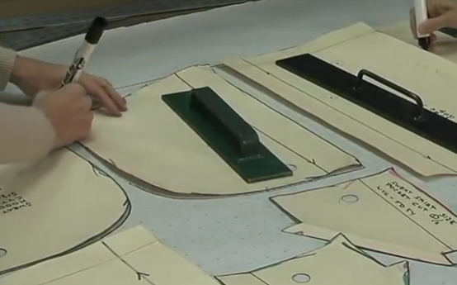
Marker making by manual method
Drawing Marker on Paper
Carbon duplicating: In this method, 6 to 8 markers can be duplicated at a time. Both sided carbon papers are placed in between each two marker papers. When marking of patterns is done on the upper page by pens or pencils, duplicate markers are thus achieved.
Advantages:
- Cost and time effective in case of lower number of copies like 3 to 4.
Disadvantages:
- Labour intensive
- Time consuming as it takes long time.
Spirit duplicating:
In spirit duplicating m/c the master marker is drawn on paper with a layer of special hectograph paper underneath it. This paper transfers a blue line onto the back of the master marker as it is drawn. The master is then used to make one copy at a time in spirit duplicating m/c. It is a messy process but mane copies can be produced.
Advantages:
- A large number of copies can be developed so it is cost effective.
Disadvantages:
- Overlapping, folding or shrinkage of marker papers may cause faulty copies.
- In case of higher width of marker, it would be difficult to duplicate.
Perforated marker:
The patterns are first placed on to the marker paper, and then marking is done with pencils. Small perforation is done along the drawn lines of the marker papers. This perforated marker is then placed onto the fabric lay and powder of French chalk is spread over the marker. French chalk slates on the fabric like bubbles outside the drawn line and thus patterns appear.
Advantages:
- This type of marker may be used several times.
Disadvantages:
- o Time consuming;
- o Not cost effective i.e. it incurs huge cost.
Using Photograph or light sensitive paper
A special kind of light sensitive paper is used in this technique. When patterns are kept on it

Fabric Spreading:
This is a preparatory operation for cutting and consists of laying plies of cloth one on top of the other in a predetermined direction and relationship between the right and wrong sides of the cloth. The composition of each spread i.e. the number of plies of each color is obtained from the cut order plan. Number of plies depends on:
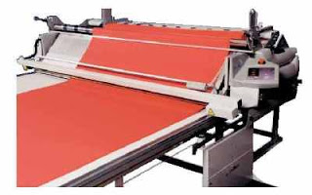
Fabric spreading
1. Capacity of the cutting machine
2. Volume of production
3. Type of fabric itself (rough or slippery)
4. Thickness of fabric
Types of Fabric Spreading:
The spreads can be of two basic types:
1. Flat spreads- all plies are of the same length.
2. Stepped spreads- this as the name suggests, is built up in steps, with all the plies in one step having the same length. A stepped spread is generally used when the quantities to be cut precludes the use of a flat spread. The cut order plan details the colors and ply lengths for a stepped spread, if it is needed.

Requirements of Spreading Process:
1. Alignment of plies in both length and width direction- length and width of fabric must be at least equal to marker length and width.
2. Elimination of fabric defects/flaws- any faults identified on the incoming fabrics will be tagged and will be avoided.
3. Correct ply direction (especially for asymmetrically printed fabrics)- all faces up, all faces down, face to face etc.
4. Correct ply tension- ply tension must be uniform and as much less as possible.
5. Avoidance of distortion in the spread during cutting- polythene sheets are used under the bottom ply to resist friction of the bottom ply with the base plate of the knife.
6. Fabrics must be flat and free from any crinkle & crease- these cause defect in garments due to variation in dimension.
7. Checks and stripes should be matched.

Automatic Programmable Spreading Machines:
All the requirements of spreading process can be fulfilled by fully automatic spreading machines. Their features include:
- Automatic loading/unloading and threading/rewinding device for fabric rolls.
- Automatic roll turning arrangement for face to back lay.
- Automatic levelling device for fabric edge alignment.
- Automatic cutting device (one way or two way cutoff) at the end of a run.
- Automatic tensioning device to control fabric tension.
- Automatic lay height sensing elevator.
- Programmable lay length, ply height and step-laying.
- Spreading seeds up to 140 m/min.

CHAPTER -2 SEWING

Essential properties required for sewing threads:

Industrial sewing techniques make specific and often very exacting demands on the threads involved in the sewing process. The sew ability of sewing thread is of major importance6, having a very profound effect on seam quality and production costs. The sewing and the seam performance of a sewing thread are largely influenced by the material to be sewn, the sewing technique and the end-use for which the sewn material is intended.
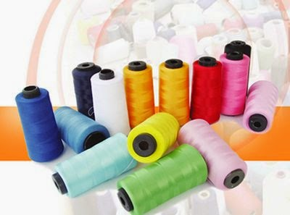
Sewing Threads
These requirements can be defined as:
- The ability of the sewing thread to meet the functional requirements of producing the desired seam effectively.
- The ability of the sewing thread to provide the desired aesthetics and serviceability in the seam.
- The cost of sewing thread and that associated with producing the desired seam.
The different important properties required by a sewing thread are discussed below:
1. Needle thread must pass freely through the small eye of the needle; consequently they must be uniform, knot-free, non-torque and fault free.
2. Tensile strength/breaking strength is one of the essential properties of the thread. It must be capable of withstanding several kinetic/lateral movements during sewing. The strength of the sewing thread must be higher than that of the fabric so that the thread does not rupture during use. During sewing at high speeds, the needle thread is subjected to repeated tensile stresses at very high rates. The thread also comes under the influence of heat, bending, pressures, torsion and wearing. The value of these stresses depends on the sewing speed, machine settings and the thread used. The stresses created within the thread have a negative effect on the processing and functional characteristics of the thread, and there is significant reduction in the thread strength after sewing.

Stitch types:
Every category of sewing machine produces a specific type of stitch depending on the number of needles, loppers and threads which combine to construct the stitch. Each of these configurations is known as stitch types and they are classified according to their main characteristics There are about seventy (70) types of stitch can be seen in common practice but among them 18 to 20 types of stitch are used in garments manufacturing industries. In tailoring purposes there are only two to three types of stitch are used. All stitches are classed in six (6) groups which are identified by the first of the three digits:
Stitch types are given below:

Stitch class – 100 (Single thread chain stitch):
Stitches under this class are produced with single thread by intra-looping technique. All the stitches under this class are unsecured and used for temporary purposes. Starting and finishing end of the stitch under this class needs bar taking or back stitching to secure the stitches. Most common uses in blind stitching, hemming, button attaching, button holing, gathering, temporary positioning of garment components, etc. purposes.
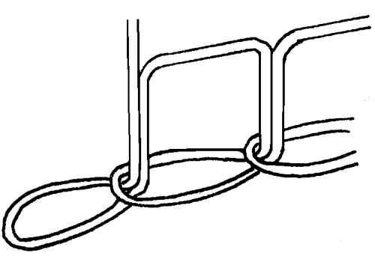
Stitch type- 101
Stitch class – 200 (Hand stitch):
Stitches under this class are also produced with single thread but by the use of special type of sewing machine. Stitch class – 200 can not be produced for longer length sewing. This class of stitches is used very rarely in the Ready Made Garments (RMG) sector as because they are very expensive to produce. They are used mainly for coat manufacturing. Stitch type – 209 is shown in diagram which is used in the lapel area.
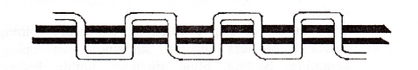
Stitch type- 209
Stitch class – 300 (Lock stitch):
Stitches under this class are produced by interlacing technique with two threads. The upper thread is called needle thread and the lower one is called bobbin thread. Stitch type – 301 is shown in diagram which is extensively used in domestic sewing machine, tailoring sewing machine, RMG sector sewing machine, for general sewing for attaching pocket, collar, cuff, etc components. Stitches under this class are naturally secured and shows good frictional resistance property. Its extensibility is about 30%, hence used extensively in Ready Made Woven Garments products.
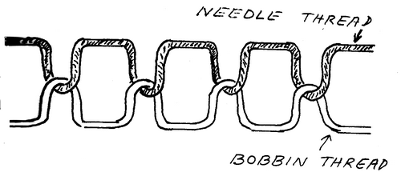
Stitch type- 301
Stitch class – 400 (Multi thread chain stitch):
Stitch class – 400 is produced by interlacing and interloping technique. The upper thread is called the needle thread and the lower one is called looper thread. Stitch class – 400 is stronger than stitch class – 300, hence used for joining heavy fabrics, side seam of trouser, etc purposes.
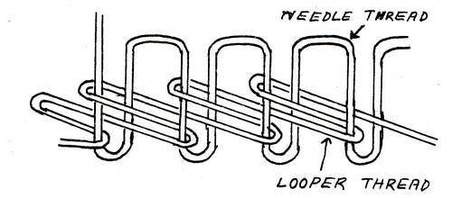
Stitch type- 401
Stitch class – 500 (Over edge stitch):
Stitches under this class are produced with one or a group of more threads (one needle thread and two or more looper thread) and at least threads of one group round the edge of the fabric stop fraying i.e. threads from the edge of the fabric can not come out. The knife of the machine cuts the edge first producing a clear edge for seaming. Stitch under this class is sometimes called over locking, but actually it is over edge stitch. Sometimes it is used for decorative purpose. Extensibility is quite well (may be 300%) and the width of the stitch is about 3 to 5 mm. Stitch class – 504 is shown in the figure below:
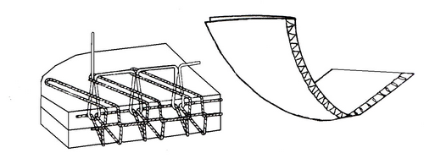
Stitch type- 504
Stitch class – 600 (Covering chain stitch):
Stitches under this class are formed with at least three groups of threads and threads of two groups are seen in both side of the fabric. Threads of first group are called needle thread and threads of second group are called top cover threads and threads of third group are called bottom cover thread. This type of stitch is so complex and sometimes usage of 9 threads can be seen. This type of stitch is used for sewing underwear, for attaching lace, braid, elastic, etc. It is also used for making cover stitch, decorative stitch and top stitching. Stitch class – 602 and 606 are shown in figure below:
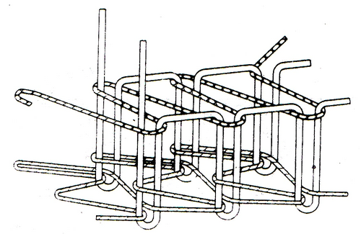
Stitch type- 602 & 606

All types of seams are described below:
- Seam class-1: Super imposed seam: ...
- Seam class-2: Lapped seam: ...
- Seam class-3: Bound seam: ...
- Seam class-4: Flat seam: ...
- Seam class-5: Decorative seam: ...
- Seam class-6: Edge neatening: ...
- Seam class-7 (Attaching of separate items): ...
- Seam class-8 (Single ply construction):

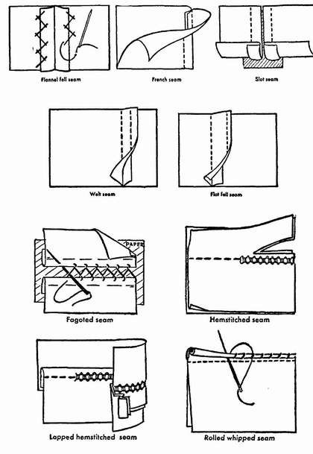
Sewing Machine Needle and Its Purposes:
Needle is the central feature of any sewing machine. The manner in which fabric is pierced by the needle during stitching has a direct impact on the strength of the seam as well as garment appearance.
The purposes of the sewing needles are to:
- Make a hole in the fabric so that the sewing thread could pass through it to form a stitch without causing any damage to the fabric while doing so.
- To carry the needle thread through the fabric to form a loop. This is then taken up by the hook in a lockstitch machine or by means of the looper in chain stitch machines.
- Pass the needle thread through the loop created by the looper mechanism on a chain stitch machine.
Parts of a Sewing Needle:
The different parts of a sewing needle are shown in Figure-1.
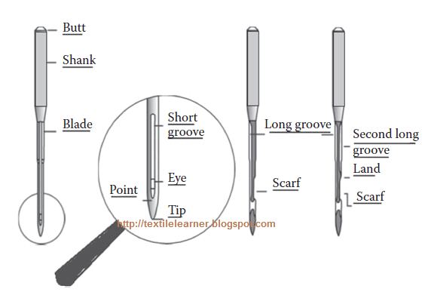
Figure-1: Parts of a sewing machine needle.
Every parts of sewing machine needle are described below:
Shank: It is the top portion of the needle, which positions inside the needle bar. It could be designed as cylindrical or have a flat side, based on the method of holding it on to the needle bar. It is the principal support of the entire needle and is larger in diameter than the remaining part of the needle to give the strength.
Shoulder: It is the part in-between the shank and the blade, with the blade forming the longest portion of the needle up to the needle eye.
Blade: It undergoes an enormous amount of friction from the fabric through which the needle passes. In case of needles specifically designed for high-speed sewing, the shoulder is normally extended into the upper part of the blade to give a thicker cross section. This arrangement of reinforced blade strengthens the needle and produces the enlarged hole in the fabric while the needle is at its lowest point, thus minimising the friction between it and the material. On the other hand, the blade could be designed as a tapered one, reducing its diameter gradually from shank to tip to minimise the friction.
Long groove: It gives a shielding channel for the sewing thread while it is carried down into the fabric for stitch formation thus reducing the abrasion and friction with the fabric.
Short groove: It is located on the reverse side of the long groove, that is, towards the hook or looper; it extends slightly above and below the needle eye. It assists in the formation of the needle thread loop.
Eye: It is the hole or opening in the sewing needle, lengthened through the blade along the long and short grooves on the needle. The profile of inside part of the eye at the top is vital in reducing sewing thread damage and in producing a good loop formation.
Scarf: The scarf otherwise known as clearance cut is a nook across the whole face of the needle immediately above the needle eye. Its objective is to facilitate closer setting of the bobbin hook or looper to the needle so that the needle thread loop could be entered more easily by the point of the hook or looper.
Point: It is tapering portion of the needle created to give a better penetration of the needle on various kinds of fabric. It should be properly selected to prevent damage of the fabric to be sewn.
Tip: It is the ultimate end of the point, which combines with the point in defining the penetration performance of the needle.
Special Needles:
Several over-edge and safety stitch sewing machines utilize curved needles instead of straight needles. These needles are costly though the life of the needle is lesser compared to straight needles. However, the sewing machines utilising curved needles (Figure-2a) could achieve higher speeds than by using straight needles. Blind stitching machines also utilise needles that are curved, but the purpose here is to avoid penetration right through the fabric. Sewing machines (pick stitching machine) that imitate hand stitch (class 209) utilise a double-pointed sewing needle with an eye in the middle (Figure-2b), through which is threaded the short length of thread with which this machine sews.
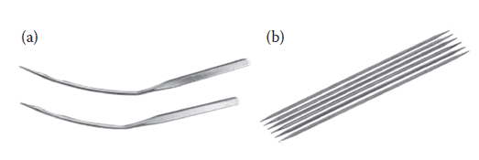
Figure-2: Special needle shapes. (a) Blind stitch needle. (b) Pick stitch needle.
Identification of Sewing Needle:
Three parameters are generally used for the identification of sewing needles such as system, point and size.
System:
It describes the elements of a needle to suit the sewing machine type. Based on the type of sewing machine and type of stitch, the needle is designed with variants in blade length, shank thickness, type of needle eye, etc. It is worthwhile to ensure with the sewing machine manufacturer for appropriateness of needle system to machine.
Needle Point:
A needle point is broadly categorized into two types:
- Round point needle – set or cloth points
- Cutting or leather point needle
Cutting Point Needles:
Cutting point sewing needles have spiky tips like blades and a wide range of cross-sectional profiles such as rounded, triangular, square and lens exist. They are normally used to sew highly dense and non-fabric based materials. Five universal kinds of cutting point sewing needles are shown in Figure-3, along with their profile of incision produced when used in a machine with the commonest threading direction.
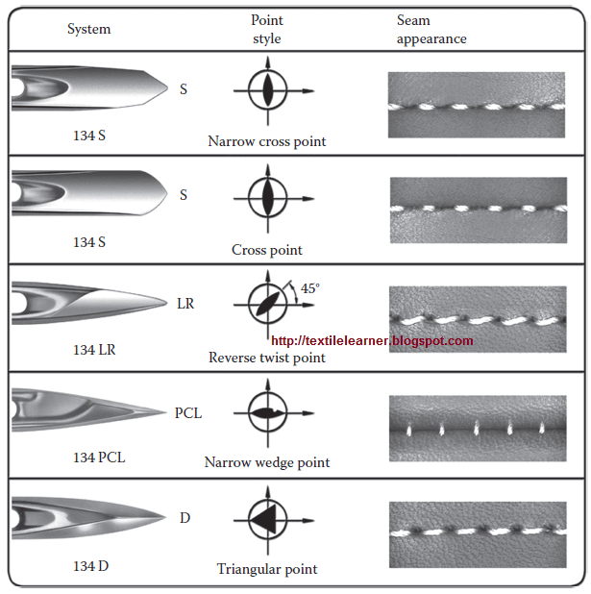
Figure-3: Cutting point needles.
The narrow wedge point needle: It cuts the material at right angles (90°) to the seam direction and permits to go for a high stitch density (SPI) while leaving adequate material between the needle holes to retain seam strength of material. On soft leather material, stitch densities as high as 12 per centimetre are achievable. It is the most frequently utilised cutting point needle for stitching uppers in the shoe industry.
- The narrow reverse point needle: It produces cut that lies 45° to the seam direction, and produces a seam where the thread is turned to the left on the surface of the material.
- The narrow cross point needle: It makes a cut along the line of the seam and necessitates a longer stitch length. Heavy decorative seams could be made where thicker sewing threads are used at lower stitch densities, that is, longer stitch length.
Numerous kinds of other point types exist for the variety of leathers, seams, sewing machines and strength and appearance requirements that arise. This involves triangular cross sections for multi-directional sewing.
Cloth Point Needles:
These kinds of needles are used for sewing textile materials instead of the leather/sheet materials as in the case of cutting point needles. The points have a round cross section contrasting to the various cutting profiles of the cutting point needles and the tip at the end of the point can vary in profile to suit the particular material being sewn.
- The contour of the tip of the needle point which attains the deflection rather than penetration is a fine ball shape and the needle is called a light ball point needle which is utilised primarily for sewing knitted fabrics.
- The tip of the needle point which attains the penetration has the shape of a cone and is known as a set point needle which is utilised for sewing woven fabrics. Both ball and set point needles are available in a number of types, illustrated in Figure-4.
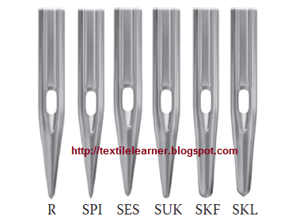
Figure-4: Types of cloth point needles. R: set cloth point, SPI: slim set point, SES: light ball point, SUK: medium ball point, SKF: heavy ball point, SKL: special ball point.
Slim set point (SPI): It is generally used for sewing denser woven fabrics and aids in achieving a straighter stitch which could minimise seam pucker. Generally used for heavy woven fabrics, coated fabrics and topstitching of collars and cuffs.
Medium set point needle: It is the general purpose needle in no problem sewing situations. It is commonly used for sewing a range of woven fabrics and in many circumstances could be used for knitted fabrics also.
Set cloth point (R): It is generally utilized for sewing standard fabrics with regular seams.
Acute set point: This kind of needle is used while sewing very dense fabrics like shirting fabric and interlining in collars and cuffs, where a straight line of stitching is required.
Heavy set point: These needles are used for sewing buttons as the button can be deflected to some

How to Choose a Sewing Machine
1. What's your sewing skill level?
Beginners only really need a small selection of stitches and basic functions while they get used to using a sewing machine, whereas intermediate or advanced sewers will most likely require more complex features and a greater range of stitches, buttonholes and alphabets to expand their creative options. The key thing to take away here is this: there's no use splashing the cash on a machine too advanced for your requirements, or equally wasting money on one too basic for your skillset! Make sure your new machine complements the complexity of your stitching talents, keeping up with your creative drive.
2. What will you use a sewing machine for?
It's important to really think about why you're buying a sewing machine - what will be your primary reason for using it? There's no use buying a machine with hundreds of quilting features when you're only interested in dressmaking or making simple alterations, but similarly you won't want a machine with basic functions and a small workspace if you're looking to take on bigger tasks, such as creating a quilt or embroidering designs onto fabric. If you have specific projects in mind, those should be taken into consideration - but similarly, you may just be looking to try out a new hobby.
3. How often will you use a sewing machine?
If you believe you'll rarely use your sewing machine, there's no point buying the newest model with hundreds of stitches, features and accessories that'll never be used. If you usually stitch by hand or are considering a new craft, begin with something a little more basic to get a feel for it - you've always got the option to upgrade as your passion increases. In addition, if you know that you'll use a sewing machine very frequently, it's important that you buy a strong machine with a sturdy and durable frame - one that can withstand a lot of wear and tear. It'd be worth the extra money to know that you'll have a tool you can always rely on!
4. Where will you use a sewing machine?
This final thought may not be initially applicable to everyone - but it is a factor that may prove to be important in the future. Consider where you'll use your sewing machine, and whether it's likely that you'll need to easily transport it to another location. Where do you craft the most - do you prefer to create in your craft room, or do you like to travel to friends' houses or craft clubs? If your answer is the latter, and you know you'll be moving around frequently, you won't want to haul around a heavy machine with you - a more compact, portable machine may be best suited to your needs.

Chapter-3 Use of components and trims
Accessories:
The materials or components except the main fabric used in the garments are called garment accessories. Besides the main fabric, various additional things are used for making the garments. Accessories include Sewing Thread, Button, Zipper, Velcro, Label, Shoulder pad, Linings, Interlinings, etc. Accessories are of two types namely visible accessories and invisible accessories. Some accessories are used for functional purposes and some are for decorative purposes.
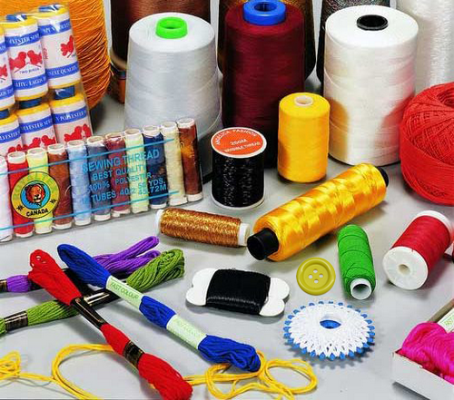
Garments accessories
Types of accessories:
- Visible accessories: Visible accessories can be seen from outside of the garments e.g. Button, Sewing Thread, Zipper, Velcro, etc.
- Invisible accessories: They can not be seen from outside of the garments e.g. Interlining.
Sewing thread:
Almost all garments produced have one component in common; the sewing thread. Whilst sewing thread is usually a relatively a small percentage of the cost of garments, it has an extremely significant influence on the appearance and durability of the finished product. The production of sewing thread is an extensive and complex subject.
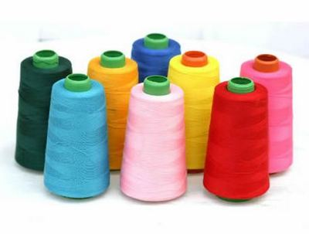
Sewing thread
Types of sewing thread
For practical purposes, sewing threads for clothing industry can be divided into three broad groups; Cotton, Synthetics and Core spun.

Thread size
There are many systems for defining thread size but the most widely used system is ‘Tex’. This is based on the gram weight of 1000 m of yarn, so a fine thread would have a low ‘Tex’ number and a thick thread would have a high ‘Tex’ number. Thread manufacturers using other systems will provide the Tex equivalent values.

Button:
In clothing and fashion design, a button is a small plastic or metal disc- or knob-shaped, typically round, object usually attached to an article of clothing in order to secure an opening, or for ornamentation. Functional buttons work by slipping the button through a fabric or thread loop, or by sliding the button through a reinforced slit called a buttonhole. Buttons may be manufactured from an extremely wide range of materials, including natural materials such as antler, bone, horn, ivory, shell, vegetable ivory, and wood; or synthetics such as celluloid, glass, metal, bakelite and plastic. Hard plastic is by far the most common material for newly manufactured buttons; the other materials tend to occur only in premium apparel.
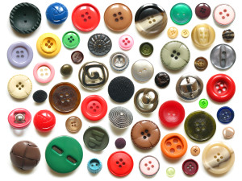
Button
Rivets:
Rivets are not used to open or close the opening parts of garments. They are used for following purposes:
- Widely used for decorative and reinforcement (support) purposes of Denim or Jeans garments.
- It has two parts and requires an appropriate device to attach on garments
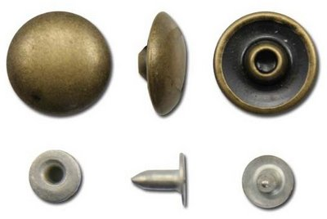
Rivets
Hook and loop fastener (Velcro):

This item consists of two woven polyamide tapes; one is covered with very fine hooks and the other with very fine loops. When pressed together they adhere (stick) securely to each other. This fastener is also used instead of buttons or zippers. A Swiss inventor made this product and he offered the trade name ‘Velcro’ for it. This word comes from two French words ‘Velour, and ‘Crochet’. It is used in only a limited number of garments e.g. shoes, belts, sportswear, children wear, medical textiles, etc. Velcro is available in roll form in the market which has most common width of 5/8 to 3/4 inch.
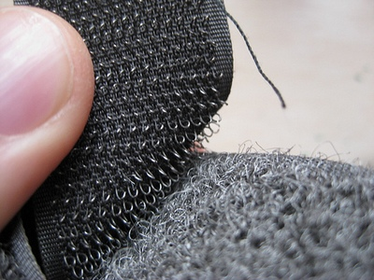
Hook and loop fastener
Zipper:
A zipper (British English: zip fastener or zip) is a popular device for temporarily joining two edges of fabric. It is used in clothing (e.g. jackets and jeans), luggage and other bags, sporting goods, camping gear (e.g., tents and sleeping bags), and other daily use items. This is one kind of accessories used to open and close of some special parts of a garment. It is sometime also used for decorative purposes. In making trouser and jackets, this is an essential component.
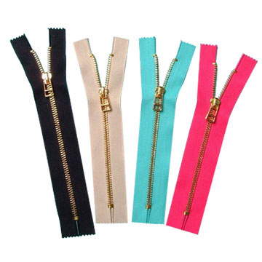
Zipper
Label:
Label is an attached component of garment on which important information regarding the garment are written or printed. No garment can be sold without some kind of label attached to it. Specially, in case of export business label on garment is must. For example: the size of garment, trade mark, country of origin, type of raw materials, etc. are written on label. There are mainly three types of label:
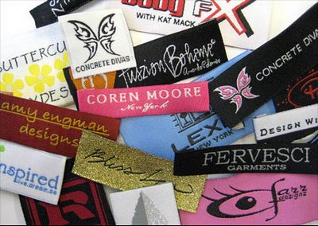
Label
- Main label: Main label contains brand name or trade name of buyer which is registered by the buyer e.g. Levi’s, Polo, Addidas, GAP, Lewis Philippe, etc.
- Size label: It indicates the size of the garment i.e. S, M, L, XL, XXL, or collar length of shirt 15, 16, 17, 18, etc.
- Care label: It contains the care instructions of the garment by some internationally recognized signs. It shows the washing, drying, dry-cleaning and ironing conditions of garments.
The all other labels are called sub-label.
Care code label
Due to daily usage, normally a garment becomes dirty. This garment should be cleaned and ironed before further using. For this caring of garment, some rules or instructions are expressed by some internationally recognized symbols which are called international care labeling code.
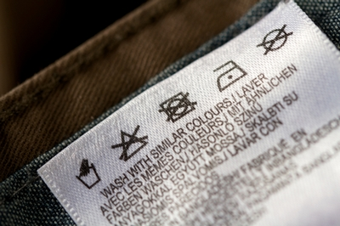
Care code label
Motif:
The special component which is attached outside of the garment for decorative purpose called motif. Company name, trade mark or other symbols can be written on the motif.
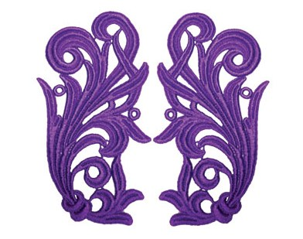
Motif
Lining:
Linings are generally functional parts of a garment. They are used to maintain the shape of the garment to the hang and comfort by allowing it to slide over other garment. Linings are available as knitted and woven fabric made from polyester, polyamide, acetate or viscose for use where decoration and warm handle is required. Linings are joined to main garment by sewing and for this purpose normal plain sewing machine is used. Linings are widely used in jackets, coats, overcoats, pockets, pocket flaps, children wear, etc. Generally cheap fabrics are used as lining materials.
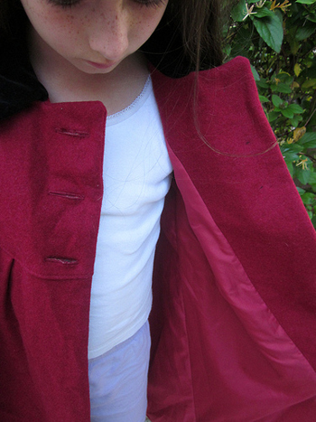
Lining
Interlining:
Interlinings are used to support, reinforce and control the shape of some areas of garments such collar, cuffs, waist bands, facings and lappets of coat. They may be sewn into the garment or they may be attached by fusing. Now-a-days sewing interlinings are rarely used and the use of fusible interlining is wide. Interlinings are available in a wide variety of weights and constructions to match the base fabric of the garment. They can be either woven or non-woven products. Woven interlinings are most commonly of plain weave construction, whereas non-woven interlinings are made directly from textile fibres and are held together by mechanical, chemical, thermal or solvent means or combination of these. Sewn interlinings are made by sewing some plies of fabrics together densely then they are joined with the main garment by sewing again, whereas fusible interlinings have coatings of thermoplastic materials on them and are joined to garment by means of heat and pressure. Fusible interlinings give better result than that of sewn ones.
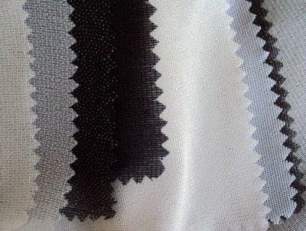
Interlinings
Shoulder pad:
Shoulder pad is a standard item in tailored garments for both women and men. Linings are used on the top and bottom of shoulder pad. As a result the appearance becomes more attractive, comfortable and lasts for a long time. Shoulder pads are used for functional purposes and sometimes for decorative purposes.
Shoulder pad
Snap fastener:
A snap fastener (also called snap, popper, and press stud) is a pair of interlocking discs commonly used in place of buttons to fasten clothing. A circular lip under one disc fits into a groove on the top of the other, holding them fast until a certain amount of force is applied. Snaps can be attached to fabric by hammering (using a specific punch and die set), plying, or sewing. For plying snap fasteners, there are special snap pliers. Snap fasteners were first patented by German inventor Heribert Bauer in 1885 as the "Federknopf-Verschluss", a novelty fastener for men's trousers. These first versions featured an S-shaped spring in the top disc instead of a groove.
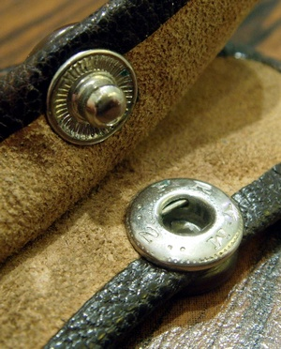
Snap fastener
Hook-and-eye closure:
A hook-and-eye closure is a clothing fastener that consists of two parts, each sewn to their respective pieces of cloth, one with a small protruding blunt hook, and the other with a small loop (also known as the "eye" or "eyelet") protruding. To fasten the garment, the hook is slotted into the loop. Hook-and-eye closures are typically used in groups to provide sufficient strength to bear the forces involved in normal wear. For this reason, hooks and eyes are commonly available in the form of hook-and-eye tape, consisting of two tapes, one equipped with hooks and the other equipped with eyelets in such a way that the two tapes can be "zipped" together side-by-side. To construct the garment, sections of hook-and-eye tape are sewn into either side of the garment closure. Hook-and-eye closures are commonly used in corsetry.
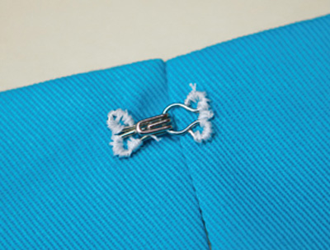
Hook-and-eye closure
Frog (fastening):
A frog (sometimes referred to as a Chinese frog) is an ornamental braiding for fastening the front of a garment that consists of a button and a loop through which it passes. The usual purpose of frogs is to provide a closure for a garment while decorating it at the same time. These frogs are usually used on garments that appear oriental in design. Tops with a mandarin collar often use frogs at the shoulder and down the front to keep the two sections of the front closed. Frogs are usually meant to be a design detail that "stands out". Many sewers make their own because supplies are inexpensive and the results are customizable. Using larger or smaller size cording or fabric tubes will result in larger and smaller frogs. Also, self-fabric can be used to create frogs that are the same color as the garment, though frogs are usually chosen to be a contrasting color to that of the garment. Frogs are made by looping and interlocking the cording or fabric tube into the desired design, then securing the places where the cords touch by hand-sewing. The frog is then stitched onto a garment, usually by hand. When a fabric tube is used, the fabric is cut on bias. This allows the fabric tube to remain smooth and flex easily when bent into curves.
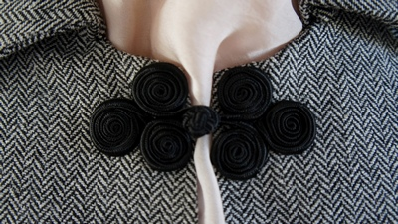
Frog (fastening)
Interfacing:
Interfacing is a textile used on the unseen or "wrong" side of fabrics to make an area of a garment more rigid. Interfacings can be used to:
- Stiffen or add body to fabric, such as the interfacing used in shirt collars.
- Strengthen a certain area of the fabric, for instance where buttonholes will be sewn.
- Keep fabrics from stretching out of shape, particularly knit fabrics.
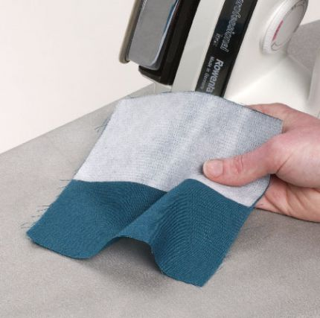

Bias tape:
Bias tape or bias binding is a narrow strip of fabric, cut on the bias (UK cross-grain). The strip's fibers, being at 45 degrees to the length of the strip, make it stretcher as well as more fluid and more drape able compared to a strip that is cut on grain. Many strips can be pieced together into a long "tape." The tape's width varies from about 1/2" to about 3" depending on applications. Bias tape is used in making piping, binding seams, finishing raw edges, etc. It is often used on the edges of quilts, placemats, and bibs, around armhole and neckline edges instead of a facing, and as a simple strap or tie for casual bags or clothing.
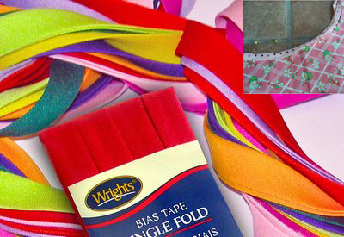
Bias tape
Cord (sewing):
In sewing, cord is a trimming made by twisting two or more strands of yarn together. Cord is used in a number of textile arts including dressmaking, upholstery and couching.
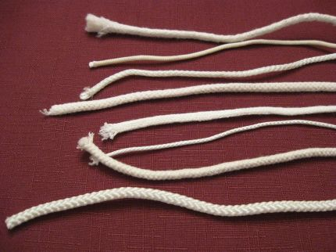
Cord (sewing)
Lace:
Lace is an openwork fabric, patterned with open holes in the work, made by machine or by hand. The holes can be formed via removal of threads or cloth from a previously woven fabric, but more often open spaces are created as part of the lace fabric. Lace-making is an ancient craft. True lace was not made until the late 15th and early 16th centuries. A true lace is created when a thread is looped, twisted or braided to other threads independently from a backing fabric. Originally linen, silk, gold, or silver threads were used. Now lace is often made with cotton thread. Manufactured lace may be made of synthetic fiber. A few modern artists make lace with a fine copper or silver wire instead of thread.
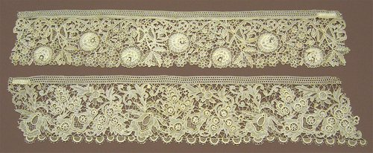
Lace
Ribbon:
A ribbon or riband is a thin band of flexible material, typically cloth but also plastic or sometimes metal, used primarily for binding and tying. Cloth ribbons, which most commonly includes silk, are often used in connection with dress, but also applied for innumerable useful, ornamental and symbolic purposes; cultures around the world use this device in their hair, around the body, or even as ornamentation on animals, buildings, and other areas.
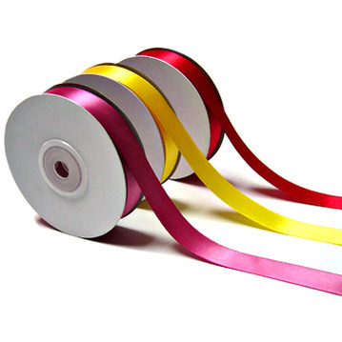
Ribbon

Chapter-4 Pressing
Pressing equipment used in garment industry
- Flat Bed Press.
- Heat Press Machine.
- Garment Machinery.
- Pressing Machine.
- Laundry Equipment.
- Baling Presses.
- Steam Machine.
- Mushroom Press Machine.
- Types of Pressing machinery and equipment
- It is possible to press samples of light clothing, such as dresses, blouses, and nightdresses, on versatile unit equipped with a hand iron. However, if the samples are of constructed garments, while most of the simple under pressing operations can be performed with a hand iron, there are still several operations which require the specialized machines in the factory. This is especially relevant to top pressing where to most of the operations are performed on special purpose machines.
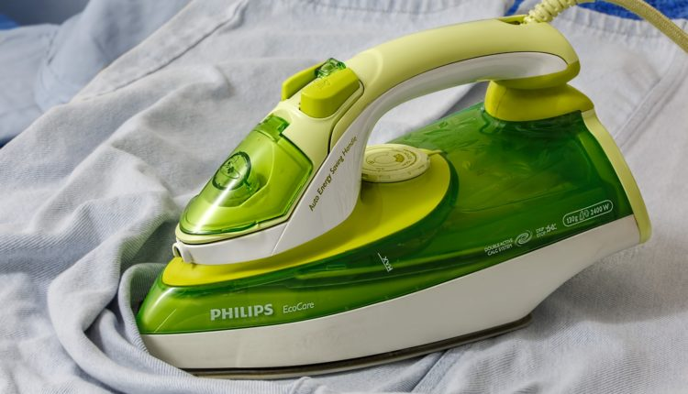
The usual procedure is for the sample room to do what can be done correctly and then use the factory’s machines for everything else. 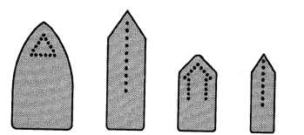
There are hundreds of different types of pressing machines on the market because of the variety of garment types produced, each with its own specific pressing requirements. Here are the respective of there types.
High tech pressing machine for men’s and women’s clothing is a digital programmer and presses the shoulder, sleeve head and sleeve cuff in one set-up.To sum up it is no exaggeration to say that a part of cutting, the two cornerstones of garment quality are fusing and pressing. The pressing processes give the final finish and appearance. The importance of pressing should never be underestimated, because of its decisive contribution to garment quality and appeal.

Hand irons
Hand irons are used for numerous operations in the production of clothing. One example of these is electric high-pressure steam iron.Hand irons are produced in a variety of shapes and weights to suit specific types of operations.The following are some examples of the sole plate shapes available.

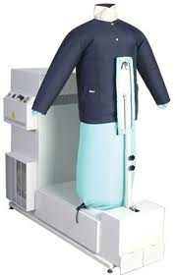The form finishing machine

The small cabinet press
Is designed to press the heat shirts before they are buttoned, thus preventing button marks on the finished article. During the pressing process, the back and front are tensioned by air-filled bags, which ensure an even pressing surface when the shirt is between the two shaped pressing plates.This particular machine can be efficiently operated by one person only when there is a reasonable balance between the handling and pressing cycle times.

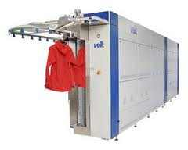A tunnel finisher
Is used for knitwear which can carry up to 30 articles at a time through the finishing process. The tunnel has two sections, one for gentle seaming and the other for quick drying of the garment.. Garment forms can be adjusted for different styling and sizes and the microprocessor controls the processing time, steaming time and the quantity and steam and air temperature. Up to 24 individual pressing programs can be stored in the microprocessor.

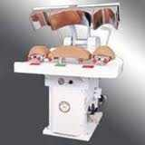High tech pressing machine
High tech pressing machine for men’s and women’s clothing is a digital programmer and presses the shoulder, sleeve head and sleeve cuff in one set-up. To sum up it is no exaggeration to say that apart from cutting, the two cornerstones of garment quality are fusing and pressing. The pressing processes give the final finish and appearance. The importance of pressing should never be underestimated, because of its decisive contribution to garment quality and appeal.

Chapter-5 quality control and just in time

We enable our customers to increase sales and build trust with their customers. It is important for every company to maintain a high level of quality in everything that they produce.
In the garment industry, garment quality control is practised right from the initial stage of sourcing raw materials to the stage of a final finished garment.
Shelton Vision provides machine vision solutions that help detect and reduce the number of defects within the production process.
Shelton’s WebSPECTOR is a quality control system that is made up of four components, all contribute to an automated optical inspection system that achieves maximum inspection ensuring maximum profit from each batch.

The cost of quality?
- More waste means less profit
- Poor quality will damage your chances of winning new business
- Consistent defects can ruin relationships with your customers or stop a brand launch in its tracks

Commercial advantages to effective quality control
- Staying ahead of the competition
- Less waste leads to more margin on the bottom line
- Happy customers and clients
- Savings from a reduction in waste can be invested back into your business
- Once the inspection system is set up and running man power can be used elsewhere

Introduction
Just-in-time manufacturing was a concept introduced to the United States by the Ford motor company. It works on a demand-pull basis, contrary to hitherto used techniques, which worked on a production-push basis.
To elaborate further, under just-in-time manufacturing (colloquially referred to as JIT production systems), actual orders dictate what should be manufactured, so that the exact quantity is produced at the exact time that is required.
Just-in-time manufacturing goes hand in hand with concepts such as Kanban, continuous improvement and total quality management (TQM).
Just-in-time production requires intricate planning in terms of procurement policies and the manufacturing process if its implementation is to be a success.
Highly advanced technological support systems provide the necessary back-up that Just-in-time manufacturing demands with production scheduling software and electronic data interchange being the most sought after.

ADVANTAGES
Following are the advantages of Adopting Just-In-Time Manufacturing Systems
- Just-in-time manufacturing keeps stock holding costs to a bare minimum. The release of storage space results in better utilization of space and thereby bears a favorable impact on the rent paid and on any insurance premiums that would otherwise need to be made.
- Just-in-time manufacturing eliminates waste, as out-of-date or expired products; do not enter into this equation at all.
- As under this technique, only essential stocks are obtained, less working capital is required to finance procurement. Here, a minimum re-order level is set, and only once that mark is reached, fresh stocks are ordered making this a boon to inventory management too.
- Due to the aforementioned low level of stocks held, the organizations return on investment (referred to as ROI, in management parlance) would generally be high.
- As just-in-time production works on a demand-pull basis, all goods made would be sold, and thus it incorporates changes in demand with surprising ease. This makes it especially appealing today, where the market demand is volatile and somewhat unpredictable.

DISADVANTAGES
Following are the disadvantages of Adopting Just-In-Time Manufacturing Systems
- Just-in-time manufacturing provides zero tolerance for mistakes, as it makes re-working very difficult in practice, as inventory is kept to a bare minimum.
- There is a high reliance on suppliers, whose performance is generally outside the purview of the manufacturer.
- Due to there being no buffers for delays, production downtime and line idling can occur which would bear a detrimental effect on finances and on the equilibrium of the production process.
- The organization would not be able to meet an unexpected increase in orders due to the fact that there are no excess finish goods.
- Transaction costs would be relatively high as frequent transactions would be made.
- Just-in-time manufacturing may have certain detrimental effects on the environment due to the frequent deliveries that would result in increased use of transportation, which in turn would consume more fossil fuels.

Chapter-6 care labelling system

Contents
Introduction
Lesser Known Facts About Care Labels
Care Labelling Systems
The International Care Labelling System
The Japanese Care Labelling System
The Canadian Care Labelling System
The European Care Labelling System
The American Care Labelling System

Introduction
Care instructions are small solutions to big problems. Care labels provide guidelines to consumers about apparel care, and the best cleaning procedures to be used for a particular combination of fabric, thread decoration and construction techniques. Following the instructions on the care labels is an assurance that the appearance and fit of the garment will be maintained after repeated cleaning treatments.
From a manufacturer’s point of view, damage to garments from incorrect cleaning methods can lead to complaints; costly customer returns and a bad image. Whereas accurate and clearly written care labels can prevent customer dissatisfaction. From a consumer’s point of view, accurate and clearly written care instructions serve as a cleaning guide and influence purchase. Garments with ease of care are often preferred over garments with complicated or difficult to understand care procedures.
Many different care labelling systems have evolved over the world. Some have been established as a governmental regulation, while others are international standards. Not all of them however, are mandatory.
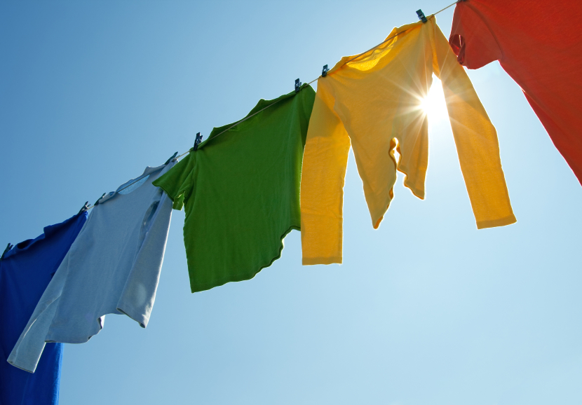
This Bulletin Post is a comprehensive guide to the different care labelling systems, their usage and the newly developed Fabric Performance Codes.

Lesser Known Facts About Care Labels
- The country where the garment is sewn is the country of origin listed on the care label
- Care labels must be permanently attached so that they are easily accessible to the consumer at the point of purchase. Generally, it is placed on the side or bottom
- The manufacturer or importer who directs production is responsible for the accuracy of care instructions
- A product may be imported without a care label, but it must be attached before the product is sold

Care Labelling Systems
There are five care labelling systems which are generally used on care labels. These systems are:
- The International Care Labelling System
- The Japanese Care Labelling System
- The Canadian Care Labelling System
- The European Care Labelling System
- The American Care Labelling System

The International Care Labelling System
The International Association for Textile CareLabelling (GINETEX) is the world body which governs care labels since 1975.
Member nations of GINETEX are Belgium, France, Germany, England, Netherlands, Israel, Austria, Switzerland, and Spain.
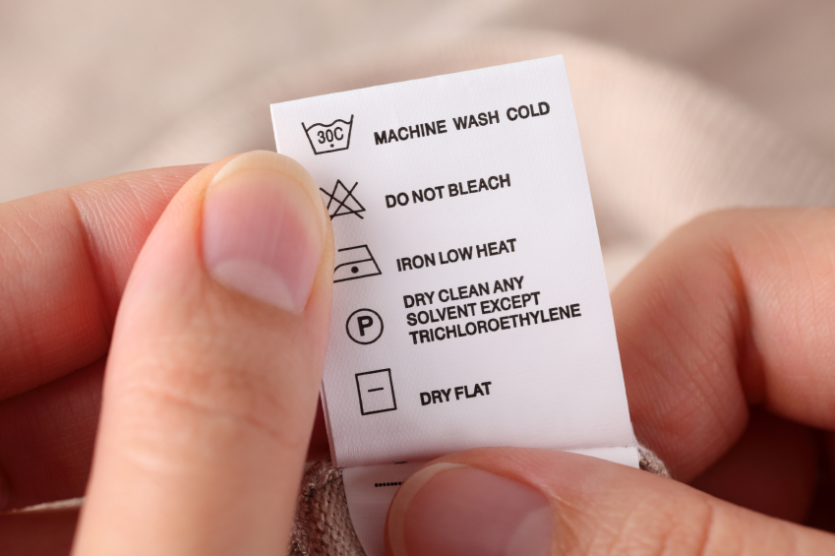
Its objectives are to:
- Inform consumers on the correct care labelling of textiles through a system of uniform and simple care labelling symbols, independent of language
- Achieve and promote voluntary care labelling on an international basis through the uniform symbols of GINETEX, thus avoiding the use of different systems
The GINETEX care labelling system is based on the following principles:
- The care symbols provide information on the maximum permitted type of treatment
- The care symbols must always be used in full and in the prescribed sequence
- The care labelling must be clear, readily understandable, easy to use and not dependent on any particular language
- The care symbols must not leave room for possible misinterpretation by the consumer
- Uniform positioning of labels and harmonised use of the care symbols
- The uniform care labelling system using symbols must take account of consumer habits without using complex technical data
- The appliances used for textile care purposes must ensure the best possible implementation of the recommended care treatment
- Adaptations which are necessary to keep up with ongoing technical and economic developments must as far as possible be made without the use of new symbols and additions in the framework of the existing system
Five basic symbols are used in the International care labelling system in this order:
Note: The symbols for the International Care Labelling System are the same as those listed in the European Care Labelling System.

The Japanese Care Labelling System
The Japanese system, like other care labelling systems must have symbols placed in a specified order. Labels should be designed based on the following convention:
- Symbols should be arranged from left to right according to the following sequence: 1) Washing, 2) Bleaching, 3) Ironing, 4) Dry-Cleaning, 5) Wringing & 6) Drying
- For coloured products which are not usually bleached, the symbol for possibility of chlorine bleached may be omitted
- For products which are not usually ironed, the symbols for ironing may be omitted. (Except 'cannot be ironed')
- For products which can be washed with water, the symbols for dry-cleaning may be omitted. (Except ‘cannot be dry-cleaned’)
- The symbols should be either in black or dark blue whereas the prohibition symbols are in red and on a white background
Japanese Care Labelling - Washing (with water)
Washing (with water)
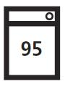 | Machine washable in maximum water temperature of 95°C |  | 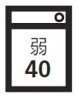 |  | Machine washable at slow water current or gentle hand wash in maximum water temperature of 40°C
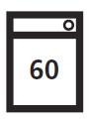 | Machine washable in maximum water temperature of 60°C |  | 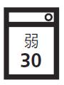 |  | Machine washable at slow water current or gentle hand wash in maximum water temperature of 30°C
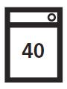 | Machine washable in maximum water temperature of 40°C |  | 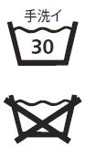 |  | Should be washed gently by hand (not machine washable)  Cannot be washed with water
Japanese Care Labelling - Bleaching
Bleaching
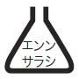 |  | Chlorine-based bleaching allowed |  | 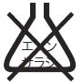 |  | Do not use chlorine-based bleach

Japanese Care Labelling - Ironing
Ironing
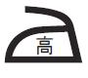 | Should be ironed at a temperature between 180°C - 210°C | 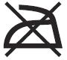 | Cannot be ironed
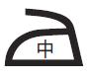 | Should be ironed at a temperature between 140°C - 160°C | 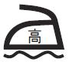 | May be ironed at 180°C - 210°C if a cloth is placed between iron and garment
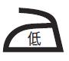 | Should be ironed at a temperature between 80°C - 120°C
Japanese Care Labelling - Dry Cleaning
Dry Cleaning
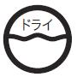 | Can be dry cleaned  Use solvent of perchloroethylene or of petroleum based solvent |  |  | 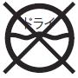 | Cannot be dry cleaned
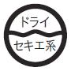 | Can be dry cleaned  Use only a petroleum based solvent

Japanese Care Labelling - Wringing
Wringing
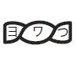 | Wring gently by hand or for a short time by centrifugal hydroextractor |  |  | 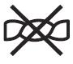 |  | Cannot be wrung
Japanese Care Labelling - Drying
Drying
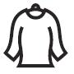 |  | Hang dry | 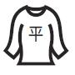 |  | Lay flat to dry
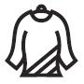 |  | Hang dry in shade | 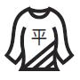 |  | Lay flat to dry in shade
Note:
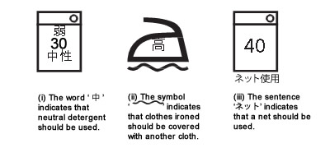
.
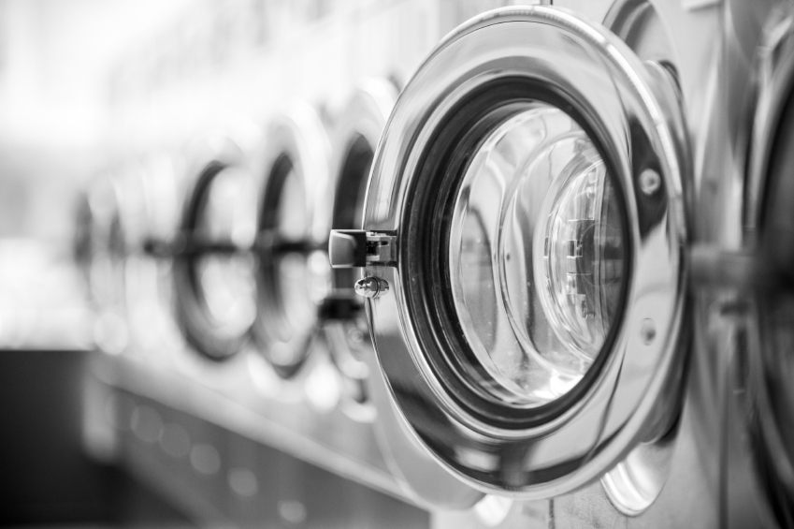

The European Care Labelling System
Individual committees of the European Union are reviewing existing care label standards by collaborating with other international bodies so that they can create a unified system under the ISO scheme.
The symbols used in Europe are trademarked by GENETEX and a trademark fee needs to be paid to GENETEX, the trademark holder, if the garments are to be sold in a GENETEX country.

A correct care label for European countries is required to consist of at least four and sometimes five symbols in the following sequence: 1) Washing, 2) Bleaching, 3) Ironing, 4) Dry-Cleaning & 5) Drying.
European Care Labelling - Washing Process
Washing Process
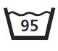 | Maximum temperature 95°C  Mechanical action normal  Rinsing normal  Spinning normal |  | 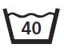 |  | Maximum temperature 40°C  Mechanical action normal  Rinsing normal  Spinning normal
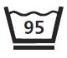 | Maximum temperature 95°C  Mechanical action reduced  Rinsing at gradually decreasing temperature (cool down)  Spinning reduced |  | 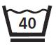 |  | Maximum temperature 40°C  Mechanical action reduced  Rinsing at gradually decreasing temperature (cool down)  Spinning reduced
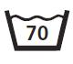 | Maximum temperature 70°C  Mechanical action normal  Rinsing normal  Spinning normal |  | 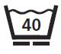 |  | Maximum temperature 40°C  Mechanical action much reduced  Rinsing normal  Spinning normal  Do not wring by hand
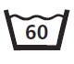 | Maximum temperature 60°C  Mechanical action normal  Rinsing normal  Spinning normal |  | 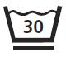 |  | Maximum temperature 30°C  Mechanical action much reduced  Rinsing normal  Spinning reduced
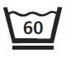 | Maximum temperature 60°C  Mechanical action reduced  Rinsing at gradually decreasing temperature (cool down)  Spinning reduced |  |  |  | Hand wash only  Do not machine wash  Maximum temperature 40°C  Handle with care
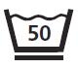 | Maximum temperature 50°C  Mechanical action reduced  Rinsing at gradually decreasing temperature (cool down)  Spinning reduced |  |  |  | Do not wash  Be cautious when treating in wet stage
European Care Labelling - Bleaching Process
Bleaching Process
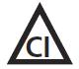 |  | Chlorine-based bleaching allowed.  Only cold and dilute solution. |  | 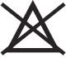 |  | Do not use chlorine-based bleach

European Care Labelling - Ironing Process
Ironing Process
 | Iron at a maximum sole-plate temperature of 200°C |  | 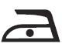 |  | Iron at a maximum sole-plate temperature of 110°C  Steam-ironing may be risky
 | Iron at a maximum sole-plate temperature of 150°C |  | 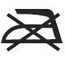 |  | Do not iron  Steaming and steam treatments are not allowed
European Care Labelling - Dry Cleaning Process
Dry Cleaning Process
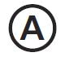 | Dry-cleaning in all solvents normally used for dry-cleaning - this includes all solvents listed for the symbol P, plus trichloroethylene and 1,1, 1-trichloroethane | 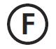 |  | Dry-cleaning in trifluorotrichloroethane, white spirit (distillation temperature between 150°C and 210°C, flash point 38°C to 60°C)  Normal cleansing procedures without restrictions.
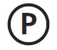 | Dry-cleaning in tetrachloroethylene, monofluorotrichloro methane and all solvents listed for the symbol F  Normal cleansing procedures without restrictions | 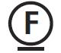 |  | Dry-cleaning in the solvents listed in the previous paragraph. Strict limitations on the addition of water and / or mechanical action and / or temperature during cleaning and / or drying  No self-service cleaning allowed
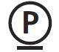 | Dry-cleaning in the solvents listed in the previous paragraph. Strict limitations on the addition of water and / or mechanical action and / or temperature during cleaning and / or drying  No self-service cleaning allowed |  |  | Do not dry-clean  No stain removal with solvents

European Care Labelling - Drying Process
Drying Process
 | Tumble dry possible  Normal drying cycle | 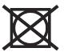 | Do not tumble dry
Tumble dry possible
Drying at lower temperature setting

The American Care Labelling System
According to the Federal Trade Commission’s Care Label rule, care labels may be composed of either words or symbols. Irrespective of whether the content is words, symbols, or both, care instructions appear in the following order:
- Machine wash / hand wash / dry-clean
- Washing temperature (hot / warm / cold)
- Washing machine programme (delicate / permanent press / normal cycle)
- Bleaching instruction (do not bleach / non-chlorine bleach / chlorine bleach)
- Drying method (tumble dry / line dry / flat dry / drip dry)
- Ironing (do not iron / cool iron / warm iron / hot iron)
- Warnings
In addition to the care label instructions, manufacturers and importers must provide labels that:
- Are permanently attached so that they can be easily seen at the point of sale. If the product is packaged, displayed or folded so that the customers cannot find the label, care information must also appear on the side of the package or on a hang tag
- Remain fastened and legible during the useful life of the product
- Mention the regular care needed for the ordinary use of the product
- Warn the customer about additional factors which may harm the garment
Since December 1996, a new system using only symbols and no words has been used in the United States of America. The revised care symbols developed by the American Society for Testing and Materials (ASTM) with their meanings are listed below.

Symbols used in the American Care Labelling System (ASTM Symbols)
