Unit-1
Introduction to Mobile Computing , WiFi , Bluetooth Introduction:
The rapidly expanding technology of cellular communication, wireless LANs, and satellite services will make information accessible anywhere and at any time. Regardless of size, most mobile computers will beequippedwitha wireless connection to thefixed partof the network, and, perhaps, to other mobile computers. The resulting computing environment, which is often referred to as mobile or nomadic computing, no longer requires users to maintain a fixed and universally known position in the network and enables almost unrestricted mobility. Mobilityand portabilitywillcreateanentirenew class of applications and, possibly, new massive markets combining personal computing and consumer electronics.

Mobile Computing is an umbrella term used to describe technologies that enable people to access network services anyplace, anytime, and anywhere.

A communication device can exhibit any one of the following characteristics:
- Fixed and wired: This configuration describes the typical desktop computerin an office. Neither weight nor power consumption of the devices allow for mobile usage. The devices use fixed networks for performance reasons.

- Mobile and wired: Many of today’s laptops fall into this category; users carry the laptop from one hotel to the next, reconnecting to the company’s network via the telephone network and amodem.

- Fixed and wireless: This mode is used for installing networks, e.g., in historical buildings to avoid damage by installing wires, or at trade shows to ensure fast networksetup.

- Mobile and wireless: This is the most interesting case. No cable restricts the user, who can roam between different wireless networks. Most technologies discussed in this book deal with this type of device and the networks supporting them. Today’s most successful example for this category is GSM with more than 800 million users.

Mobile computing is human–computer interaction in which a computer is expected to be transported during normal usage, which allows for transmission of data, voice and video. Mobile computing involves mobile communication, mobile hardware, and mobile software. Communication issues include ad hoc networks and infrastructure networks as well as communication properties, protocols, data formats and concrete technologies. Hardware includes mobile devices or device components, for example a receptor medium, which is capable of sensing and receiving signals. Mobile software deals with the characteristics and requirements of mobile applications. Examples of some mobile software is Mac OS, Windows OS, Android, and Linux.

Main principles
Computing remotely on mobile devices has its advantages and disadvantages. With the ability to utilize mobile software and communicate actively, these are several principles in which mobile computing stands by:

- Portability: Facilitates movement of device(s) within the mobile computing environment.
- Connectivity: Ability to continuously stay connected with minimal amount of lag/downtime, without being affected by movements of the connected nodes
- Social Interactivity: Maintaining the connectivity to collaborate with other users, at least within the same environment.
- Individuality: Adapting the technology to suit individual needs. or
- Portability: Devices/nodes connected within the mobile computing system should facilitate mobility. These devices may have limited device capabilities and limited power supply, but should have a sufficient processing capability and physical portability to operate in a movable environment.
- Connectivity: This defines the quality of service (QoS) of the network connectivity. In a mobile computing system, the network availability is expected to be maintained at a high level with the minimal amount of lag/downtime without being affected by the mobility of the connected nodes.
- Interactivity: The nodes belonging to a mobile computing system are connected with one another to communicate and collaborate through active transactions of data.
- Individuality: A portable device or a mobile node connected to a mobile network often denote an individual; a mobile computing system should be able to adopt the technology to cater the individual needs and also to obtain contextual information of each node.

Mobile computing security issues
The mobile computing is the communication between computing devices without a physical connection between them through wireless networks, which mean there are some of new mobile security issues that are originated from wireless security issues. The security issues and threats of mobile computing can be divided into two categories:

security issues that related to transmission of information over wireless networks, and the issues that related to information and data residing on mobile devices.
A General Security Issue Confidentiality: Preventing unauthorized users from gaining access to critical information of any particular user.
Integrity: Ensures unauthorized modification, destruction or creation of information cannot take place.
Availability: Ensuring authorized users getting the access they require.
Legitimate: Ensuring that only authorized users have access to services.
E. Accountability: Ensuring that the users are held responsible for their security related activities by arranging the user and his/her activities are linked if and when necessary.
B Wireless Security Issues
The security issues that related of wireless networks are happened by intercepted of their radio signals by hacker, and by non-management of its network entirely by user because most of wireless networks are dependent on other private networks which managed by others, so the user has less control of security procedures. There are some of the main security issues of mobile computing, which introduced by using of wireless networks are:
Denial of Service (DOS) attacks: It's one of common attacks of all kinds of networks and specially in wireless network, which mean the prevent of users from using network services by sending large amounts of unneeded data or connection requests to the communication server by an attacker which cause slow network and therefore the users cannot benefit from the use of its service.
Traffic Analysis: It's identifying and monitoring the communicating between users through listening to traffic flowing in the wireless channel, in order to access to private information of users that can be badly used by attacker.
Eavesdropping: The attacker can be log on to the wireless network and get access to sensitive data, this happens if the wireless a network was not enough secure and also the information was not encrypted. Session Interception and Messages Modification: Its interception the session and modify transmitted data in this session by the attacker through scenario which called: man in the middle which inserts the attacker’s host between sender and receiver host.
Spoofing: The attacker is impersonating an authorized account of another user to access sensitive data and unauthorized services.
Captured and Re transmitted Messages: Its can get some of network services to attacker by get unauthorized access through capture a total message and replay it with some modifications to the same destination or another
C Device Security Issues Mobile devices are vulnerable to new types of security attacks and vulnerable to theft not because of the get these devices itself, but because of get to sensitive data That exists within its devices. Mobile computing, like any computer software may damage by malware such as Virus, Spyware and Trojan. A virus is a real part of malicious software and Spyware is gathering information about the user without

his knowledge. Some of main new mobile computing security issues introduced by using mobile devices include:
Pull Attacks: In pull Attack, the attacker controls the device as a source of data by an attacker which obtained data by device itself.
Push Attacks: It's creation a malicious code at mobile device by attacker and he may spread it to affect on other elements of the network.
Forced De-authentication: The attacker convinces the mobile end-point to drop its connection and re-connection to get new signal, then he inserts his device between a mobile device and the network. Multi-protocol Communication: It is the ability of many mobile devices to operate using multiple protocols, e.g. a cellular provider’s network protocol, most of the protocols have a security holes, which help the attacker to exploit this weakness and access to the device.
Mobility: The mobility of users and their data that would introduce security threats determined in the location of a user, so it must be replicate of user profiles at different locations to allow roaming via different places without any concern regarding access to personal and sensitive data in any place and at any time. But the repetition of sensitive data on different sites that increase of security threats.
Disconnections: When the mobile devices cross different places it occurs a frequent disconnections caused by external party resulting hand off.

History of mobile computing
The Idea of mobile computing has only been around since the 1990s. Since then, Mobile computing has evolved from two-way radios that use large antennas to communicate simple messages to three inch personal computers that can do almost everything a regular computer does. People can’t go to their local Starbucks and not see a laptop linked up to a hotspot Static network. This actually used to mean radio transmitters that operated on a stable base, usually with the help of large antennas. 2 way radios used by police officers were also considered mobile technology but now, it means people can connect wirelessly to the internet or to a private network almost anywhere. As long as a person has one of the devices capable of wirelessly accessing the internet, they are participating in mobile computing. Chances are, you have done it with a laptop computer or a personal digital assistant or PDA.So they decide to came up with an idea of portable devices These days, Pocket PCs are another way to conveniently access the internet on the earth devices that have been developed for mobile computing have taken over the wireless industry. This new type of communication is a very powerful tool for both businesses and personal use. The portable computer has change computing world confiered to hundred years’ back. from huge machines that could not do much more than word processing to tiny hand held device. It offers the opportunity to bring people together and give everyone access to a greater wealth of information and knowledge, and to share their knowledge with others.

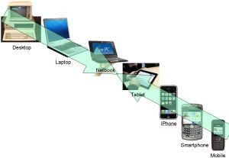
WHY MOBILE COMPUTING

Mobile computing is all about portable and small computers, which includes PDAs (Personal Digital Assistants) like mobile phones, palmtops, laptops etc. In this growing technological world, people are much bound to work on computers and Internet. People are attracted towards mobile devices because of their major features such as- Mobile computing can be defined as the ability to use technology that is not physically connected to any static network. Nowadays, most laptops and personal digital assistants(PDA) all have wireless cards or Bluetooth interfaces built into them for very Good mobile internet access.

-They are wireless devices.
-Mobile devices are portable that enables easy to carry and work with while you are on the move.
-Has attractive user interface.
-Provide many features like wireless LAN to access Internet from any part of the world.
-Enables voice and typical data transmission
-Enables one to one contact to have conversations
-Though the mobile computing devices have drawbacks such as low bandwidth, lack of security, loss of connectivity and battery backup issue, people still prefer mobile computing devices to desktops.

APPLICATIONS OF MOBILE COMPUTING
In many fields of work, the ability to keep on the move is vital in order to utilise time efficiently. The importance of Mobile Computers has been highlighted in many fields of which a few are described below:
- Vehicles: Music, news, road conditions, weather reports, and other broadcast information are received via digital audio broadcasting (DAB) with 1.5 Mbit/s. For personal communication, a universal mobile telecommunications system (UMTS) phone might be available offering voice and data connectivity with 384 kbit/s. The current position of the car is determined via the global positioning system (GPS). Cars driving in the same area build a local ad-hoc network for the fast exchange of information in emergency situations or to help each other keep a safe distance. In case of an accident, not only will the airbag be triggered, but the police and ambulance service will be informed via an emergency call to a

service provider. Buses, trucks, and trains are already transmitting maintenance and logistic information to their home base, which helps to improve organization (fleet management), and saves time and money.

- Emergencies: An ambulance with a high-quality wireless connection to a hospital can carry vital information about injured persons to the hospital from the scene of the accident. All the necessary steps for this particular type of accident can be prepared and specialists can be consulted for an early diagnosis. Wireless networks are the only means of communication in the case of natural disasters such as hurricanes or earthquakes. In the worst cases, only decentralized, wireless ad-hoc networks survive.

- Business: Managers can use mobile computers say, critical presentations to major customers. They can access the latest market share information. At a small recess, they can revise the presentation to take advantage of this information. They can communicate with the office about possible new offers and call meetings for discussing responds to the new proposals. Therefore, mobile computers can leverage competitive advantages. A travelling salesman today needs instant access to the company’s database: to ensure that files on his or her laptop reflect the current situation, to enable the company to keep track of all activities of their travelling employees, to keep databases consistent etc. With wireless access, the laptop can be turned into a true mobile office, but efficient and powerful synchronization mechanisms are needed to ensure data consistency.

- Credit Card Verification: At Point of Sale (POS) terminals in shops and supermarkets, when customers use credit cards for transactions, the intercommunication required between the bank central computer and the POS terminal, in order to effect verification of the card usage, can take place quickly and securely over cellular channels using a mobile computer unit. This can speed up the transaction process and relieve congestion at the POS terminals.

- Replacement of Wired Networks: wireless networks can also be used to replace wired networks, e.g., remote sensors, for tradeshows, or in historic buildings. Due to economic reasons, it is often impossible to wire remote sensors for weather forecasts, earthquake detection, or to provide environmental information. Wireless connections, e.g., via satellite, can help in this situation. Other examples for wireless networks are computers, sensors, or information displays in historical buildings, where excess cabling may destroy valuable walls or floors.

- Infotainment: wireless networks can provide up-to-date information at any appropriate location. The travel guide might tell you something about the history of a building (knowing via GPS, contact to a local base station, or triangulation where you are) downloading information about a concert in the building at the same evening via a local wireless network. Another growing field of wireless network applications lies in

entertainment and games to enable, e.g., ad-hoc gaming networks as soon as people meet to play together.

Limitations of Mobile Computing
- Resource constraints: Battery
- Interference: Radio transmission cannot be protected against interference using shielding and result in higher loss rates for transmitted data or higher bit error rates respectively
- Bandwidth: Although they are continuously increasing, transmission rates are still very low for wireless devices compared to desktop systems. Researchers look for more efficient communication protocols with low overhead.
- Dynamic changes in communication environment: variations in signal power within a region, thus link delays and connection losses
- Network Issues: discovery of the connection-service to destination and connection stability
- Interoperability issues: the varying protocol standards

- Security constraints: Not only can portable devices be stolen more easily, but the radio interface is also prone to the dangers of eavesdropping. Wireless access must always include encryption, authentication, and other security mechanisms that must be efficient and simple to use.

Mobile computing Devices
Mobile computer devices are designed to be portable, often to fit on your lap, in the palm of your hand or in your pocket. With some mobile devices, you can do many of the things you do with a desktop computer while you are away from home or traveling. Features in mobile computer devices include batteries, video camera, camera, voice recorder and music player. Laptop computers, tablets, smartphones, e-readers and handheld gaming devices are five types of mobile technology used to connect to the Internet and communicate with others.

  - Laptop Computers
Laptop computers are personal computers that are easy to carry and use in various locations. Many laptops on the market are designed to offer you all the functionality of a desktop computer, which means you can run the same software and open the same types of files.
The laptop has an all-in-one design with built-in touchpad, keyboard, monitor and speakers. Laptops also offer you the option of connecting to a larger monitor, regular mouse and other peripherals. This feature means you can turn a laptop into a desktop computer, but one you can disconnect from the peripherals and carry with you wherever you go.

Most laptops have the same types of ports desktop computers have -- USB, HDMI and Firewire -- although there are usually fewer of them to save space. However, some laptop ports are different from desktop computers and may require an adapter to use them. For example, the monitor port on a laptop is a Mini DisplayPort, which is smaller than the DisplayPort on a desktop computer.

  - Tablets
Tablets are also designed to offer portability. However, they provide you with a computing experience different from laptops with the biggest difference being that tablets do not have a touchpad or keyboard. Instead, the touch screen offers a virtual keyboard you use to input text, while your finger replaces the mouse as a pointer.
Tablets are bigger than a smartphone and smaller than a laptop. Like the smartphone, you can browse the Internet, carry out videoconferences, stay connected through email, read e-books, play games, watch movies, share photos and listen to music with the tablet.
Basic features of tablet computers include:

- Mobile OS: Tablets run on mobile operating systems different from their desktop counterparts. Examples include Windows, iOS and Android.
- Solid-state drives: Tablets use solid-state drives, which are faster and more durable than hard disk drives.
- Wi-Fi: Because tablets are optimized for Internet use, they have built-in Wi-Fi.

  - Smartphones

A smartphone is a powerful mobile phone capable of running applications in addition to providing with phone service. These devices have most of the features available on tablets along with cellular Internet connectivity. Cell phone companies offer data plans that offer you Internet access anywhere with coverage.

4.E-Readers
E-readers, or e-book readers, resemble tablet computers, but that they are mainly designed for reading digital and downloadable documents. E-readers have either an LCD or e-ink display.

- LCD Display: This is the same screen found on laptops and tablet computers. This type of screen is suitable for viewing books and magazines with photos because the LCD screen can display colors.
- E-Ink Display: E-ink is short for electronic ink and usually displays in black and white. It is designed to offer you the look of an actual page in a book. Unlike the LCD display, the e-ink version is not backlit, so text is readable even outdoors in full sun. E-ink displays offer a reading experience with less eyestrain.

5.Handheld Gaming Devices

Handheld gaming devices are portable, lightweight video game consoles that have built-in game controls, screen and speakers. With a handheld gaming console, you can

play your favorite console games wherever you are, whether on the move or while someone else is watching the TV.
Basic features of handheld gaming devices such as Nintendo 3DS and PS Vita include:
- Online access to free and paid games
- Access to online movies, TV shows
- Social media apps
- Web browsing
- Online and local multiplayer support

Types of Wireless Communication Technologies

In recent days, the wireless communication technology has become an integral part of several types of communication devices as it allows users to communicate even from remote areas. The devices used for wireless communication are cordless telephones, mobiles, GPS units, ZigBee technology, wireless computer parts, and satellite television, etc.
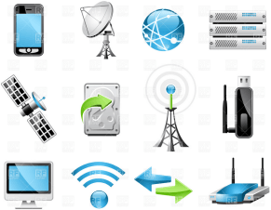
Types of Communication Technologies

Satellite

Satellite communication is one of the wireless technologies, which is widely spread all over the world allowing users to stay connected virtually anywhere on the Earth. The Satellites used in this mode of communication, communicate directly with the orbiting satellites via radio signals. Portable satellite phones and modems have more powerful broadcasting abilities than the cellular devices as they have high range, apart from being more expensive in terms of cost, than their counterparts. For example, for outfitting a ship through satellite communication, a traditional communication system is linked to a single satellite, which allows multiple users to share the same broadcast equipment.

Wireless Networking

Wireless Networking technologies connect multiple computers, systems and devices together without requiring wires or cables: a wireless local area network or WLAN comes under Wi-Fi.

WiMAX

There are wireless broadband systems that offer fast Web surfing without being getting connected through cable or DSL (Example of wireless broadband is WiMAX). Although WiMAX can potentially deliver data rates of more than 30 Megabits per second, yet the providers offer average 0 data rates of 6 Mbps and often deliver less, making the service significantly slower than the hard-wired broadband. The actual cost of the data available using WiMAX widely varies with the distance from the transmitter. WiMAX is also one of the versions of 4G wireless available in phones as Sprint’s 4G technology.
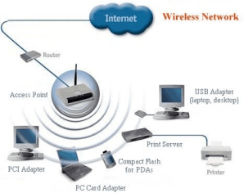
Wireless Networking

Wi-Fi

Wi-Fi is a form of low-power wireless communication used by many electronic devices such as laptops, systems, smart phones, etc. In a Wi-Fi setup, a wireless router serves as the communication hub. These networks are extremely limited in range due to low power of transmissions allowing users to connect only within close proximity to a router or signal repeater. Wi-Fi is common in home networking applications which provides portability without any need of cables. Wi-Fi networks need to be secured with passwords for security purposes in order not to be accessed by others.
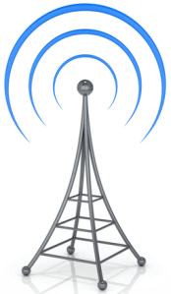
Wi-Fi
Wireless Networking (Wi-Fi):

Advantages

- Ease of Integration and Convenience – The wireless nature of such networks allows users to access network resources from nearly any convenient location.

- Mobility – With the emergence of public wireless networks, users can access the internet even outside their normal working environment.
- Expandability – Wireless networks are capable of serving a suddenly-increased number of clients with the existing equipment. In a wired network, additional clients require additional wiring.
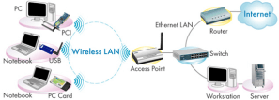
Wireless Networking WiFI

Disadvantages

- Wireless LANs may not be desirable for a number of reasons.
- Radio Frequency transmission and wireless networking signals are subjected to a wide variety of interference including the complex propagation effects that are beyond the control of the network administrator.
- Security Problems – Wireless networks may choose to utilize some of the various encryption technologies.
- Range will be insufficient for a larger structure – and, in order to increase its range, repeaters or additional access points have to be purchased.
- The speed on most wireless networks will be slower than the slowest common wired networks.
- Installation of an infrastructure-based wireless network is a complex to set up.

Bluetooth Technology

Bluetooth technology allows you to connect a variety of different electronic devices wirelessly to a system for the transfer and sharing of data and this is the main function of Bluetooth. Cell phones are connected to hands-free earpieces, wireless keyboard, mouse and mike to laptops with the help of Bluetooth as it transmits information from one device to other device. Bluetooth technology has many functions, and it is used most commonly in wireless communications’ market.
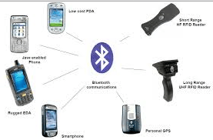
Bluetooth Technology

Features

- Bluetooth technology uses radio waves to communicate between devices. Most of these radio waves have a range of 15-50 feet.
- According to the official Bluetooth website, Bluetooth uses a low-power signal with a maximum range of 50 feet with sufficient speed to enable transmission of data.
- The pairing process identifies and connects any two devices to each other. It also prevents interference from other non-paired Bluetooth devices in the area.
- It uses maximum power only when it is required, thus preserving battery life.

ZigBee

ZigBee is a wireless communication standard designed to address the unique needs of low-power, low-cost wireless sensor, and control networks. ZigBee can be used almost anywhere, as it is easy to implement and requires little power to operate. Zigbee has been developed looking into the needs of the communication of data with a simple structure like the data from the sensors.
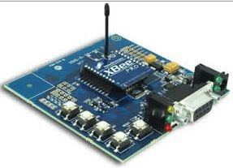
Zigbee Technology Features
- ZigBee devices are designed for low-power consumption.
- ZigBee is used in Commercial Applications like sensing and monitoring applications.
- ZigBee uses very low power and extremely long device battery life.
- ZigBee gives flexibility to do more with the reliable wireless performance and battery operation.

Types of Wireless Data Transmission

Wireless technology defines the electronic devices that communicate in air without cables using radio frequency signals. Wireless technology is used in a variety of modern device and provides greater mobility. Wireless devices play an important role in voice and Internet communications.

Wireless Router

Wireless routers accepts an incoming Internet connection and sendsthe data as RF signals to other wireless devices that are near to the router. A network set up with a wireless router is called as a Wireless Local Area Network (WLAN).Many routers have built-in

security features such as firewalls that help protect devices connected to the router against malicious data such as computer viruses.
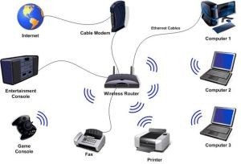
Wireless Router

A wireless router is used in many houses to connect their computers to the Internet.

Wireless Adapters

Wireless adapters are hardware devices that are installed inside computers which enables wireless connectivity. If a computer does not have a wireless adapter, it will not be able to connect to a router in order to access the Internet. Some computers have wireless adapters built directly into the motherboard, while it is also possible to install stand-alone wireless adapters to add wireless capability to a computer that doesn’t have a built-in facility.

Wireless Repeater

A wireless repeater is a wireless networking device that is used to extend the range of a wireless router. A repeater receives wireless signals and amplifies the strength of the signals, and then re-emits them. The strength of the signal can be increased by placing a repeater between the router and the computer connected to the router.
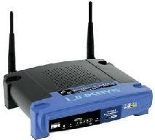
Wireless Repeater Microwave
Microwave is an effective type of wireless data transmission that transfers information using two separate methods. One method which is used to transmit data through the wireless media of a microwave is the satellite method that transmits information via a satellite that orbits 22,300 miles above the Earth. Stations on the ground send and receive data signals to and from the satellite with a frequency ranging from 11 GHz to 14 GHz and with a transmission speed of 1 Mbps to 10 Mbps. Another method is a terrestrial method, in which two microwave towers with a clear line of sight between them are used ensuring no obstacles to disrupt that line of sight. For the purpose of privacy, it is used

often. The frequency of data transmission for terrestrial systems is typically 4 GHz to 6 GHz or 21 GHz to 23 GHz, and the speed is usually 1 megabit per second (Mbps) to 10 Mbps.

Infrared (IR)

Infrared is a media transmission system that transmits data signals through light emitting diodes (LEDs) or Lasers. Infrared is an electromagnetic energy at a wavelength which is longer than that of the red light. The information cannot be travelled through obstacles in an infrared system, but can be inhibited by light. One type of infrared is the point to point system in which transmission is possible between two points limited to a range and line of sight.

The signal frequency to transmit in a point to point system is 100 GHz to 1,000 terahertz (THz), and the speed ranges from 100 Kbps to 16 Mbps. Another method of transmission of infrared includes the broadcast system – and, in this method, a reflective material or a transmission unit amplifies and retransmits a data signal to several other units. The normal frequency of an infrared broadcast system is 100 GHz to 1,000 THz with a limited speed of 1 Mbps.
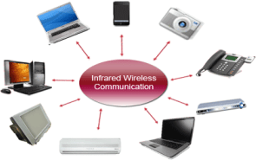
Infrared

Types of Wireless Devices
Radio

The radio system is one type of wireless data transmission, and it is a wireless media that transfers data by carrying electromagnetic waves with low frequencies to distant locations through an electrical conductor and an antenna. Ham radio enthusiasts share information and serve as emergency communication aids during disasters with their powerful amateur broadcasting equipment and can even communicate digital data over the radio spectrum.

Citizen’s band and maritime radios provide communication services for truckers and sailors. The transmission frequency for information transmitted through a radio system ranges from 10 kilohertz (kHz) to 1 gigahertz (GHz), and the frequencies are regulated by the Federal Communications Commission (FCC).

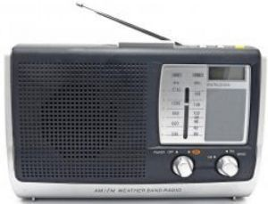
Radio Wireless Phones
The evolution of cellular networks is enumerated by generations. Many different users communicate across a single frequency band through Cellular and cordless phones. Cellular and cordless phones are two more examples of devices that make use of wireless signals.

Cordless phones have a limited range but cell phones typically have a much larger range than the local wireless networks since cell phone use large telecommunication towers to provide cell phone coverage. Some phones make use of signals from satellites to communicate, similar to Global Positioning System (GSP) devices.
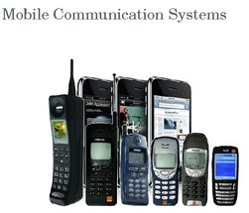
Wireless Phones Other Devices
Anything that uses radio signals to communicate can be considered as a wireless device. Common devices such as garage door openers, baby monitors, certain video game consoles and walkie-talkies make use of wireless technology.

Advantages and Disadvantages of Wireless Communications
Advantages

- Any information can be conveyed or transmitted quickly and with a high speed.
- The Internet can be accessed from anywhere and at anytime without the need to carry cables or wires and it improves easy access and productivity.
- Helpful for Doctors, workers and other professionals working in remote areas as they can be in touch with the medical centers through wireless communication.

- Emergency situations can be alerted through wireless communication. The affected regions can be provided support with the help of these alerts through wireless communication.
- Wireless networks cost less for installation and maintenance.

Disadvantages

- A Hacker can easily capture the wireless signals that spread through the air.
- It is very important to secure the wireless network so that the information cannot be exploited by unauthorized users, and this also increases the risk of losing data or information.

Thus, Wireless networks are one of the fastest growing technologies in telecommunications market. WiMax, Bluetooth, Wi-Fi, Femtocell and 4G are some of the most significant standards of Wireless technology for the next generations. Radio, Mobiles, Internet, etc., all use technological advancements in wireless data transmission systems that carry invisible electromagnetic waves to transmit data over long distances within a short amount of time. The information provided in this article will be helpful to the viewers.

Fundamental of Mobile Data Network: Medium Access Control
In wireless networks, multiple terminals need to communicate at the same time and a medium access control (MAC) protocol allows several terminals to transmit over the wireless channel and to share its capacity.MAC protocols multiplex several data streams of different terminals to share the same channel and deal with issues such as addressing, how a terminal obtains a channel when it needs one, and so forth.
The design of MAC protocols closely relates to the condition of the physical channels. Initially MAC protocols were designed for wired communications where multiple computers need to transmit data packets at the same time in a local area network (LAN). With wired networks, the physical medium can be copper or fiber optics, which are in general very reliable with abundant bandwidth. Packet loss in wired networks is mainly due to collisions and the MAC designs are relatively simple.
The MAC design in wireless networks is much more challenging. The difficulties lie in the following aspects. With wireless communications, a radio signal may experience reflection, diffraction or scattering before reaching its receiver. Any of them will deteriorate the signal and incur variation of signal quality in time, frequency and space. Another main issue is the broadcast nature of wireless channels. For reliable transmission against fading, strong radio transmission power needs to be used by the transmitter. This incurs strong interference with other terminals in the vicinity. The stronger the transmission power or the closer the neighboring terminals, the stronger the interference will be. Because of fading and interference, wireless networks are more vulnerable compared to wired ones. Usually the bit error rate of wired networks is better than 10−6 and that of wireless ones is worse than 10−3. The difficulty also lies in the fact that

wireless terminals usually have to operate in half-duplex mode. This is because transmission power is in general much stronger than reception power, and with full- duplex operation the leakage of transmission power to the receiver component will incur very strong self-interference and therefore the terminal will not be able to receive packets or detect a collision when it is sending.
MAC schemes can be divided into two categories, contention-free and contention-based protocols. A contention-free MAC protocol requires a central controller to coordinate the resource allocation and the central controller can be a base station in a cellular network or an access point in a wireless local area network.

A simplified reference model
The figure shows the protocol stack implemented in the system according to the reference model. End-systems, such as the PDA and computer in the example, need a full protocol stack comprising the application layer, transport layer, network layer, data link layer, and physical layer. Applications on the end-systems communicate with each other using the lower layer services. Intermediate systems, such as the interworking unit, do not necessarily need all of the layers.
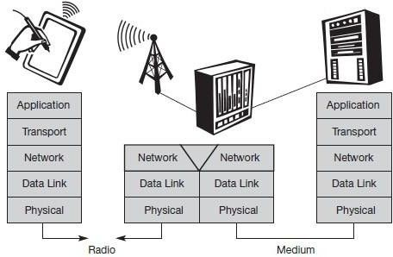
A Simplified Reference Model

  - Physical layer: This is the lowest layer in a communication system and is responsible for the conversion of a stream of bits into signals that can be transmitted on the sender side. The physical layer of the receiver then transforms the signals back into a bit stream. For wireless communication, the physical layer is responsible for frequency selection, generation of the carrier frequency, signal detection (although heavy interference may disturb the signal), modulation of data onto a carrier frequency and (depending on the transmission scheme) encryption.
  - Data link layer: The main tasks of this layer include accessing the medium, multiplexing of different data streams, correction of transmission errors, and synchronization (i.e., detection of a data frame). Altogether, the data link layer is responsible for a reliable point-to-point connection between two devices or a point-to-multipoint connection between one sender and several receivers.
  - Network layer: This third layer is responsible for routing packets through a

network or establishing a connection between two entities over many other intermediate systems. Important functions are addressing, routing, device location, and handover between different networks.
  - Transport layer: This layer is used in the reference model to establish an end- to-end connection
  - Application layer: Finally, the applications (complemented by additional layers that can support applications) are situated on top of all transmission oriented layers. Functions are service location, support for multimedia applications, adaptive applications that can handle the large variations in transmission characteristics, and wireless access to the world-wide web using a portable device.

Architecture of Mobile Computing
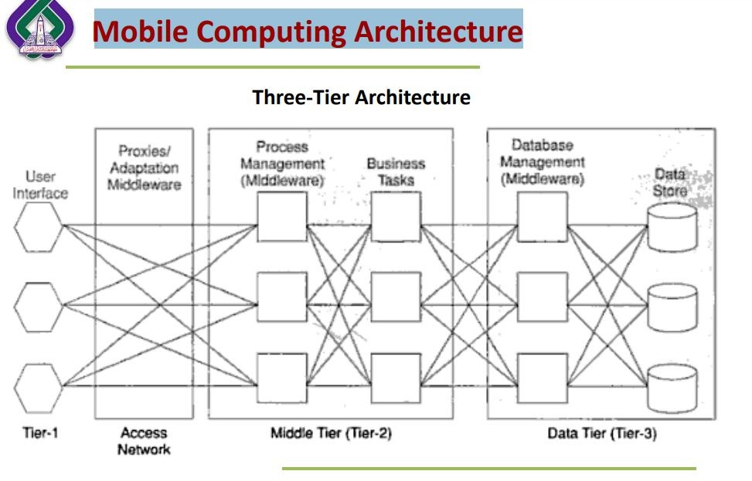

- Presentation (Tier - 1):
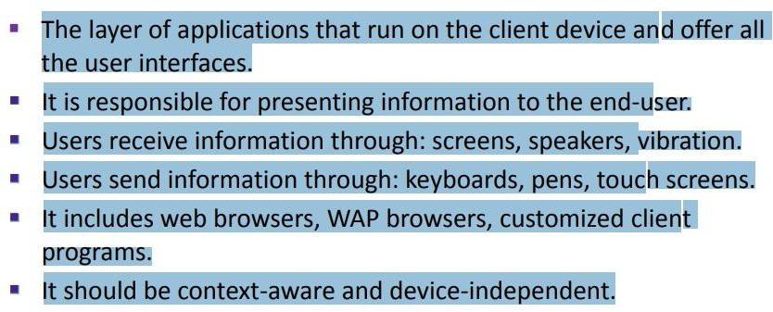
- Application (Tier - 2):

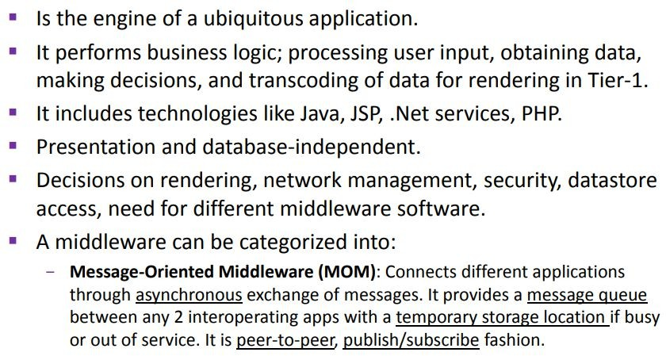

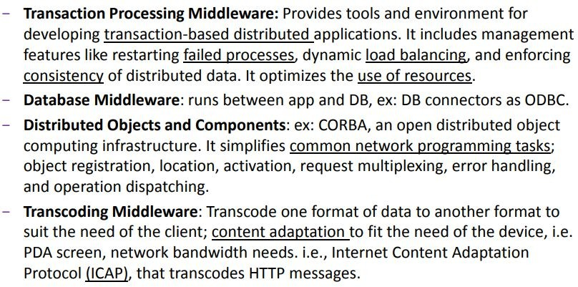

- Data (Tier -3):

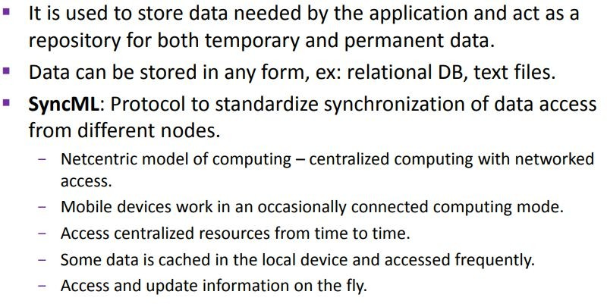

Unit:2
Introduction to GSM , SMS ,GPRS , Mobile OS
GSM : Mobile services, System architecture, Radio interface, Protocols, Localization and calling, Handover, Security, and New data services.

GSM Services

GSM is the most successful digital mobile telecommunication system in the world today. It is used by over 800 million people in more than 190 countries. GSM permits the integration of different voice and data services and the interworking with existing networks. Services make a network interesting for customers. GSM has defined three different categories of services: bearer, tele and supplementary services.

Bearer services: GSM specifies different mechanisms for data transmission, the original GSM allowing for data rates of up to 9600 bit/s for non-voice services. Bearer services permit transparent and non-transparent, synchronous or asynchronous data transmission. Transparent bearer services only use the functions of the physical layer (layer 1) to transmit data. Data transmission has a constant delay and throughput if no transmission errors occur. Transmission quality can be improved with the use of forward error correction (FEC), which codes redundancy into the data stream and helps to reconstruct the original data in case of transmission errors. Transparent bearer services do not try to recover lost data in case of, for example, shadowing or interruptions due to handover. Non-transparent bearer services use protocols of layers two and three to implement error correction and flow control. These services use the transparent bearer services, adding a radio link protocol (RLP). This protocol comprises mechanisms of high-level data link control (HDLC), and special selective-reject mechanisms to trigger retransmission of erroneous data.Using transparent and non-transparent services, GSM specifies several bearer services for interworking with PSTN, ISDN, and packet switched public data networks (PSPDN) like X.25, which is available worldwide. Data transmission can be full-duplex, synchronous with data rates of 1.2, 2.4, 4.8, and 9.6 kbit/s or full-duplex, asynchronous from 300 to 9,600 bit/s.

Tele services: GSM mainly focuses on voice-oriented tele services. These comprise encrypted voice transmission, message services, and basic data communication with terminals as known from the PSTN or ISDN (e.g., fax). The primary goal of GSM was the provision of high-quality digital voice transmission. Special codecs (coder/decoder) are used for voice transmission, while other codecs are used for the transmission of analog data for communication with traditional computer modems used in, e.g., fax machines. Another service offered by GSM is the emergency number (eg 911, 999). This service is mandatory for all providers and free of charge. This connection also has the highest

priority, possibly pre-empting other connections, and will automatically be set up with the closest emergency center. A useful service for very simple message transfer is the short message service (SMS), which offers transmission of messages of up to 160 characters. Sending and receiving of SMS is possible during data or voice transmission. It can be used for “serious” applications such as displaying road conditions, e-mail headers or stock quotes, but it can also transfer logos, ring tones, horoscopes and love letters.
The successor of SMS, the enhanced message service (EMS), offers a larger message size, formatted text, and the transmission of animated pictures, small images and ring tones in a standardized way. But with MMS, EMS was hardly used. MMS offers the transmission of larger pictures (GIF, JPG, WBMP), short video clips etc. and comes with mobile phones that integrate small cameras. Another non-voice tele service is group 3 fax, which is available worldwide. In this service, fax data is transmitted as digital data over the analog telephone network according to the ITU-T standards T.4 and T.30 usingmodems.

Supplementary services: In addition to tele and bearer services, GSM providers can offer supplementary services. these services offer various enhancements for the standard telephony service, and may vary from provider to provider. Typical services are user identification, call redirection, or forwarding of ongoing calls, barring of incoming/outgoing calls, Advice of Charge (AoC) etc. Standard ISDN features such as closed user groups and multiparty communication may be available.

GSM Architecture

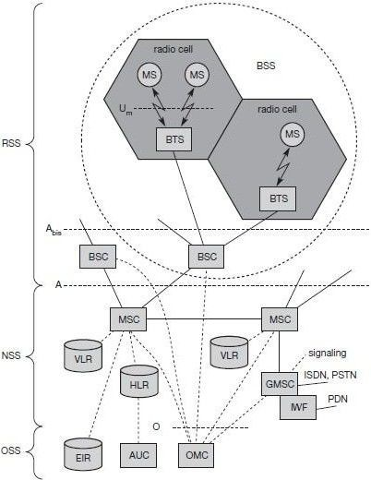
A GSM system consists of three subsystems, the radio sub system (RSS), the network and switching subsystem (NSS), and the operation subsystem (OSS).

22

Functional Architecture of a GSM System

Network Switching Subsystem: The NSS is responsible for performing call processing and subscriber related functions. The switching system includes the following functional units:
- Home location register (HLR): It is a database used for storage and management of subscriptions. HLR stores permanent data about subscribers, including a subscribers service profile, location information and activity status. When an individual buys a subscription from the PCS provider, he or she is registered in the HLR of that operator.
- Visitor location register (VLR): It is a database that contains temporary information about subscribers that is needed by the MSC in order to service visiting subscribers. VLR is always integrated with the MSC. When a MS roams into a new MSC area, the VLR connected to that MSC will request data about the mobile station from the HLR. Later if the mobile station needs to make a call, VLR will be having all the information needed for call setup.
- Authentication center (AUC): A unit called the AUC provides authentication and encryption parameters that verify the users identity and ensure the confidentiality of each call.
- Equipment identity register (EIR): It is a database that contains information about the identity of mobile equipment that prevents calls from stolen, unauthorized or defective mobile stations.
- Mobile switching center (MSC): The MSC performs the telephony switching functions of the system. It controls calls to and from other telephone and data systems.
Radio Subsystem (RSS): the radio subsystem (RSS) comprises all radio specific entities, i.e., the mobile stations (MS) and the base station subsystem (BSS). The figure shows the connection between the RSS and the NSS via the A interface (solid lines) and the connection to the OSS via the O interface (dashed lines).
- Base station subsystem (BSS): A GSM network comprises many BSSs, each controlled by a base station controller (BSC). The BSS performs all functions necessary to maintain radio connections to an MS, coding/decoding of voice, and rate adaptation to/from the wireless network part. Besides a BSC, the BSS contains several BTSs.
- Base station controllers (BSC): The BSC provides all the control functions and physical links between the MSC and BTS. It is a high capacity switch that provides functions such as handover, cell configuration data, and control of radio frequency (RF) power levels in BTS. A number of BSC’s are served by and MSC.
- Base transceiver station (BTS): The BTS handles the radio interface to the mobile station. A BTS can form a radio cell or, using sectorized antennas, several and is connected to MS via the Um interface, and to the BSC via the Abis interface. The Um interface contains all the mechanisms necessary for wireless transmission (TDMA, FDMA etc.)The BTS is the radio equipment (transceivers and antennas) needed to service each cell in the network. A group of BTS’s are controlled by an BSC.

Traffic Channels: Traffic channels carry user information such as encoded speech or

user data. Traffic channels are defined by using a 26-frame multiframe. Two general forms are defined:
- Full rate traffic channels (TCH/F), at a gross bit rate of 22.8 kbps (456bits / 20ms)
- Half rate traffic channels (TCH/H), at a gross bit rate of 11.4 kbps. Uplink and downlink are separated by three slots (bursts) in the 26-multiframe structure. This simplifies the duplexing function in mobile terminals design, as mobiles will not need to transmit and receive at the same time. The 26-frame multiframe structure, shown below multiplexes two types of logical channels, a TCH and a Slow Associated Control CHannel (SACCH).
However, if required, a Fast Associated Control CHannel (FACCH) can steal TCH in order to transmit control information at a higher bit rate. This is usually the case during the handover process. In total 24 TCH/F are transmitted and one SACCH.

Control Channels: Control channels carry system signalling and synchronisation data for control procedures such as location registration, mobile station synchronisation, paging, random access etc. between base station and mobile station. Three categories of control channel are defined: Broadcast, Common and Dedicated. Control channels are multiplexed into the 51-frame multiframe.
  - Broadcast control channel (BCCH): A BTS uses this channel to signal information to all MSs within a cell. Information transmitted in this channel is, e.g., the cell identifier, options available within this cell (frequency hopping), and frequencies available inside the cell and in neighboring cells. The BTS sends information for frequency correction via the frequency correction channel (FCCH) and information about time synchronization via the synchronization channel (SCH), where both channels are subchannels of the BCCH.
  - Common control channel (CCCH): All information regarding connection setup between MS and BS is exchanged via the CCCH. For calls toward an MS, the BTS uses the paging channel (PCH) for paging the appropriate MS. If an MS wants to set up a call, it uses the random access channel (RACH) to send data to the BTS. The RACH implements multiple access (all MSs within a cell may access this channel) using slotted Aloha. This is where a collision may occur with other MSs in a GSM system. The BTS uses the access grant channel (AGCH) to signal an MS that it can use a TCH or SDCCH for further connection setup.
  - Dedicated control channel (DCCH): While the previous channels have all been unidirectional, the following channels are bidirectional. As long as an MS has not established a TCH with the BTS, it uses the stand-alone dedicated control channel (SDCCH) with a low data rate (782 bit/s) for signaling. This can comprise authentication, registration or other data needed for setting up a TCH. Each TCH and SDCCH has a slow associated dedicated control channel (SACCH) associated with it, which is used to exchange system information, such as the channel quality and signal power level. Finally, if

more signaling information needs to be transmitted and a TCH already exists, GSM uses a fast associated dedicated control channel (FACCH). The FACCH uses the time slots which are otherwise used by the TCH. This is necessary in the case of handovers where BTS and MS have to exchange larger amounts of data in less time.

GSM Protocols

The signalling protocol in GSM is structured into three general layers depending on the interface, as shown below. Layer 1 is the physical layer that handles all radio-specific functions. This includes the creation of bursts according to the five different formats, multiplexing of bursts into a TDMA frame, synchronization with the BTS, detection of idle channels, and measurement of the channel quality on the downlink. The physical layer at Um uses GMSK for digital modulation and performs encryption/decryption of data, i.e., encryption is not performed end-to-end, but only between MS and BSS over the air interface.

Protocol architecture for Signaling

The main tasks of the physical layer comprise channel coding and error detection/correction, which is directly combined with the coding mechanisms. Channel coding makes extensive use of different forward error correction (FEC) schemes. Signaling between entities in a GSM network requires higher layers. For this purpose, the LAPDm protocol has been defined at the Um interface for layer two. LAPDm has been derived from link access procedure for the D-channel (LAPD) in ISDN systems, which is a version of HDLC. LAPDm is a lightweight LAPD because it does not need synchronization flags or checksumming for error detection. LAPDm offers reliable data transfer over connections, re- sequencing of data frames, and flow control.

The network layer in GSM, layer three, comprises several sublayers. The lowest sublayer is the radio resource management (RR). Only a part of this layer, RR’, is implemented in the BTS, the remainder is situated in the BSC. The functions of RR’ are supported by the BSC via the BTS management (BTSM). The main tasks of RR are setup, maintenance, and release of radio channels. Mobility management (MM) contains functions for registration, authentication, identification, location updating, and the provision of a temporary mobile subscriber identity (TMSI).

Finally, the call management (CM) layer contains three entities: call control (CC), short message service (SMS), and supplementary service (SS). SMS allows for message transfer using the control channels SDCCH and SACCH, while SS offers the services like user identification, call redirection, or forwarding of ongoing calls. CC provides a point- to- point connection between two terminals and is used by higher layers for call establishment, call clearing and change of call parameters. This layer also provides functions to send in- band tones, called dual tone multiple frequency (DTMF), over the GSM network. These

tones are used, e.g., for the remote control of answering machines or the entry of PINs in electronic banking and are, also used for dialing in traditional analog telephone systems.
Additional protocols are used at the Abis and A interfaces. Data transmission at the physical layer typically uses pulse code modulation (PCM) systems. LAPD is used for layer two at Abis, BTSM for BTS management. Signaling system No. 7 (SS7) is used for signaling between an MSC and a BSC. This protocol also transfers all management information between MSCs, HLR, VLRs, AuC, EIR, and OMC. An MSC can also control a BSS via a BSS application part (BSSAP).

Localization and Calling

The fundamental feature of the GSM system is the automatic, worldwide localization of users for which, the system performs periodic location updates. The HLR always contains information about the current location and the VLR currently responsible for the MS informs the HLR about the location changes. Changing VLRs with uninterrupted availability is called roaming. Roaming can take place within a network of one provider, between two providers in a country and also between different providers in different countries. To locate and address an MS, several numbers are needed:

  - Mobile station international ISDN number (MSISDN):- The only important number for a user of GSM is the phone number. This number consists of the country code (CC), the national destination code (NDC) and the subscriber number (SN).
  - International mobile subscriber identity (IMSI): GSM uses the IMSI for internal unique identification of a subscriber. IMSI consists of a mobile country code (MCC), the mobile network code (MNC), and finally the mobile subscriber identification number (MSIN).
  - Temporary mobile subscriber identity (TMSI): To hide the IMSI, which would give away the exact identity of the user signalling over the air interface, GSM uses the 4 byte TMSI for local subscriber identification.
  - Mobile station roaming number (MSRN): Another temporary address that hides the identity and location of a subscriber is MSRN. The VLR generates this address on request from the MSC, and the address is also stored in the HLR. MSRN contains the current visitor country code (VCC), the visitor national destination code (VNDC), the identification of the current MSC together with the subscriber number. The MSRN helps the HLR to find a subscriber for an incoming call.
For a mobile terminated call (MTC), the following figure shows the different steps that take place:

(MTC) step 1: User dials the phone number of a GSM

subscriber.
step 2: The fixed network (PSTN) identifies the number belongs to a user in GSM network and forwards the call setup to the Gateway MSC (GMSC).
step 3: The GMSC identifies the HLR for the subscriber and signals the call setup to HLR
step 4: The HLR checks for number existence and its subscribed services and requests an MSRN from the current VLR.
step 5: VLR sends the MSRN to HLR
step 6: Upon receiving MSRN, the HLR determines the MSC responsible for MS and forwards the information to the GMSC
step 7: The GMSC can now forward the call setup request to the MSC indicated
step 8: The MSC requests the VLR for the current status of the MS
step 9: VLR sends the requested information
step 10: If MS is available, the MSC initiates paging in all cells it is responsible for.
step 11: The BTSs of all BSSs transmit the paging signal to the MS
step 12: Step 13: If MS answers, VLR performs security checks
step 15: Till step 17: Then the VLR signals to the MSC to setup a connection to the MS For a mobile originated call (MOC), the following steps take place:
step 1: The MS transmits a request for a new connection
step 2: The BSS forwards this request to the MSC
step 3: Step 4: The MSC then checks if this user is allowed to set up a call with the requested and checks the availability of resources through the GSM network and into the PSTN. If all resources are available, the MSC sets up a connection between the MS and the fixed network.

Handover
Cellular systems require handover procedures, as single cells do not cover the whole service area. However, a handover should not cause a cut-off, also called call drop. GSM aims at maximum handover duration of 60 ms. There are two basic reasons for a handover:
- The mobile station moves out of the range of a BTS, decreasing the received signal level increasing the error rate thereby diminishing the quality of the radio link.
- Handover may be due to load balancing, when an MSC/BSC decides the traffic is too high in one cell and shifts some MS to other cells with a lower load.

The four possible handover scenarios of GSM are shown below:
  - Intra-cell handover: Within a cell, narrow-band interference could make transmission at a certain frequency impossible. The BSC could then decide to change the

carrier frequency (scenario 1).
  - Inter-cell, intra-BSC handover: This is a typical handover scenario. The mobile station moves from one cell to another, but stays within the control of the same BSC. The BSC then performs a handover, assigns a new radio channel in the new cell and releases the old one (scenario 2).
  - Inter-BSC, intra-MSC handover: As a BSC only controls a limited number of cells; GSM also has to perform handovers between cells controlled by different BSCs. This handover then has to be controlled by the MSC (scenario 3).
  - Inter MSC handover: A handover could be required between two cells belonging to different MSCs. Now both MSCs perform the handover together (scenario 4).

To provide all the necessary information for a handover due to a weak link, MS and BTS both perform periodic measurements of the downlink and uplink quality respectively. Measurement reports are sent by the MS about every half-second and contain the quality of the current link used for transmission as well as the quality of certain channels in neighboring cells (the BCCHs).

Handover decision depending on receive level

More sophisticated handover mechanisms are needed for seamless handovers between different systems.

Security
GSM offers several security services using confidential information stored in the AuC and in the individual SIM. The SIM stores personal, secret data and is protected with a PIN against unauthorized use. Three algorithms have been specified to provide security services in GSM. Algorithm A3 is used for authentication, A5 for encryption, and A8 for the generation of a cipher key. The various security services offered by GSM are:

Access control and authentication: The first step includes the authentication of a valid user for the SIM. The user needs a secret PIN to access the SIM. The next step is the subscriber authentication. This step is based on a challenge-response scheme as shown below:

Authentication is based on the SIM, which stores the individual authentication key Ki, the user identification IMSI, and the algorithm used for authentication A3. The AuC performs the basic generation of random values RAND, signed responses SRES, and cipher keys Kc for each IMSI, and then forwards this information to the HLR. The current VLR requests the appropriate values for RAND, SRES, and Kc from the HLR. For authentication, the VLR sends the random value RAND to the SIM. Both sides, network

and subscriber module, perform the same operation with RAND and the key Ki, called A3. The MS sends back the SRES generated by the SIM; the VLR can now compare both values. If they are the same, the VLR accepts the subscriber, otherwise the subscriber is rejected.

Confidentiality: All user-related data is encrypted. After authentication, BTS and MS apply encryption to voice, data, and signalling as shown below.

To ensure privacy, all messages containing user-related information are encrypted in GSM over the air interface. After authentication, MS and BSS can start using encryption by applying the cipher key Kc, which is generated using the individual key Ki and a random value by applying the algorithm A8. Note that the SIM in the MS and the network both calculate the same Kc based on the random value RAND. The key Kc itself is not transmitted over the air interface. MS and BTS can now encrypt and decrypt data using the algorithm A5 and the cipher key Kc.

Anonymity: To provide user anonymity, all data is encrypted before transmission, and user identifiers are not used over the air. Instead, GSM transmits a temporary identifier (TMSI), which is newly assigned by the VLR after each location update. Additionally, the VLR can change the TMSI at any time.

New Data Services
To enhance the data transmission capabilities of GSM, two basic approaches are possible. As the basic GSM is based on connection-oriented traffic channels, e.g., with 9.6 kbit/s each, several channels could be combined to increase bandwidth. This system is called HSCSD
{high speed circuit switched data}. A more progressive step is the introduction of packet- oriented traffic in GSM, i.e., shifting the paradigm from connections/telephone thinking to packets/internet thinking. The system is called GPRS {general packet radio service}.

HSCD: A straightforward improvement of GSM’s data transmission capabilities is high speed circuit switched data (HSCSD) in which higher data rates are achieved by bundling several TCHs. An MS requests one or more TCHs from the GSM network, i.e., it allocates several TDMA slots within a TDMA frame. This allocation can be asymmetrical, i.e. more slots can be allocated on the downlink than on the uplink, which fits the typical user behaviour of downloading more data compared to uploading. A major disadvantage of HSCD is that it still uses the connection-oriented mechanisms of GSM, which is not efficient for computer data traffic.

GPRS: The next step toward more flexible and powerful data transmission avoids the problems of HSCSD by being fully packet-oriented. The general packet radio service

(GPRS) provides packet mode transfer for applications that exhibit traffic patterns such as frequent transmission of small volumes (e.g., typical web requests) or infrequent transmissions of small or medium volumes (e.g., typical web responses) according to the requirement specification. For the new GPRS radio channels, the GSM system can allocate between one and eight time slots within a TDMA frame. Time slots are not allocated in a fixed, pre-determined manner but on demand. All time slots can be shared by the active users; up- and downlink are allocated separately. Allocation of the slots is based on current load and operator preferences. The GPRS concept is independent of channel characteristics and of the type of channel (traditional GSM traffic or control channel), and does not limit the maximum data rate (only the GSM transport system limits the rate). All GPRS services can be used in parallel to conventional services. GPRS includes several security services such as authentication, access control, user identity confidentiality, and user information confidentiality.
The GPRS architecture introduces two new network elements, which are called GPRS support nodes (GSN) and are in fact routers. All GSNs are integrated into the standard GSM architecture, and many new interfaces have been defined. The gateway GPRS support node (GGSN) is the interworking unit between the GPRS network and external packet data networks (PDN). This node contains routing information for GPRS users, performs address conversion, and tunnels data to a user via encapsulation. The GGSN is connected to external networks (e.g., IP or X.25) via the Gi interface and transfers packets to the SGSN via an IP- based GPRS backbone network (Gn interface). The other new element is the serving GPRS support node (SGSN) which supports the MS via the Gb interface. The SGSN, for example, requests user addresses from the GPRS register (GR), keeps track of the individual MSs’ location, is responsible for collecting billing information (e.g., counting bytes), and performs several security functions such as access control. The SGSN is connected to a BSC via frame relay and is basically on the same hierarchy level as an MSC. The GR, which is typically a part of the HLR, stores all GPRS-relevant data.

GPRS Architecture Reference Model

As shown above, packet data is transmitted from a PDN, via the GGSN and SGSN directly to the BSS and finally to the MS. The MSC, which is responsible for data transport in the traditional circuit-switched GSM, is only used for signalling in the GPRS scenario. Before sending any data over the GPRS network, an MS must attach to it, following the procedures of the mobility management. The attachment procedure includes assigning a temporal identifier, called a temporary logical link identity (TLLI), and a ciphering key sequence number (CKSN) for data encryption. For each MS, a GPRS context is set up and stored in the MS and in the corresponding SGSN. Besides attaching and detaching, mobility management also comprises functions for authentication, location management, and ciphering.
The following figure shows the protocol architecture of the transmission plane for

GPRS. All data within the GPRS backbone, i.e., between the GSNs, is transferred using the GPRS tunnelling protocol (GTP). GTP can use two different transport protocols, either the reliable TCP (needed for reliable transfer of X.25 packets) or the non-reliable UDP (used for IP packets). The network protocol for the GPRS backbone is IP (using any lower layers). To adapt to the different characteristics of the underlying networks, the subnetwork dependent convergence protocol (SNDCP) is used between an SGSN and the MS. On top of SNDCP and GTP, user packet data is tunneled from the MS to the GGSN and vice versa. To achieve a high reliability of packet transfer between SGSN and MS, a special LLC is used, which comprises ARQ and FEC mechanisms for PTP (and later PTM) services.
The Media Access Control (MAC) data communication protocol sub-layer, also known as the

Medium Access Control, is a sublayer of the Data Link Layer specified in the seven-layer OSI model (layer 2). The hardware that implements the MAC is referred to as a Medium Access Controller. The MAC sub-layer acts as an interface between the Logical Link Control (LLC) sublayer and the network's physical layer. The MAC layer emulates a full-duplex logical communication channel in a multi-point network. This channel may provide unicast, multicast or broadcast communication service.
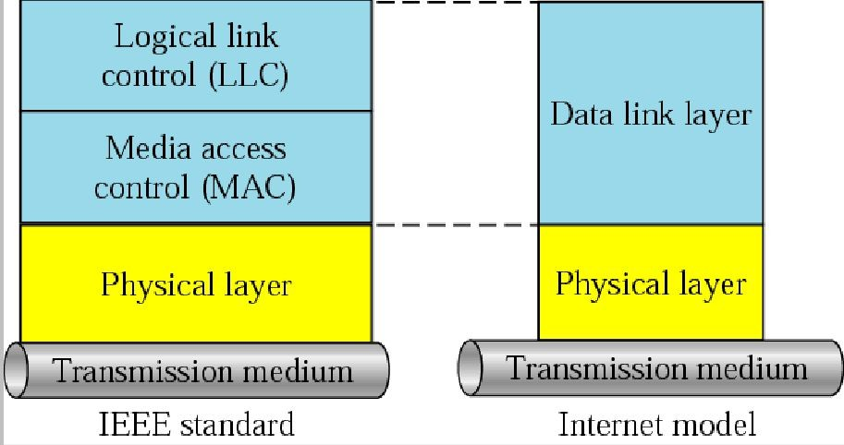
LLC and MAC sublayers

Motivation for a specialized MAC

One of the most commonly used MAC schemes for wired networks is carrier sense multiple access with collision detection (CSMA/CD). In this scheme, a sender senses the medium (a wire or coaxial cable) to see if it is free. If the medium is busy, the sender waits until it is free. If the medium is free, the sender starts transmitting data and continues to listen into the medium. If the sender detects a collision while sending, it stops at once and sends a jamming signal. But this scheme doest work well with wireless networks. The problems are:
- Signal strength decreases proportional to the square of the distance
- The sender would apply CS and CD, but the collisions happen at the receiver
- It might be a case that a sender cannot “hear” the collision, i.e., CD does not work
  - Furthermore, CS might not work, if for e.g., a terminal is “hidden”

HiddenandExposedTerminals

Consider the scenario with three mobile phones as shown below. The transmission range of A reaches B, but not C (the detection range does not reach C either). The transmission range of C reaches B, but not A. Finally, the transmission range of B reaches A and C, i.e., A cannot detect C and viceversa.
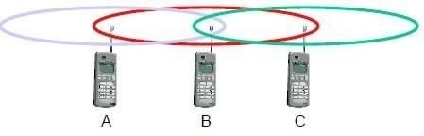
Hidden terminals
- A sends to B, C cannot hear A
- C wants to send to B, C senses a “free” medium (CS fails) and starts transmitting
- Collision at B occurs, A cannot detect this collision (CD fails) and continues with its transmission to B
- A is “hidden” from C and vice versa
Exposed terminals
- B sends to A, C wants to send to another terminal (not A or B) outside the range
- C senses the carrier and detects that the carrier is busy.
- C postpones its transmission until it detects the medium as being idle again
- but A is outside radio range of C, waiting is not necessary
- C is “exposed” to B
Hidden terminals cause collisions, where as Exposed terminals causes unnecessary delay.

Near and far terminals
Consider the situation shown below. A and B are both sending with the same transmission power.
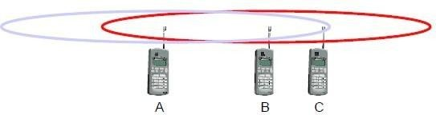
- Signal strength decreases proportional to the square of the distance
- So, B’s signal drowns out A’s signal making C unable to receive A’s transmission
- If C is an arbiter for sending rights, B drown out A’s signal on the physical layer making C unable to hear out A.

The near/far effect is a severe problem of wireless networks using CDM. All signals should arrive at the receiver with more or less the same strength for which Precise power control is to be implemented.

SDMA
Space Division Multiple Access (SDMA) is used for allocating a separated space to users in

wireless networks. A typical application involves assigning an optimal base station to a mobile phone user. The mobile phone may receive several base stations with different quality. A MAC algorithm could now decide which base station is best, taking into account which frequencies (FDM), time slots (TDM) or code (CDM) are still available. The basis for the SDMA algorithm is formed by cells and sectorized antennas which constitute the infrastructure implementing space division multiplexing (SDM). SDM has the unique advantage of not requiring any multiplexing equipment. It is usually combined with other multiplexing techniques to better utilize the individual physical channels.

FDMA
Frequency division multiplexing (FDM) describes schemes to subdivide the frequency dimension into several non-overlapping frequency bands.
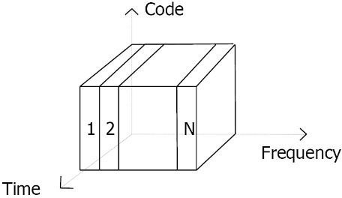

Frequency Division Multiple Access is a method employed to permit several users to transmit simultaneously on one satellite transponder by assigning a specific frequency within the channel to each user. Each conversation gets its own, unique, radio channel. The channels are relatively narrow, usually 30 KHz or less and are defined as either transmit or receive channels. A full duplex conversation requires a transmit & receive channel pair. FDM is often used for simultaneous access to the medium by base station and mobile station in cellular networks establishing a duplex channel. A scheme called frequency division duplexing (FDD) in which the two directions, mobile station to base station and vice versa are now separated using different frequencies.

The two frequencies are also known as uplink, i.e., from mobile station to base station or from ground control to satellite, and as downlink, i.e., from base station to mobile station or from satellite to ground control. The basic frequency allocation scheme for GSM is fixed and regulated by national authorities. All uplinks use the band between 890.2 and 915 MHz, all downlinks use 935.2 to 960 MHz. According to FDMA, the base station, shown on the right side, allocates a certain frequency for up- and downlink to establish a duplex channel with a mobile phone. Up- and downlink have a fixed relation. If the uplink frequency is fu = 890 MHz + n·0.2 MHz, the downlink frequency is fd = fu + 45 MHz,
- ., fd = 935 MHz + n·0.2 MHz for a certain channel n. The base station selects the channel. Each channel (uplink and downlink) has a bandwidth of 200 kHz.
This scheme also has disadvantages. While radio stations broadcast 24 hours a day, mobile communication typically takes place for only a few minutes at a time. Assigning a

separate frequency for each possible communication scenario would be a tremendous waste of (scarce) frequency resources. Additionally, the fixed assignment of a frequency to a sender makes the scheme very inflexible and limits the number ofsenders.

TDMA
A more flexible multiplexing scheme for typical mobile communications is time division multiplexing (TDM). Compared to FDMA, time division multiple access (TDMA) offers a much more flexible scheme, which comprises all technologies that allocate certain time slots for communication. Now synchronization between sender and receiver has to be achieved in the time domain. Again this can be done by using a fixed pattern similar to FDMA techniques, i.e., allocating a certain time slot for a channel, or by using a dynamic allocation scheme.
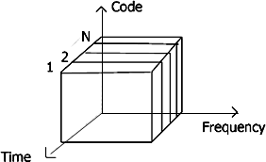
Listening to different frequencies at the same time is quite difficult, but listening to many channels separated in time at the same frequency is simple. Fixed schemes do not need identification, but are not as flexible considering varying bandwidth requirements.

Fixed TDM
The simplest algorithm for using TDM is allocating time slots for channels in a fixed pattern. This results in a fixed bandwidth and is the typical solution for wireless phone systems. MAC is quite simple, as the only crucial factor is accessing the reserved time slot at the right moment. If this synchronization is assured, each mobile station knows its turn and no
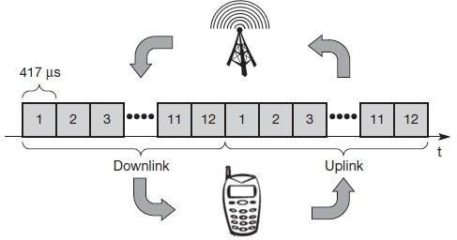
interference will happen. The fixed pattern can be assigned by the base station, where competition between different mobile stations that want to access the medium is solved.The above figure shows how these fixed TDM patterns are used to implement multiple access and a duplex channel between a base station and mobile station. Assigning different slots for uplink and downlink using the same frequency is called time division duplex (TDD). As shown in the figure, the base station uses one out of 12 slots for the downlink, whereas the mobile station uses one out of 12 different slots for the uplink. Uplink and downlink are separated in time. Up to 12 different mobile stations can use the same frequency without interference using this scheme. Each connection is allotted its own up- and downlink pair. This general scheme still wastes a lot of bandwidth. It is too static, too inflexible for data communication. In this case,

connectionless, demand-oriented TDMA schemes can beused

Inhibit sense multiple access
This scheme, which is used for the packet data transmission service Cellular Digital Packet Data (CDPD) in the AMPS mobile phone system, is also known as digital sense multiple access (DSMA). Here, the base station only signals a busy medium via a busy tone (called BUSY/IDLE indicator) on the downlink.
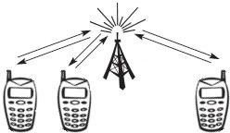
After the busy tone stops, accessing the uplink is not coordinated any further. The base station acknowledges successful transmissions; a mobile station detects a collision only via the missing positive acknowledgement. In case of collisions, additional back-off and retransmission mechanisms are implemented.

CDMA
Code division multiple access systems apply codes with certain characteristics to the transmission to separate different users in code space and to enable access to a shared medium without interference.
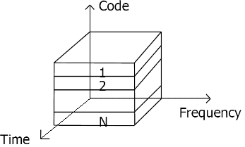
All terminals send on the same frequency probably at the same time and can use the whole
bandwidth of the transmission channel. Each sender has a unique random number, the sender XORs the signal with this random number. The receiver can “tune” into this signal if it knows the pseudo random number, tuning is done via a correlation function
Disadvantages:
- higher complexity of a receiver (receiver cannot just listen into the medium and start receiving if there is a signal)
  - all signals should have the same strength at areceiver Advantages:
- all terminals can use the same frequency, no planning needed
- huge code space (e.g. 232) compared to frequency space
- interferences (e.g. white noise) is not coded

- forward error correction and encryption can be easily integrated

What is CDMA?
Code Division Multiple Access (CDMA) is a digital cellular technology used for mobile communication. CDMA is the base on which access methods such as cdmaOne, CDMA2000, and WCDMA are built. CDMA cellular systems are deemed superior to FDMA and TDMA, which is why CDMA plays a critical role in building efficient, robust, and secure radio communication systems.

Salient Features of CDMA
CDMA, which is based on the spread spectrum technique has following salient features −
- In CDMA, every channel uses the full available spectrum.
- Individual conversations are encoded with a pseudo-random digital sequence and then transmitted using a wide frequency range.
- CDMA consistently provides better capacity for voice and data communications, allowing more subscribers to connect at any given time.
- CDMA is the common platform on which 3G technologies are built. For 3G, CDMA uses 1x EV-DO and EV-DV.
Third Generation Standards
CDMA2000 uses Frequency Division Duplexing-Multicarrier (FDD-MC) mode. Here, multicarrier implies N × 1.25 MHz channels overlaid on N existing IS-95 carriers or deployed on unoccupied spectrum. CDMA2000 includes −
- 1x — uses a spreading rate of 1.2288 Mcps.
- 3x — uses a spreading rate of 3 × 1.2288 Mcps or 3.6864 Mcps.
- 1xEV-DO (1x Evolution – Data Optimized) — uses a spreading rate of 1.2288 Mcps, optimized for the data.
- WCDMA/FDD-DS — Wideband CDMA (WCDMA) Frequency Division Duplexing-Direct Sequence spreading (FDD-DS) mode. This has a single 5 MHz channel. WCDMA uses a single carrier per channel and employs a spreading rate of 3.84 Mcps.

CDMA Development Group (CDG)
The CDMA Development Group (CDG), founded in December 1993, is an international consortium of companies. It works together to lead the growth and evolution of advanced wireless telecommunication systems.
CDG is comprised of service providers, infrastructure manufacturers, device vendors, test equipment vendors, application developers, and content providers. Its members jointly define the technical requirements for the development of complementary systems CDMA2000 and 4G. Further, the interoperability with

other emerging wireless technologies are meant to increase the availability of wireless products and services to consumers and businesses worldwide.

CDMA - Channels
CDMA channels can be broadly categorized as Forward channel and Reverse channel. This chapter explains the functionalities of these channels.

Forward Channel
The Forward channel is the direction of the communication or mobile-to-cell downlink path. It includes the following channels −
- Pilot Channel − Pilot channel is a reference channel. It uses the mobile station to acquire the time and as a phase reference for coherent demodulation. It is continuously transmitted by each base station on each active CDMA frequency. And, each mobile station tracks this signal continuously.
- Sync Channel − Synchronization channel carries a single, repeating message, which gives the information about the time and system configuration to the mobile station. Likewise, the mobile station can have the exact system time by the means of synchronizing to the short code.
- Paging Channel − Paging Channel’s main objective is to send out pages, that is, notifications of incoming calls, to the mobile stations. The base station uses these pages to transmit system overhead information and mobile station specific messages.
- Forward Traffic Channel − Forward Traffic Channels are code channels. It is used to assign calls, usually voice and signaling traffic to the individual users.

Reverse Channel
The Reverse channel is the mobile-to-cell direction of communication or the uplink path. It consists of the following channels −
- Access Channel − Access channel is used by mobile stations to establish a communication with the base station or to answer Paging Channel messages. The access channel is used for short signaling message exchanges such as call-ups, responses to pages and registrations.
- Reverse Traffic Channel − Reverse traffic channel is used by the individual users in their actual calls to transmit traffic from a single mobile station to one or more base stations.

Multiple Access Methods
The possibility to operate in either FDD or TDD mode is allowed for efficient use of available spectrum according to frequency allocation in different regions.

Frequency Division Duplex
A duplex method whereby the Uplink and the Downlink transmissions use two separate frequency bands −

- Uplink − 1920 MHz to 1980 MHz
- Downlink − 2110 MHz to 2170 MHz
- Bandwidth − Each carrier is located on the center of a 5 MHz wide band

Channel Separation
Nominal value of 5 MHz that can be adjusted.

Channel Raster
200 kHz (center frequency must be a multiple of 200 kHz).

Tx-Rx Frequency Separation
Nominal value of 190 MHz. This value can be either fixed or variable (minimum of 134.8 and maximum of 245.2 MHz).

Channel Number
The carrier frequency is designated by the UTRA Absolute Radio Frequency Channel Number (UARFCN). This number is sent by the network (for the uplink and downlink) on the BCCH logical channel and is defined by Nu = 5 * (Frequency uplink MHz) and ND = 5 * (Frequency downlink MHz).

Time Division Duplex
Time division duplex is a technique by which the Uplink and the Downlink transmissions are carried over the same frequency by using synchronized time intervals. The carrier uses a 5 MHz band, although there is a low chip rate solution under study by the 3GPP (1.28 Mcps). The available frequency bands for TDD will be 1900–1920 MHz and 2010 – 2025 MHz.

Duplex Methods of Radio Links

In case of Time Division Duplex, the forward link frequency is same as the reverse link frequency. In each link, signals are transmitted continuously in turns
– just like a ping-pong game.

Example of TDD System
TDD uses a single frequency band for both to transmit and to receive. Further, it shares the band by assigning alternate timeslots for transmitting and receiving operations. The information to be transmitted can be voice, video, or computer data in bit-serial format. Each time interval can be 1 byte long or may be a part of several bytes.
TDD alternates the transmission and reception station data over time. Timeslots can be of variable length. Due to the nature of high-speed data, the communicating parties cannot mean that the transmissions are intermittent.

Transmissions that appear as simultaneous are actually competing each other. Digitally converted into analog voice, no one can say that it is not a full duplex.

In some TDD systems, alternative time intervals are of same duration or having both DL and UL; however, the system does not need to be symmetric 50/50. The system may be asymmetrical as required.
For example, while accessing the Internet, the download speed is usually higher than the upload speed. Most of the equipment work on asynchronous mode where the download speed is higher than the upload speed. When the download speed is higher than the upload speed, less timeslots are needed for uploading. Some TDD formats offer dynamic bandwidth allocation when the number of time intervals or durations is changed on the fly as needed.
The real advantage of TDD is that it is only a single channel of the frequency spectrum and it doesn’t require band guards or channel separations as the intervals take place using timeslots. The disadvantage is that the successful implementation of TDD requires a timing system. The precise timing to both the transmitter and the receiver is needed to ensure that the time intervals do not overlap or interfere with another.
Timing is often synchronized to GPS atomic clock standards specific derivative. The guard time is also needed between timeslots to avoid duplication. This time is generally equal to the transmission-reception processing time (transmission- reception switching time) and the transmission delays (latency) on the communications channel.

Frequency Division Duplex
In Frequency Division Duplex (FDD), the forward link frequency is not the same as the reverse link frequency. In each link, signals are continuously transmitted in parallel.

Example of FDD System
FDD requires two symmetrical segments of spectrum for the uplink and downlink channels.
In a cell phone with a transmitter and receiver, operating simultaneously in such close proximity, the receiver has to filter as much of the signal from the transmitter as possible. More separation of the spectrum, the most effective filters.

FDD uses a lot of frequency spectrum, generally twice of the required TDD spectrum. In addition, there must be adequate spectrum separation between transmission and reception of the channels. These bands keep saying − it cannot

be used, they are unnecessary. Given the scarcity and cost of the spectrum, they are real disadvantages.

Use of FDD
FDD is widely used in different cellular telephone systems. In some systems, the band 869-894 MHz is used as the downlink (DL) spectrum from the cell site tower to the device. And, the band 824-849 MHz is used as the uplink (UL) spectrum of the handset at the cell site.
FDD also works on a cable where transmit and receive channels are given different parts of the cable spectrum, as in cable TV systems. And, filters are used to keep the channels separate.

Disadvantage of FDD
The drawback of FDD is that it does not allow special techniques like multiple antennas, multiple input-output (MIMO), and beamforming. These technologies are an essential element of the new strategies Long Term Evolution (LTE) 4G cell phone to increase the data rate. It is difficult to make broad enough bandwidth to cover both sets of antenna spectrum. Circuit complex dynamic adjustment is required.

Multiple Access Methods
The radio channel is a communication medium shared by several users in a geographic area. Mobile stations are in competition with one another for the frequency resource to transmit their information flow. Without other measures to control concurrent access of several users, collisions can occur. Since collisions are undesirable for connectionoriented communication such as mobile phones, personal/mobile subscriber stations need to be allocated the dedicated channels on request.

The mobile communication, sharing wireless resources on all users, must be communicated to identify the user. While identifying the user, it is referred to as "multiple access" (Multiple Access) that is receiving a radio wave of a number of transmitting stations in a receiving station (as shown in the following image).

FDMA – Technology
Frequency Division Multiple Access (FDMA) is one of the most common analogue multiple access methods. The frequency band is divided into channels of equal bandwidth so that each conversation is carried on a different frequency (as shown in the figure below).

FDMA Overview

In FDMA method, guard bands are used between the adjacent signal spectra to minimize crosstalk between the channels. A specific frequency band is given to one person, and it will received by identifying each of the frequency on the receiving end. It is often used in the first generation of analog mobile phone.

Advantages of FDMA
As FDMA systems use low bit rates (large symbol time) compared to average delay spread, it offers the following advantages −
- Reduces the bit rate information and the use of efficient numerical codes increases the capacity.
- It reduces the cost and lowers the inter symbol interference (ISI)
- Equalization is not necessary.
- An FDMA system can be easily implemented. A system can be configured so that the improvements in terms of speech encoder and bit rate reduction may be easily incorporated.
- Since the transmission is continuous, less number of bits are required for synchronization and framing.

Disadvantages of FDMA
Although FDMA offers several advantages, it has a few drawbacks as well, which are listed below −
- It does not differ significantly from analog systems; improving the capacity depends on the signal-to-interference reduction, or a signal-to-noise ratio (SNR).
- The maximum flow rate per channel is fixed and small.
- Guard bands lead to a waste of capacity.
- Hardware implies narrowband filters, which cannot be realized in VLSI and therefore increases the cost.

TDMA – Technology
Time Division Multiple Access (TDMA) is a digital cellular telephone communication technology. It facilitates many users to share the same frequency without interference. Its technology divides a signal into different timeslots, and increases the data carrying capacity.

TDMA Overview
Time Division Multiple Access (TDMA) is a complex technology, because it requires an accurate synchronization between the transmitter and the receiver. TDMA is used in digital mobile radio systems. The individual mobile stations cyclically assign a frequency for the exclusive use of a time interval.
In most of the cases, the entire system bandwidth for an interval of time is not assigned to a station. However, the frequency of the system is divided into sub- bands, and TDMA is used for the multiple access in each sub-band. Sub-bands

are known as carrier frequencies. The mobile system that uses this technique is referred as the multi-carrier systems.
In the following example, the frequency band has been shared by three users. Each user is assigned definite timeslots to send and receive data. In this example, user ‘B’ sends after user ‘A,’ and user ‘C’ sends thereafter. In this way, the peak power becomes a problem and larger by the burst communication.

FDMA and TDMA
This is a multi-carrier TDMA system. A 25 MHz frequency range holds 124 single chains (carrier frequencies 200) bandwidth of each kHz; each of these frequency channels contains 8 TDMA conversation channels. Thus, the sequence of timeslots and frequencies assigned to a mobile station is the physical channels of a TDMA system. In each timeslot, the mobile station transmits a data packet.
The period of time assigned to a timeslot for a mobile station also determines the number of TDMA channels on a carrier frequency. The period of timeslots are combined in a so-called TDMA frame. TDMA signal transmitted on a carrier frequency usually requires more bandwidth than FDMA signal. Due to the use of multiple times, the gross data rate should be even higher.

Advantages of TDMA
Here is a list of few notable advantages of TDMA −
- Permits flexible rates (i.e. several slots can be assigned to a user, for example, each time interval translates 32Kbps, a user is assigned two 64 Kbps slots per frame).
- Can withstand gusty or variable bit rate traffic. Number of slots allocated to a user can be changed frame by frame (for example, two slots in the frame 1, three slots in the frame 2, one slot in the frame 3, frame 0 of the notches 4, etc.).
- No guard band required for the wideband system.
- No narrowband filter required for the wideband system.

Disadvantages of TDMA
The disadvantages of TDMA are as follow −
- High data rates of broadband systems require complex equalization.
- Due to the burst mode, a large number of additional bits are required for synchronization and supervision.
- Call time is needed in each slot to accommodate time to inaccuracies (due to clock instability).
- Electronics operating at high bit rates increase energy consumption.
- Complex signal processing is required to synchronize within short slots.

Comparison of FDMA, CDMA and IDMA
In the desirable radio frequencies occupied by Public Safety and Utilities organizations, there is only so much radio spectrum to share between everyone who wants to use it.

Traditionally, analog radio modulation methods such as AM and FM limited the amount of information conveyed within a given channel, and each channel could only host a single conversation at any one time -a pair of users, one transmitting and one receiving.

Analog modulation (AM) places a very finite limit on the number of users that can occupy the radio spectrum, and does not cater well to today’s expanding needs.

Digital radio, using various modulation schemes, is moving to alleviate this problem by increasing the amount of information that can be conveyed on a channel.

Digital radio has developed ways in which more than one conversation can be accommodated (multiplexed) inside the same physical RF channel. There are three common ways of achieving this:

- Frequency Division Multiple Access (FDMA)
- Time Division Multiple Access (TDMA)
- Code Divisional Multiple Access (CDMA)

- FREQUENCY DIVISION MULTIPLE ACCESS (FDMA)
The RF (radio frequency) channel is split into several smaller sub-channels. For example, one 12.5kHz wide narrowband FM channel that previously carried only one conversation becomes two 6.25kHz sub-channels, each capable of carrying a separate conversation.

This technique has been around for decades and is used with either analog or digital radios. A ‘telephone style conversation’ can be set up if one sub-channel is used to transmit and one to receive.

The drawback of this is the more sub-channels you try to fit in to the original channel, the more likely that the users will suffer interference on the call. This is because the reduced channel spacing makes it harder to filter only the intended sub-channel and reject all the others at the receiver.

Consequently, dividing a single narrowband 12.5kHz channel frequency into more than two sub-channels becomes impractical.

- TIME DIVISION MULTIPLE ACCESS (TDMA)
Instead of splitting the original RF channel in to two RF sub-channels, it is instead split into timeslots. The transmitted RF frequency is identical in each slot, but each slot is still capable of carrying a separate conversation.

In the diagram, the channel is split in to four time slots, so in each slot the speech is transmitted in a quarter of the time taken to say it.

This speech compression is possible using digital technology, but eventually practical near/far limits* are encountered that limit how many slots can be accommodated in a single RF channel before neighboring slots begin to overlap at the Base Station.

Again, a ‘telephone-style conversation’ can be set up, if certain slots are used for transmit and others for receive.

- CODE DIVISIONAL MULTIPLE ACCESS (CDMA)
Instead of splitting the RF channel in to sub-channels or time slots, each slot has a unique code. Unlike FDMA, the transmitted RF frequency is the same in each slot, and unlike TDMA, the slots are transmitted simultaneously. In the diagram, the channel is split in to four code slots.

Each slot is still capable of carrying a separate conversation because the receiver only reconstructs information sent from a transmitter with the same code.
However this does create a problem, as transmissions on the same frequency with different codes are still received and decoded but simply re-appear as noise. This means the greater the number of users, the higher the noise level on the system, which of course can affect coverage.

Near/far issues also require dynamic power control in CDMA systems to make sure all signals arrive at the Base Station at roughly the same level to ensure that signals from distant transmitters are not lost.

Unit 3
Introduction to ANDROID
Introduction:
Android is a Linux based operating system it is designed primarily for touch screen mobile devices such as smart phones and tablet computers. The operating system have developed a lot in last 15 years starting from black and white phones to recent smart phones or mini computers. One of the most widely used mobile OS these days is android. The android is software that was founded in Palo Alto of California in 2003.

The android is a powerful operating system and it supports large number of applications in Smartphones. These applications are more comfortable and advanced for the users. The hardware that supports android software is based on ARM architecture platform. The android is an open source operating system means that it’s free and any one can use it. The android has got millions of apps available that can help you managing your life one or other way and it is available low cost in market at that reasons android is very popular.
The android development supports with the full java programming language. Even other packages that are API and JSE are not supported. The first version 1.0 of android development kit (SDK) was released in 2008 and latest updated version is jelly bean.

Android Architecture:
The android is a operating system and is a stack of software components which is divided into five sections and four main layers that is

- Linux kernel
- Libraries
- Android runtime Application frame work:

The following diagram shows the architecture of Android,
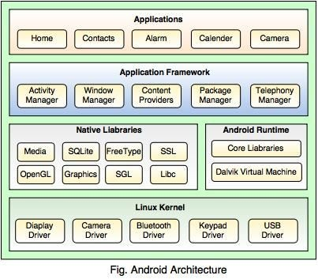
Linux kernel: The android uses the powerful Linux kernel and it supports wide range

of hardware drivers. The kernel is the heart of the operating system that manages input and output requests from software. This provides basic system functionalities like process management, memory management, device management like camera, keypad, display etc the kernel handles all the things. The Linux is really good at networking and it is not necessary to interface it to the peripheral hardware. The kernel itself does not interact directly with the user but rather interacts with the shell and other programs as well as with the hard ware devices on the system.
Libraries:The on top of a Linux kennel there is a set of libraries including open source web browser such as webkit, library libc. These libraries are used to play and record audio and video. The SQLite is a data base which is useful for storage and sharing of application data. The SSL libraries are responsible for internet security etc.
Android Runtime: The android runtime provides a key component called Dalvik Virtual Machine which is a kind of java virtual machine. It is specially designed and optimized for android. The Dalvik VM is the process virtual machine in the android operating system. It is a software that runs apps on android devices.
The Dalvik VM makes use of Linux core features like memory management and multithreading which is in a java language. The Dalvik VM enables every android application to run it own process. The Dalvik VM executes the files in the .dex format.
Application frame work: The application frame work layer provides many higher level services to applications such as windows manager, view system, package manager, resource manager etc. The application developers are allowed to make use of these services in their application.
Applications and Features: You will find all the android applications at the top layer and you will write your application and install on this layer. Example of such applications are contacts, books, browsers, services etc. Each application perform a different role in the over all applications.
Features:

- Head set layout
- Storage
- Connectivity: GSM/EDGE, IDEN, CDMA, Bluetooth, WI-FI, EDGE,3G,NFC, LTE,GPS.
- Messaging: SMS, MMS, C2DM (could to device messaging), GCM (Google could messaging)
- Multilanguage support
- Multi touch
- Video calling
- Screen capture
- External storage
- Streaming media support
- Optimized graphics Android Emulator:

The Emulator is a new application in android operating system. The emulator is a new prototype that is used to develop and test android applications without using any physical device.

Application of Android- Android Application Controlled Remote Robot
Operation:
It controls the robotic vehicle using an android application. The Bluetooth device is interfaced to control unit on the robot for sensing the signals transmitted by the android application. The remote operation is achieved by any smart-phone or table etc with android OS based on touch screen operation. The transmitting end uses an android application device remote through which commands are transmitted and at the receiver side , these commands are used for controlling the robot in all directions such as forward
,backward and left or right etc.
The receiver end movement is achieved by two motors that are interfaced to the microcontroller. The serial communication data sent from the android application is received by a Bluetooth receiver that is interfaced to the microcontroller.
Advantages:

- Android is Linux based open source operating system , it can be developed by any one
- Easy access to the android apps
- You can replace the battery and mass storage, disk drive and UDB option
- Its supports all Google services
- The operating system is able to inform you of a new SMS and Emails or latest updates.
- It supports Multitasking
- Android phone can also function as a router to share internet
- Its free to customize
- Can install a modified ROM
- Its supports 2D and 3D graphics

Installing SDK
- Download and install the Android SDK : SDK includes documentation, tools and examples
- Set up your IDE; Eclipse (Java EE) recommended
- Install Eclipse Android Development Tools (ADT) plugin, connect it with the Android SDK and Download your Platforms
- Create an Android project
- Standard Eclipse procedure
- Automatically creates folders and a Manifest file
- Can also be used to create a demo project

- Set up a launch configuration
- Run application from menu or
- Define settings for run configuration (project, activity, emulator options, …) from Run > Open Run Dialog >
- Run Android application in emulator
- Be Patient! The emulator takes while to boot up
- Keep it open once it was started!
Activity
- Single, focused thing or task
- Extends the Activity base class
- Refers to a single screen in a (multi-screen) application
- Displays a UI, interacts with user, responds to events
- 2 main methods: • onCreate(Bundle): initialization of activity, set UI, …
- onPause(): leaving an activity
- Moving through screens by starting other activities
- Activities managed by activity stack
- New activity put on top of the stack
- 4 states: active/running, paused, stopped, killed/shut down
Intents and Intent Filters
- Intent
- Abstract description of an operation/action to be performed
- Mostly used for launching activities; “glue between activities”
- Action: general action to be performed, e.g. VIEW_ACTION, EDIT_ACTION, MAIN_ACTION,
…
- Data: data to operate on, expressed as a URI
- Example: VIEW_ACTION content://contacts/1

- Intent Filter
- Describes what Intents an activity can handle
- Activities publish Intent Filters describing their capabilities/ how they can handle certain Intents and their actions
- Navigating between screens is accomplished by resolving Intents => system matches Intents and Intent Filters
- Activity calls method startActivity(myIntent)

Intent Receiver, Service, Content Provider
- Intent Receiver
- Used to execute code upon an external event, e.g. phone rings
- Usually no UI; may use the NotificationManager

- Service
- Application component running in the background
- Runs indefinitely, no UI, no interaction with user
- E.g. media player
- Content Provider
- Used to share data with other applications

Life Cycle of an Android Application
- Each Android application runs in its own Linux process
- Process’s lifetime not directly controlled by application
- Determined by the system, depending on running applications, their importance, available memory
- Components (Activity, Service, Intent Receiver) impact the lifetime of the application’s process
- Importance hierarchy for killing processes based on
- Components running in them
- The state of these components

Android’s Importance Hierarchy
- Foreground Process
  - Required for current user activities
  - E.g. running an Activity at the top of the screen
- Visible Process
  - Activity is visible but not in the foreground (onPause())
  - E.g. previous activity displayed behind a foreground dialog
- Service Process
  - Holds a Service, not directly visible (e.g. media player, network up/download)
- Background Process
  - Holds an Activity that is currently not visible (onStop())
  - Can be killed at any time to reclaim memory
- Empty Process
  - Holds no active application components

Unit 4
Views

Android UI Controls (Textview, EditText, Radio Button, Checkbox)

In android ui or input controls are the interactive or View components which are used to design the user interface of an application. In android we have a wide variety of UI or input controls available, those are TextView, EditText, Buttons, Checkbox, Progressbar, Spinners, etc.

Following is the pictorial representation of user interface (UI) or input controls in android application.
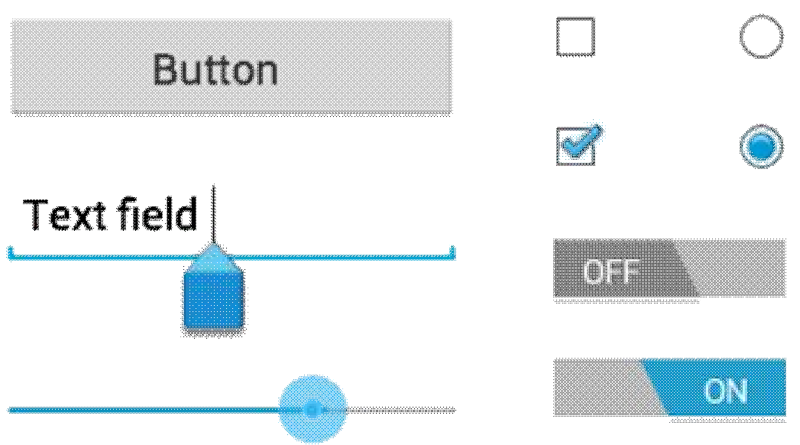

Generally, in android the user interface of an app is made with a collection of View and ViewGroup objects.

The View is a base class for all UI components in android and it is used to create an interactive UI components such as TextView, EditText, Checkbox, Radio Button, etc. and it responsible for event handling and drawing. Types of Views:

- Basic Views – commonly-used views such as TextView, EditText, and Button views
- Picker Views – views that allows users to select from, such as the TimePicker and DatePicker views
- List Views – views that display a long list of items, such as the ListView and the Spinner views
- Display Views – views that display images, such as the Gallery and ImageSwitcher views
- Menus – views that displays additional and context sensitive menu items
- Additional Views – interesting views such as the AnalogClock and DigitalClock views

The ViewGroup is a subclass of View and it will act as a base class for layouts and layout parameters. The ViewGroup will provide an invisible containers to hold other Views or ViewGroups and to define the layout properties.

Basic Views

The basic views in Android that allow you to display text information as well as perform some basic selection. Here, you will learn about the following views:

- TextView
- EditText
- Button
- ImageButton
- CheckBox
- ToggleButton
- RadioButton
- RadioGroup

TextView View
When you create a new Android project, Eclipse always creates the main.xml file (located in the res/layout folder) containing a <TextView> element:

The TextView view is used to display text to the user. This is the most basic view that you will definitely come across when you develop Android applications. If you need to allow users to edit the text displayed, you should use the subclass of TextView – EditText, which is discussed in the next section.
Button, ImageButton, EditText, CheckBox, ToggleButton, RadioButton, and RadioGroup Views
Besides the TextView view, which you will come across the most often, there are some other basic controls that you will find yourself using very often. They
are: Button, ImageButton, EditText, CheckBox, ToggleButton, RadioButton, and RadioGroup.
First, add a new file to the res/layout folder and name it as basicviews.xml. Populate it with the following elements:

Note that you use the id attribute to identify each view. The id of a view must start with the “@+id/” specifier followed by the name of the view. The above XML file contains the following views:

- Button – represents a push-button widget
- ImageButton – similar to the Button view, except that it also displays an image
- EditText – a subclass of the TextView view, except that it allows users to edit its text content
- CheckBox – a special type of button that has two states – checked or unchecked
- RadioGroup and RadioButton – the RadioButton has two states – either checked or unchecked. Once a RadioButton is checked, it cannot be unchecked. A RadioGroup is used to group together one or more RadioButton views, thereby allowing only one RadioButton to be checked within the RadioGroup
- ToggleButton – displays checked/unchecked states using a light indicator

Figure 2 shows how the various views will look like in their various states. In particular, the right side of the figure shows the CheckBox, RadioButton, and ToggleButton views in their checked state.

To handle the various common events associated with the various views, add a new class to the src/net.learn2develop.AndroidViews folder and name it as BasicViewsExample.java.

In particular, the above program displays a message (using the Toast class) when the various controls are clicked.
Add the following lines in bold to the AndroidManifest.xml file to register the new BasicViewsExample activity:

To display the BasicViewsExample activity, insert the following statements in bold in the ViewsActivity.java file:

To test the application, press F11 to debug the application on the Android emulator. Figure 3 shows the message displayed when the ToggleButton is clicked.

For the EditText view, you can also set it to accept passwords by replacing each character with a “.”. This is done using the password attribute:

- <EditText android:id="@+id/txtName"
- android:layout_width="fill_parent"
- android:layout_height="wrap_content"
- android:password = "true"
5 />

Figure 4 shows that when you enter a string of text into the view, the character you enter always appears first and then changes into a “.” when you enter the next character (or after one second if you do nothing).

ProgressBar View
The ProgressBar view provides visual feedback of some background tasks. For example, you might be downloading some data from the web and need to update the user of the status of the download. In this case, the ProgressBar view is a good choice for this task.
Using the same activity created in the previous section, insert the following element in the basicviews.xml file:

The default mode of the ProgressBar view is indeterminate – that is, it shows a cyclic animation. This mode is useful for tasks that do not have a clear indication of when they will be completed. For example, you are sending some data to a web service and waiting for the server to respond. The following code shows how you can spin off a background thread to simulate performing some long lasting tasks. When the task is completed, you hide the ProgressBar view by setting its Visibility property to GONE (value 8).

The difference between the INVISIBLE and GONE constants is that the INVISIBLE constant simply hides the ProgressBar view. The GONE constant removes the ProgressBar view from the activity and does not take up any space on the activity. The left of Figure 5 shows the ProgressBar view in action. When the background task is completed, the space taken by the view is given up when you set its Visibility property to GONE.

If you do not want to display the ProgressBar view in indeterminate mode, you can modify it to display as a horizontal bar. The following style attribute specifies the ProgressBar view to be displayed as a horizontal bar:

- <ProgressBar android:id="@+id/progressbar"
- android:layout_width="wrap_content"
- android:layout_height="wrap_content"
- style="?android:attr/progressBarStyleHorizontal" 5 />

AutoCompleteTextView View
The AutoCompleteTextView view is a view that is similar to the EditText view (in fact it is a subclass of the EditText view), except that it shows a list of completion suggestions automatically while the user is typing.
Add a new file to the res/layout folder and name it as autocomplete.xml and populate it with the following elements:

- <?xml version="1.0" encoding="utf-8"?>
- <LinearLayout xmlns:android="http://schemas.android.com/apk/res/android"
- android:orientation="vertical"
- android:layout_width="fill_parent"
- android:layout_height="fill_parent"
6 >
- <AutoCompleteTextView android:id="@+id/txtCountries"
- android:layout_width="fill_parent"
- android:layout_height="wrap_content"
10 />
11 </LinearLayout>

Add a new file to the src/net.learn2develop.AndroidViews folder and name it as AutoCompleteExample.java. Populate it as follows:

Note that the list of suggestions is obtained from an ArrayAdapter object.
The setThreshold() method sets the number of minimum number of characters the user must type before the suggestions appear as a drop-down menu.

Add the following lines in bold to the AndroidManifest.xml file to register the new AutoCompleteExample activity:

Android Different Types of UI Controls
We have a different type of UI controls available in android to implement user interface for our android applications.

Following are the commonly used UI or input controls in android applications.

- TextView
- EditText
- AutoCompleteTextView
- Button
- ImageButton
- ToggleButton
- CheckBox
- RadioButton
- RadioGroup
- ProgressBar
- Spinner
- TimePicker
- DatePicker
- SeekBar
- AlertDialog
- Switch
- RatingBar

Android TextView
In android, TextView is a user interface control which is used to display the text to the user. To know more about TextView control check this, Android TextView with Examples.

Android EditText
In android, EditText is a user interface control which is used to allow the user to enter or modify the text.

To know more about EditText, check this Android EditText with Examples.

Android AutoCompleteTextView
In android, AutoCompleteTextView is an editable text view which is used to show the list of suggestions based on the user typing text. The list of suggestions will be shown as a dropdown menu from which the user can choose an item to replace the content of textbox.

To know more about AutoCompleteTextView, check this Android AutoCompleteTextView with Examples.

Android Button
In android, Button is a user interface control which is used to perform an action when the user click or tap on it.

To know more about Button in android check this, Android Buttons with Examples.

Android Image Button
In android, Image Button is a user interface control which is used to display a button with image to perform an action when user click or tap on it.
Generally, the Image button in android looks similar as regular Button and perform the actions same as regular button but only difference is for image button we will add an image instead of text.

To know more about Image Button in android check this, Android Image Button with Examples.

Android Toggle Button
In android, Toggle Button is a user interface control which is used to display ON (Checked) or OFF (Unchecked) states as a button with a light indicator.
To know more about Toggle Button in android check this, Android Toggle Button with Examples.

Android CheckBox
In android, Checkbox is a two states button that can be either checked or unchecked.

To know more about CheckBox in android check this, Android CheckBox with Examples.

Android Radio Button
In android, Radio Button is a two states button that can be either checked or unchecked and it cannot be unchecked once it is checked.

To know more about Radio Button in android check this, Android Radio Button with Examples.

Android Radio Group

In android, Radio Group is used to group one or more radio buttons into separate groups based on our requirements.

In case if we group radio buttons using radio group, at a time only one item can be selected from the group of radio buttons.

To know more about Radio Group in android check this, Android Radio Group with Examples.

Android ProgressBar
In android, ProgressBar is a user interface control which is used to indicate the progress of an operation.

To know more about ProgressBar, check this Android ProgressBar with Examples.

Android Spinner
In android, Spinner is a drop-down list which allows a user to select one value from the list. To know more about Spinner, check this Android Spinner with Examples.

Android TimePicker
In android, TimePicker is a widget for selecting the time of day, either in 24-hour or AM/PM mode. To know more about TimePicker, check this, Android TimePicker with Examples.

Android DatePicker
In android, DatePicker is a widget for selecting a date.

Unit 5
Location Based Service and SQLite

Introduction
The number of smartphones shipped worldwide has passed the number of PCs and servers shipped in 2011 and the gap between them is expected to keep bigger. The emerging smartphones have created many kinds of applications that are not possible or inconvenient for PCs and servers, even notebooks. One of the best-seller applications is location-based services (LBS) according to the following market research:
- Fleishman Hillard (2012, February 6) reports 80% of smartphone owners have location- based services and half of them use services that provide offers, promotions, and sales based on their current locations.
- The most convenient mobile shopping experience is price comparison and product research according to JiWire (2011, October 14).
- The number of location-based services users was increased from 12.3 million in 2009 to 33.2 million in 2010 (170% increase) in the US based on SNL Kagan (Cohen, 2011, January 20).
Location-based services are popular, but the details of their design and implementation are still not known for most people. This paper tries to relieve the problem by explaining the LBS design and implementation from a developer perspective. It divides the LBS system into five components: (i) mobile handheld devices, (ii) positioning system, (iii) mobile and wireless networks, (iv) service providers, and (v) geographical data providers. Subjects closely related to LBS including LBS architecture, handheld computing, Android application development, and embedded database SQLite will be detailed in this paper too.

The rest of this paper is organized as follows. Section 2 gives a generic LBS architecture and an LBS example showing how an LBS works. Handheld computing including a generic system structure of mobile handheld devices and client-side handheld computing is introduced in Section 3. Android application development is explained via an example in Section 4. The example includes several XML and Java files and the Eclipse IDE (Integrated Development Environment) with Android plugin and Android DDMS (Dalvik Debug Monitor Server) are introduced in this section too. An LBS requires the support from geographical data providers, which are normally a third party and charge users for their services. This study uses an embedded database SQLite for providing geographical data to small LBS projects. Section 5 introduces the embeddable database SQLite. The final section summarizes this study and gives possible LBS projects.

Location-Based Services (LBS)
This section introduces location-based services including a generic LBS architecture and an LBS example.

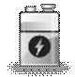
An LBS Architecture
A location-based service is a service based on the geographical position of a mobile handheld device (Kupper, 2005; Kolodziej & Hjelm, 2006). Two of the LBS examples are
  - finding a nearby ethnic restaurants and (ii) locating a nearby store with the best price of a product. A system structure of location-based services, shown in Figure 1, includes five major components (Steiniger, Neun, & Edwardes, 2006):
- Mobile handheld devices, which are small computers that can be held in one hand. For most cases, they are smartphones.
- Positioning system, which is a navigation satellite system that provides location and time information to anyone with a receiver.
- Mobile and wireless networks, which relay the query and location information from devices to service providers and send the results from the providers to devices.
- Service providers, which provide the location-based services.
- Geographical data providers, which are databases storing a huge amount of geographical data such as information about restaurants and gas stations.

- Handheld Computing
Handheld computing is the use of handheld devices like smart cellular phones to perform wireless, mobile, handheld operations such as browsing the mobile Web and finding the nearest gas stations. It is an essential part of location-based services. This section discusses two handheld computing subjects: mobile handheld devices and client-side handheld computing.

Mobile Handheld Devices
Mobile users interact with mobile commerce applications by using small wireless Internet- enabled devices, which come with several aliases such as handhelds, palms, PDAs, pocket PCs, and smart phones. To avoid any ambiguity, a general term, mobile handheld devices, is used in this article. Mobile handheld devices are small general- purpose, programmable, battery-powered computers, but they are different from desktop PCs or notebooks due to the following special features:
- limited network bandwidth,
- small screen/body size, and
- Mobility.
Data

Instruction
I/O
Syste m
Memory bus
Memory
I/O bridge
Mobile CPU
Wireless adapter
I/O devices

Batteries

Embedded database
Mobile OS
Microbrowser

Figure 2: System Structure of Mobile Handheld Devices.

Short battery life and limited memory, processing power, and functionality are additional features, but these problems are gradually being solved as the technologies improve and new methods are constantly being introduced. The limited network bandwidth prevents the display of most multimedia on a microbrowser. Though the Wi-Fi and 3G networks go some way toward addressing this problem, the wireless bandwidth is always far below the bandwidth of wired networks. The small screen/body size restricts most handheld devices to using a stylus for input. Figure 2 shows a typical system structure for handheld devices, which includes the following six major components (Hu, Wiggen, & Yang, 2005):
- Mobile operating systems: Simply adapting desktop operating systems for handheld devices has proved to be futile. A mobile operating system needs a completely new architecture and different features to provide adequate services for handheld devices. A generalized mobile operating system structure can be visualized as a six-layer stack: (i) applications, (ii) GUI, (iii) API framework, (iv) multimedia, communication infrastructure, and security, (v) computer kernel, power management, and real-time kernel, and (vi) hardware controller.
- Mobile central processing units: Handheld devices are becoming more sophisticated and efficient every day and mobile users are demanding more functionality from their devices. To achieve this advanced functionality, in addition to the obvious feature, low cost, today’s mobile processors must have the following features: (i) high performance, (ii) low power consumption, (iii) multimedia capability, and (iv) real-time capability. The cores and architectures designed by Cambridge-based ARM Holdings Ltd. have begun to dominate the mobile CPU market.
- Microbrowsers: Microbrowsers are miniaturized versions of desktop browsers such as Netscape Navigator and Microsoft Internet Explorer. They provide graphical user interfaces that allow mobile users to interact with mobile commerce applications. Microbrowsers usually use one of the following four approaches to return results to the mobile user: (i) wireless language direct access, (ii) HTML direct access, (iii) HTML to wireless language conversion, and (iv) error.
- Input/output components: Various I/O devices have been adopted by mobile handheld devices. The only major output device is the screen, but there are several popular input devices, among them: (i) keyboards and (ii) touch screens/writing areas that need a stylus.Memory: Three types of memory are usually employed by handheld devices: (i) RAM, (ii) ROM, and (iii) flash memory. Hard disks, which provide much more storage capacity, are likely to be adopted by handheld devices in the near future.
- Batteries: At present, rechargeable Lithium Ion batteries are the most common batteries used by handheld devices. However, the life of this kind of battery is short and the technology will not significantly improve unless and until manufacturers begin to switch to fuel cells, which may not happen for at least several years.
Synchronization connects handheld devices to desktop computers, notebooks, or peripherals to transfer or synchronize data. Without needing serial cables, many handheld devices now use either an infrared (IR) port or Bluetooth technology to send information to other devices.

Client-Side Handheld Computing
Client-side handheld computing is the programming for handheld devices and it does not need the supports from server-side programs. Typical applications created by it include
  - address books, (ii) video games, (iii) note pads, and (iv) to-do list. Various environments/operating systems/languages are available for client-side handheld programming.

Android Application Development
Android (N.D.) is a software stack for mobile devices such as smartphones and tablet PCs. It was developed by the Open Handset Alliance, a consortium of 80 hardware, software, and telecommunication companies led by Google devoted to advancing open standards for mobile devices. Google purchased the initial developer of the software, Android Inc., in 2005. Android includes an operating system, middleware, and key applications. The Android SDK (Software Development Kit) provides the tools and APIs necessary for developing applications on the Android platform using the Java programming language. Google released most of the Android code under the Apache License, a free software license. Android is tightly integrated with Google Maps, which provides a powerful tool for location-based services.

A Simple Android Example
This application is based on the default template when you create an Android project. It has two different screens and is able to move one screen to another screen. Figure 4 shows the result screenshots. Two activities/pages are included in this application:
- HelloWorldActivity.java, which is the startup page and
- NextPageActivity.java, which is the other page.
Other than the text, each of the pages contains a button, which is used to display the other page. The following five components of this app will be detailed next:
- Android manifest file (AndroidManifest.xml),
- Layout XML code (main.xmland next.xml),
- Strings (strings.xml),
- The R file (R.java), and
- Java source code (HelloWorldActivity.javaand
NextPageActivity.java).

Eclipse IDE with Android Plugin
Eclipse (N.D.) is a software development environment for multiple programming languages including Ada, C, C++, COBOL, Java, Perl, PHP, Python, R, Ruby, etc. It comprises an integrated development environment (IDE) and an extensible plug-in system. Android Development Tools (ADT) is a plugin for the Eclipse IDE, which gives developers an integrated environment for building Android applications. Figure 5 shows a

screenshot of the Eclipse IDE with Android plugin, which provides the functionality of a well-established IDE, along with Android-specific features that are bundled with ADT. It allows developers to perform various tasks such as (i) setting up Android projects, (ii) creating an application user interface, (iii) adding components based on the Android Framework API (Application Programming Interface), (iv) debugging applications using the Android SDK (Software Development Kit) tools, and (v) exporting .apk files in order to post your application.

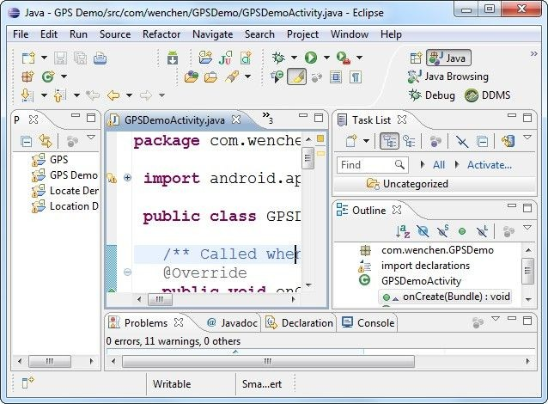Menu Bar

Standard Toolbar
Change Perspective: DDMS, Java, debug, …

Project Navigator: Project list

Editing Area

Task List

Outline: Structure of the selected file

Output Area: Properties, results, error messages, …

Status Bar
Figure 5: A Screenshot of the Eclipse IDE with Android Plugin.

Android Manifest File
The main missions of the manifest file are to explain what the application consists of, what its major building blocks are, what permissions it requires, etc. It must declare all activities, services, broadcast receivers, and content provider of the application. For example, if the application wants to access the Internet, it must define in this file that it would like to use the related permission.

<?xml version="1.0" encoding="utf-8"?>
<manifest xmlns:android="http://schemas.android.com/apk/res/android" package="com.example.HelloWorld"
android:versionCode="1" android:versionName="1.0">
<uses-sdk android:minSdkVersion="8" />
<application android:icon="@drawable/icon"
android:label="@string/app_name">
<activity android:name=".HelloWorldActivity" android:label="@string/app_name">
<intent-filter>
<action android:name="android.intent.action.MAIN" />
<category android:name="android.intent.category.LAUNCHER" />
</intent-filter>
</activity>
<activity android:name=".NextPageActivity" android:label="Next Page" />
</application>
</manifest>

Layout XML Code
The user interface for activities is defined via layouts. The layout defines the UI elements, their properties and their arrangement. A layout can be defined via Java code or via XML:
- Java code: You typically use Java code to generate the layout if you do not know the content until runtime; e.g., if your layout depends on content which you read from the Internet. An example of this is the next three statements whose screenshot is shown in Figure 6:
TextView tv = new TextView( this ); tv.setText( "Hello, Android" ); setContentView( tv );
which compose the string “Hello, Android” and display it.

- XML: XML based layouts are defined via a resource file in the folder
/res/layout. This file specifies the view groups, views, their relationship, and their attributes for a specific layout. Defining layouts via XML is usually the preferred way as this separates the programming logic from the layout definition. For example, the following two layouts are used in this application:
- home page at res/layout/main.xmland
- next page at res/layout/next.xml
The application loads the screen specified in main.xml by the following Java command in the HelloWorldActivity.java:
setContentView( R.layout.main );
The following code shows the contents of the file main.xml, one of the two screens of this application:

<?xml version="1.0" encoding="utf-8"?>
<LinearLayout xmlns:android="http://schemas.android.com/apk/res/android" android:orientation="vertical"
android:layout_width="fill_parent" android:layout_height="fill_parent" android:gravity="center" android:background="@android:color/white">
<TextView android:layout_width="fill_parent" android:layout_height="wrap_content" android:gravity="center" android:text="@string/hello" android:textSize="25sp" android:textStyle="bold" android:textColor="@android:color/black"
/>
<Button android:id="@+id/next" android:layout_width="wrap_content" android:layout_height="wrap_content" android:textSize="15sp" android:text="@string/button"
/>
</LinearLayout>

Strings
It is an XML file containing all text, such as button names, labels, and default text, used by the application. The purpose of using several XML files in an Android application is each XML file having its specific tasks. For example, a layout XML file is for user interface and a strings XML file is for their textual content. The code below shows the file strings.xmlused in this application:

<?xml version="1.0" encoding="utf-8"?>
<resources>
<string name="hello">Hello, World!\n</string>
<string name="button">Next Page</string>
<string name="app_name">Hello World</string>
</resources>
The attribute value @string/hello, where stringis the resource type and hellois the resource name, represents the string “Hello, World\n!,” where the symbol ‘\n’ is the character newline, stored in the file:
/res/values/strings.xml
You can use this syntax in an XML resource any place where a value is expected that you provide in a resource.

The R File
The directory gen in an Android project contains generated values. R.java is a generated class containing references to resources of the res folder in the project. These resources can be values, menus, layouts, or icons/pictures/animations. It is an automatically generated file so it should not be modified. The code below shows the file R.javafor this app:

/* AUTO-GENERATED FILE. DO NOT MODIFY.
*
- This class was automatically generated by the
- aapt tool from the resource data it found. It
- should not be modified by hand.
*/
package com.example.HelloWorld; public final class R {
public static final class attr {
}
public static final class drawable { public static final int icon=0x7f020000;
}
public static final class id {
public static final int home=0x7f050001; public static final int next=0x7f050000;
}

public static final class layout {
public static final int main=0x7f030000; public static final int next=0x7f030001;
}
public static final class string {
public static final int app_name=0x7f040002; public static final int button=0x7f040001; public static final int hello=0x7f040000;
}
}

The Android system provides methods to access the resources specified in the R file. Assume that two string variables hello and app_name are defined in the file res/values/strings.xml. They could be accessed anywhere in the Java code by using the following syntax:
[<package_name>.]R.<resource_type>.<resource_name>
An example of the string accesses is R.string.hello where string is the resource type and hellois the resource name. The reference is “final static int” instead of String. There are many Android APIs that can access your resources when you provide a resource ID in this format. For example, the method getString(R.string.hello) returns a string “Hello, World!\n” with the reference ID R.string.hello.

- Embedded Database SQLite
A location-based service does not require an embedded database in the handheld device. A server-side geographical database provides the necessary information for LBS. For example, GeoNames (N.D.) is a geographical database available and accessible through various Web services. However, they also charge users for their services. An embeddable database is a convenient tool for small LBS projects. This section discusses the embedded database SQLite that comes with Android packages.

An SQLite Structure
SQLite (N.D.a) is an open source embeddable relational database management system, which is embedded within an application process without the overhead associated with a client-server configuration. Embedded databases are lightweight because they require little memory during run time and are written in compact code. SQLite includes the following major features: (i) supporting most of the SQL-92 standard, (ii) running on all major operating systems, (iii) having support for the major computer languages, and (iv) including multitasked read operations and sequential writes. The SQLite structure (N.D.b) consists of four components: (i) SQL Compiler, (ii) Core, (iii) Backend, and (iv) accessories as shown in Figure 8. It can store data up to 2 TB with each database saved in a single disk using a B⁺ tree data structure. The SQL statements are compiled into assembly code executed on the SQLite virtual machine, Virtual Database Engine (VDBE).

Cor
Backen
SQL

Accessori

Test Code

Utilities

Code Generator

Parser

Tokenizer

OS
Interface

Pager

B-Tree

Virtual Machine
SQL
Command Processor

Interface

SQLite in Android
Figure 8: SQLite Internal Structure.

SQLite database is bundled with Android SDK (Software Development Kit). When the Android SDK is downloaded and installed, the SQLite database is ready to be used.
Since no extra database setup and administration are needed, developers only have to define the SQL statements for defining and managing the database. SQLite supports
standard relational database features like SQL syntax, transactions, and prepared statements and the following data types: (i) NULL, a NULL value, (ii) INTEGER, a signed integer, (iii) REAL, a floating point value, (iv) TEXT, a text string, and (v) BLOB, a binary large object. Compared to server-side databases, SQLite requires only little memory at runtime (about 250 KB). SQLite database is private to the Android application which creates it. In order to share data with other applications, the applications can use Content Provider, which manages access to a structured set of data. Content providers are the standard interface that connects data in one process with code running in another process.

